Prokon Sumo
Sumo is PROKON®’s flagship analysis tool and the centre of the PROKON universe. The program is a three-dimensional graphical modelling and analysis tool. Sumo performs frame and finite element analyses of structures. With Sumo, you can build 3D models of structures using physical structural components such as beams, columns, and slabs. With its grasp of industry-standard file formats, Sumo sits comfortably in the modern BIM process.
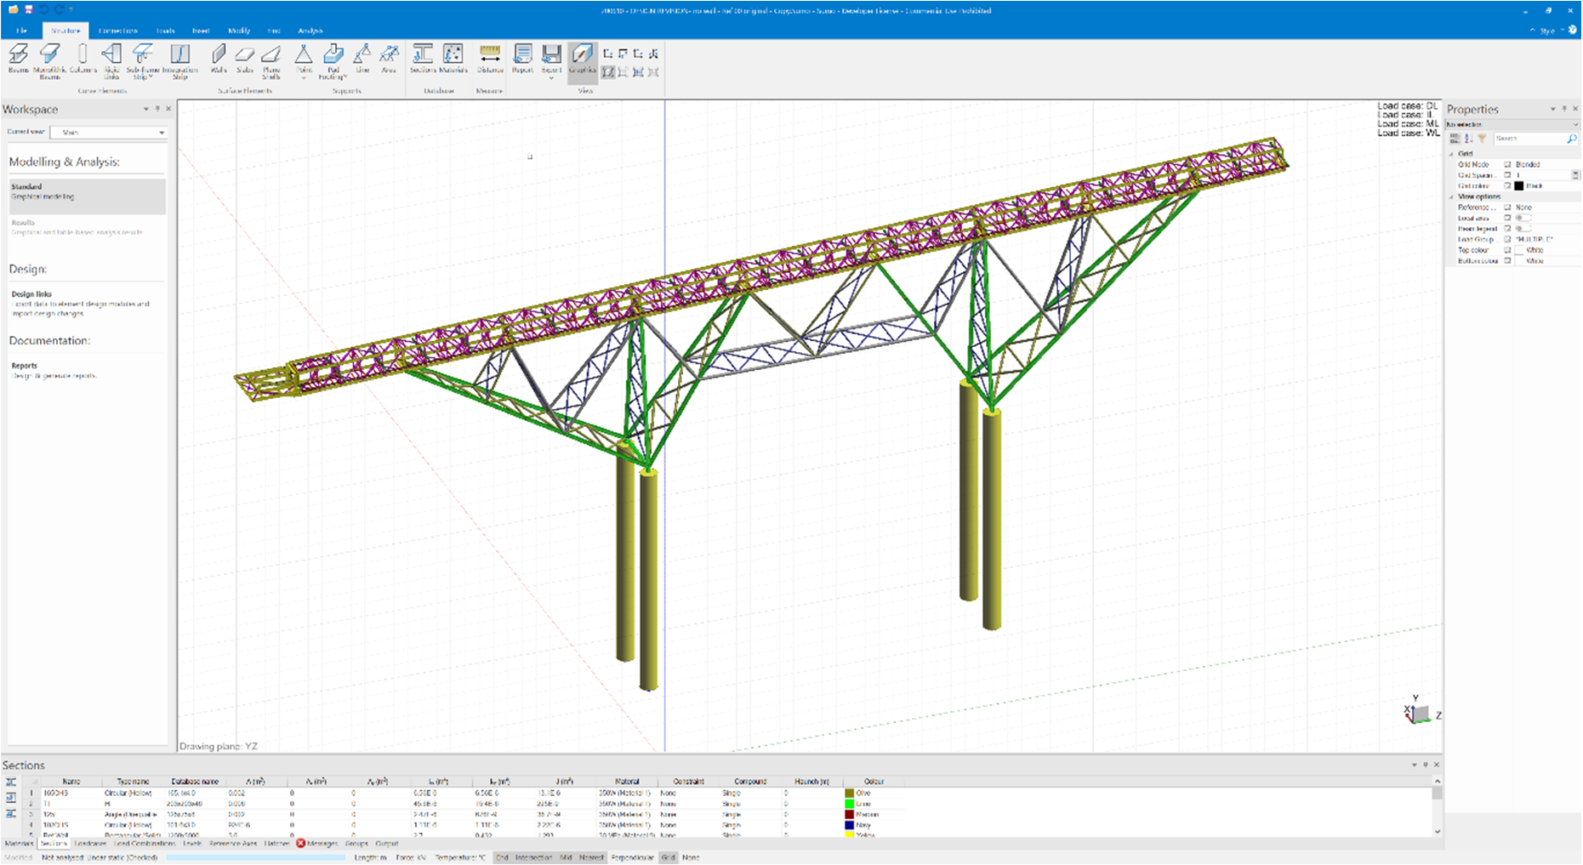

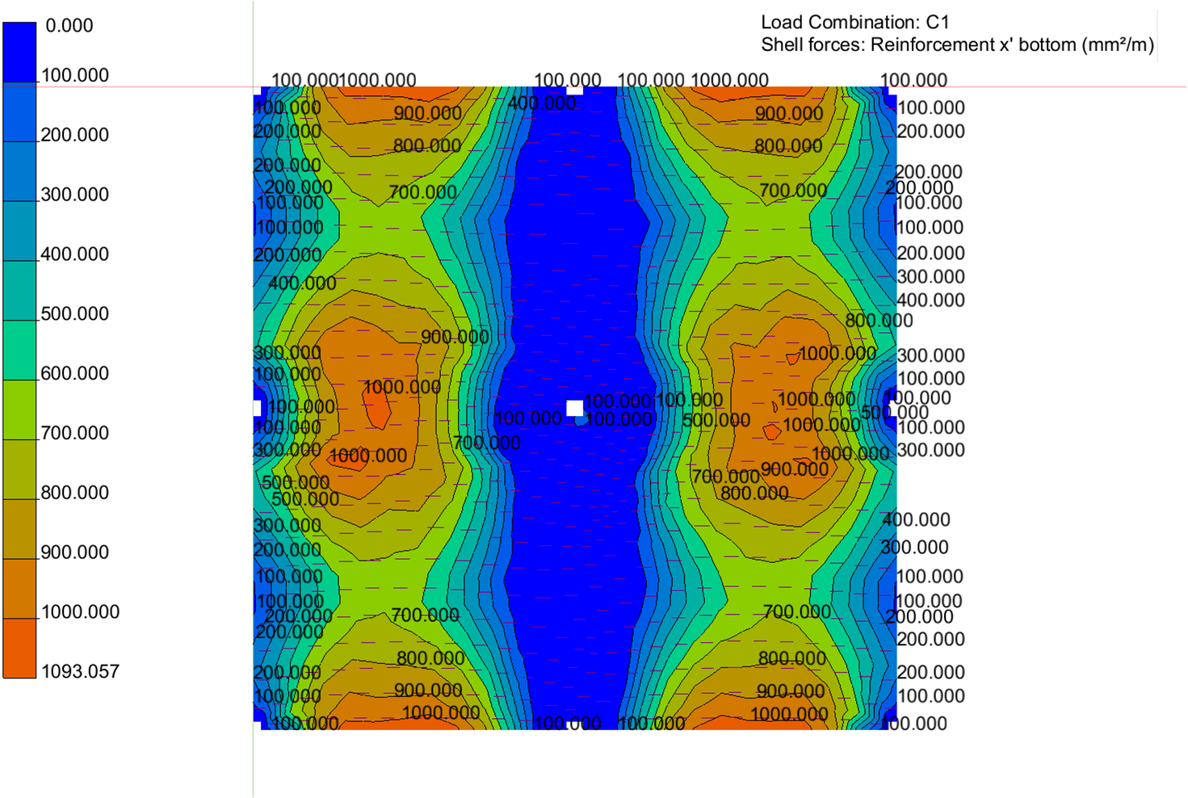
- Automated surface meshing
- Familiar and easy input
- BIM modelling
- Design links and design groups
- Various static and dynamic analysis modes
- Detailed analysis output
- Rich text format reporting
What makes this module special?

Detailed Description
Sumo is a general-purpose frame and finite element analysis software for structural engineers. With a powerful graphical modelling interface, you benefit from PROKON’s tried and tested analysis engine in a modern program. A properties palette is always visible, allowing you to navigate model parameters like most popular CAE software.
While you model, Sumo takes care of node assignment in the background. This is a significant improvement on older software, where nodes had to be modified manually when changes were made to the model. The mesh controls give the analyst complete control over the location and number of nodes.

Drawing a beam, column, or wall is as easy as selecting the beam, column or wall tool and drawing the element. Input wizards are available to speed up the modelling of typical structures.

Sumo allows collaboration with Autodesk® Revit® and Advance Steel® through the Prodesk add-ins. This avoids the need to remodel every time, saving time. Sumo also supports industry-standard file formats like IFC and DWG, making it suitable for communicating with third-party software.

Modelling
The sophisticated graphical interface makes modelling in Sumo easy. Alternatively, models can be imported from Autodesk products using the Prodesk add-in or supported exchange formats.
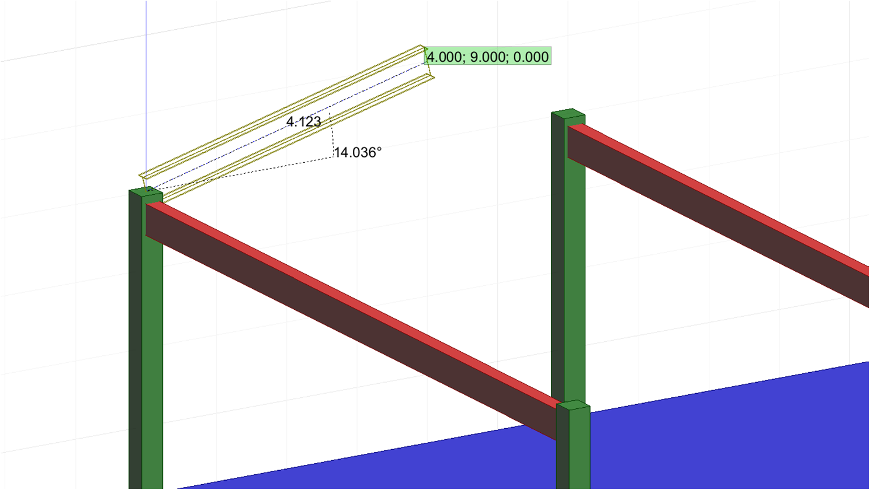

Analysis
Various analysis modes are available to aid the engineer in accurately predicting structural behaviour in every situation.

Static Dynamic

- Linear
- Second order
- Non-linear
- Buckling
- Stage
- Modal
- Seismic
- Harmonic

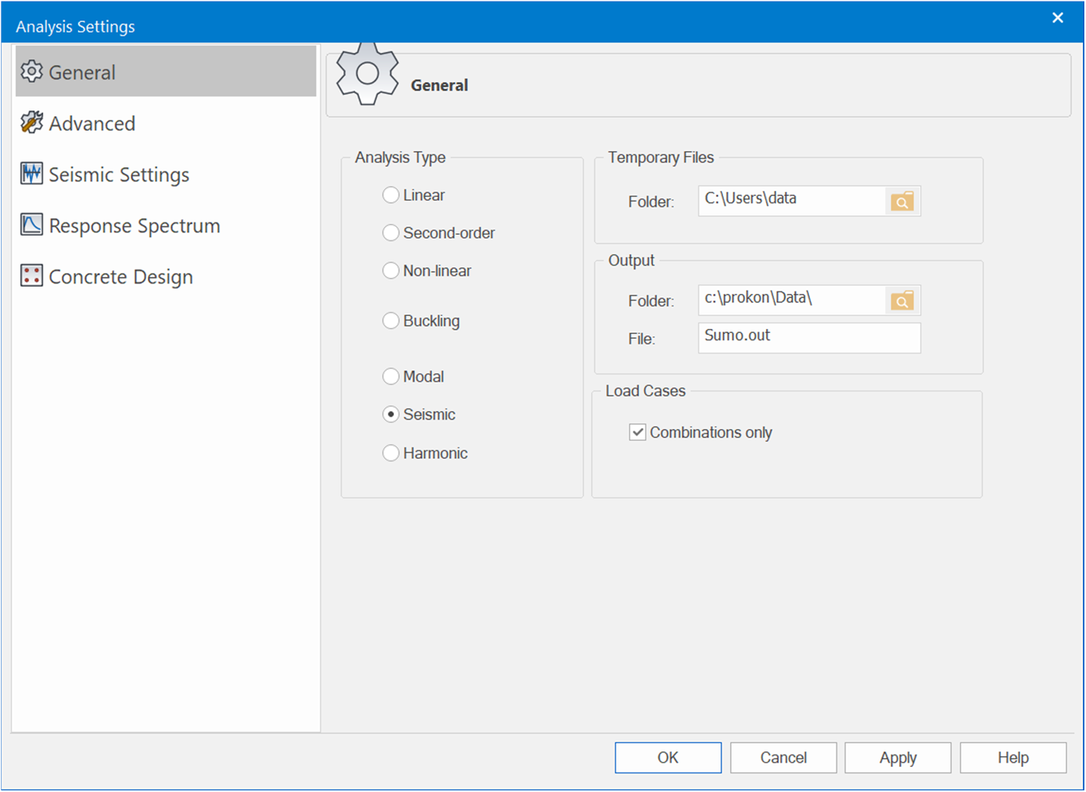

Design
Design planar reinforced concrete elements modelled with shells. The Wood-Armer theory combines out-of-plane moments with in-plane effects to specify reinforcement. The contours can be exported to Padds or Probar 2D for detailing.

Through the design links, Sumo integrates with PROKON’s various steel, concrete, and timber design modules. The design modules are sold separately, allowing you to tailor your order based on your requirements.
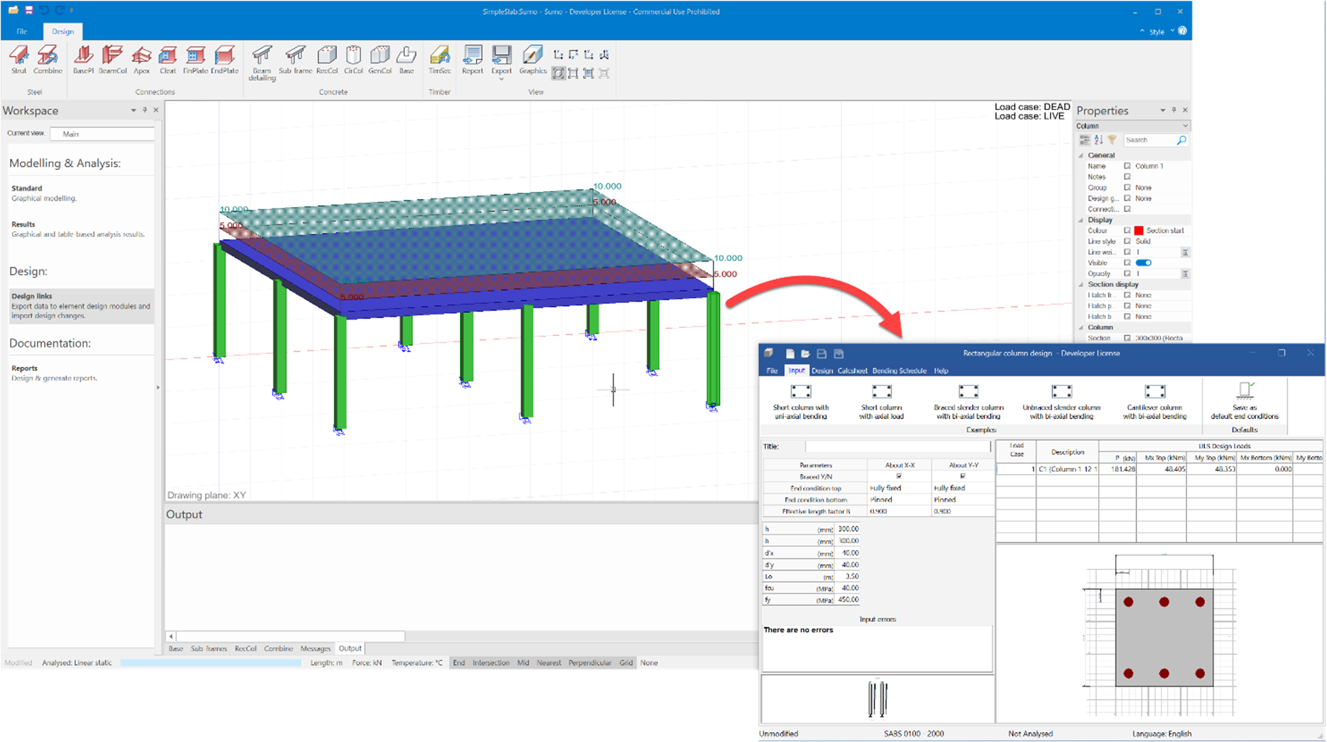

Results
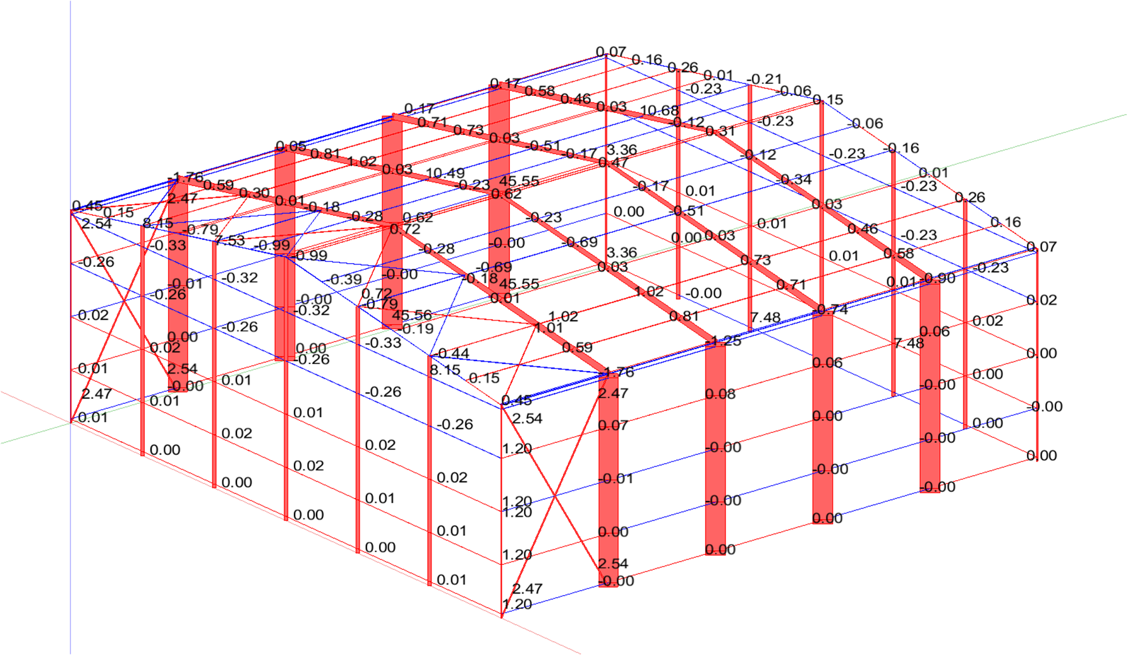
Displacements, reactions, and forces are plotted on the elements.

Raw results are available in the Grid View and can be accessed for more detailed plots using the Beam Chart feature.
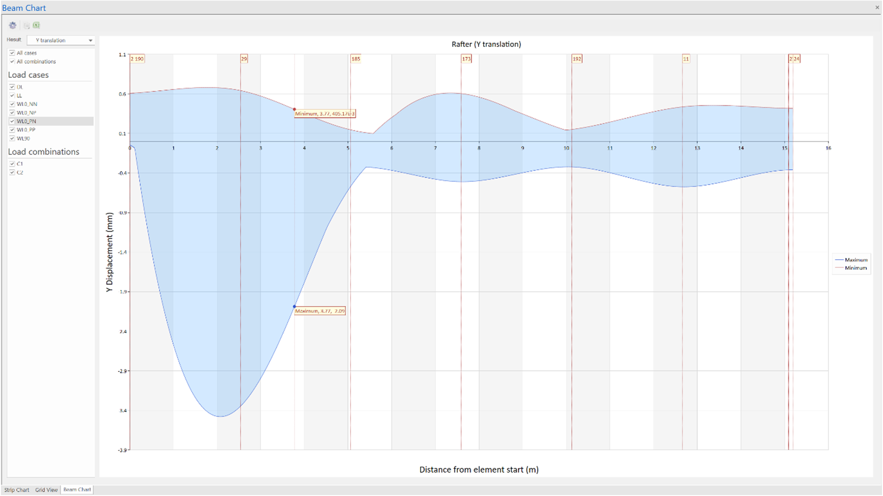

Reporting
With the built-in word processor, rich text format (.rtf) reports can be compiled while you work. Export the document to your favourite dedicated word processor to add the final touches.
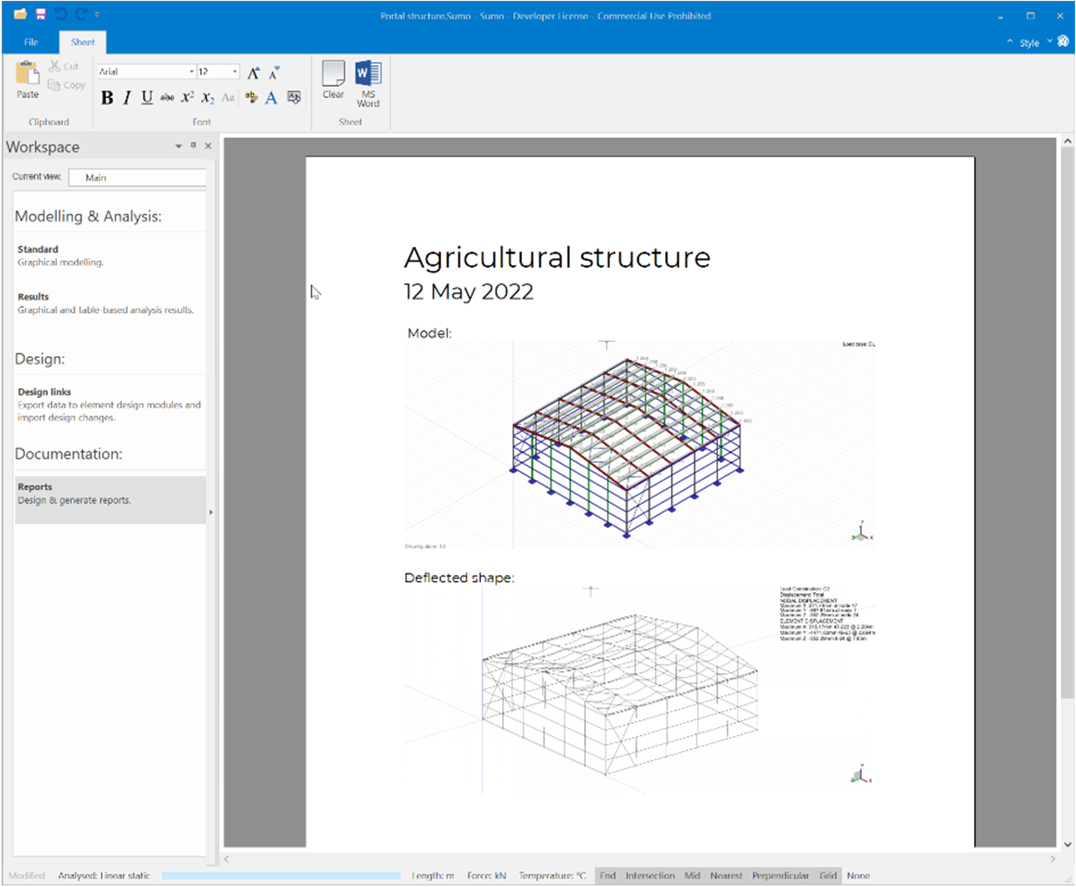

Design Codes






Concrete Design Codes
Seismic Response Spectra
- IS 1893-1 – 2002
- NZS 1170.5 – 2004
- SABS 0160 – 1989
- TMH7 – 1981
- UBC – 1994
- SANS 10160 – 2011
- EN 1998-1 – 2004

- ACI 318 – 1999
- ACI 318 – 2005
- ACI 318 - 2011
- ACI 318 – 2014
- AS3600 – 2001
- AS3600 – 2009
- AS3600 - 2018
- BS8110 – 1985
- BS8110 - 1997
- CP65 – 1999
- CSA-A23.3 – 1994
- CSA-A23.3-04 – 2010
- CSA-A23.3:2019
- Eurocode 2 -2004
- HK Concrete – 2004
- HK Concrete - 2013
- IS:456 – 2000
- NZ 3101 – 2006
- SABS 0100 – 2000
- SP63.13330.2018

Summary
Frame performs frame and finite element analyses of 2D and 3D structures. It can also perform linear, second-order, stage, and non-linear static analysis and buckling, modal, harmonic, and seismic analyses of 3D models.

Frame is easy to learn and simple to use. Build your model using a combination of beams, shells, and solid finite elements. Analysis results can be exported to various other PROKON® modules for design purposes. The design links include steel member and connection design, timber member design and reinforced concrete design. Results can be viewed and added to a Calcsheet in graphics format and analysis reports.
Frame links to other software through DXF, DWG, CIS/2, and SNF (Strucad) files. Frame models can also be exported to and imported from Autodesk® Revit® using Prodesk.
- Link with other software by way of DXF, DWG, CIS/2 and SNF (Strucad) files
- Model with different elements
- Various analysis modes
- Import/export Revit models through Prodesk
- Input wizard to speed up modelling
- Text file interface enables the use of pre- and post-processors on the data files
What makes this module special?

Detailed Description
General-purpose finite element analysis (FEA) software can be complex and challenging. This complexity leads to time lost learning the software or many costly errors. Frame is easy to learn and simple to use and has been the analysis workhorse of structural engineers worldwide for over thirty decades.

Various analysis modes are available to aid the engineer in accurately predicting structural behaviour in every situation.

Analysis Modes
Static Dynamic

  - Linear
  - Second order
  - Non-linear
  - Buckling
  - Stage
  - Modal
  - Seismic
  - Harmonic

Design planar reinforced concrete elements modelled with shells. The Wood-Armer theory combines out-of-plane moments with in-plane effects to specify reinforcement. The contours can be exported to Padds or Probar 2D for detailing.
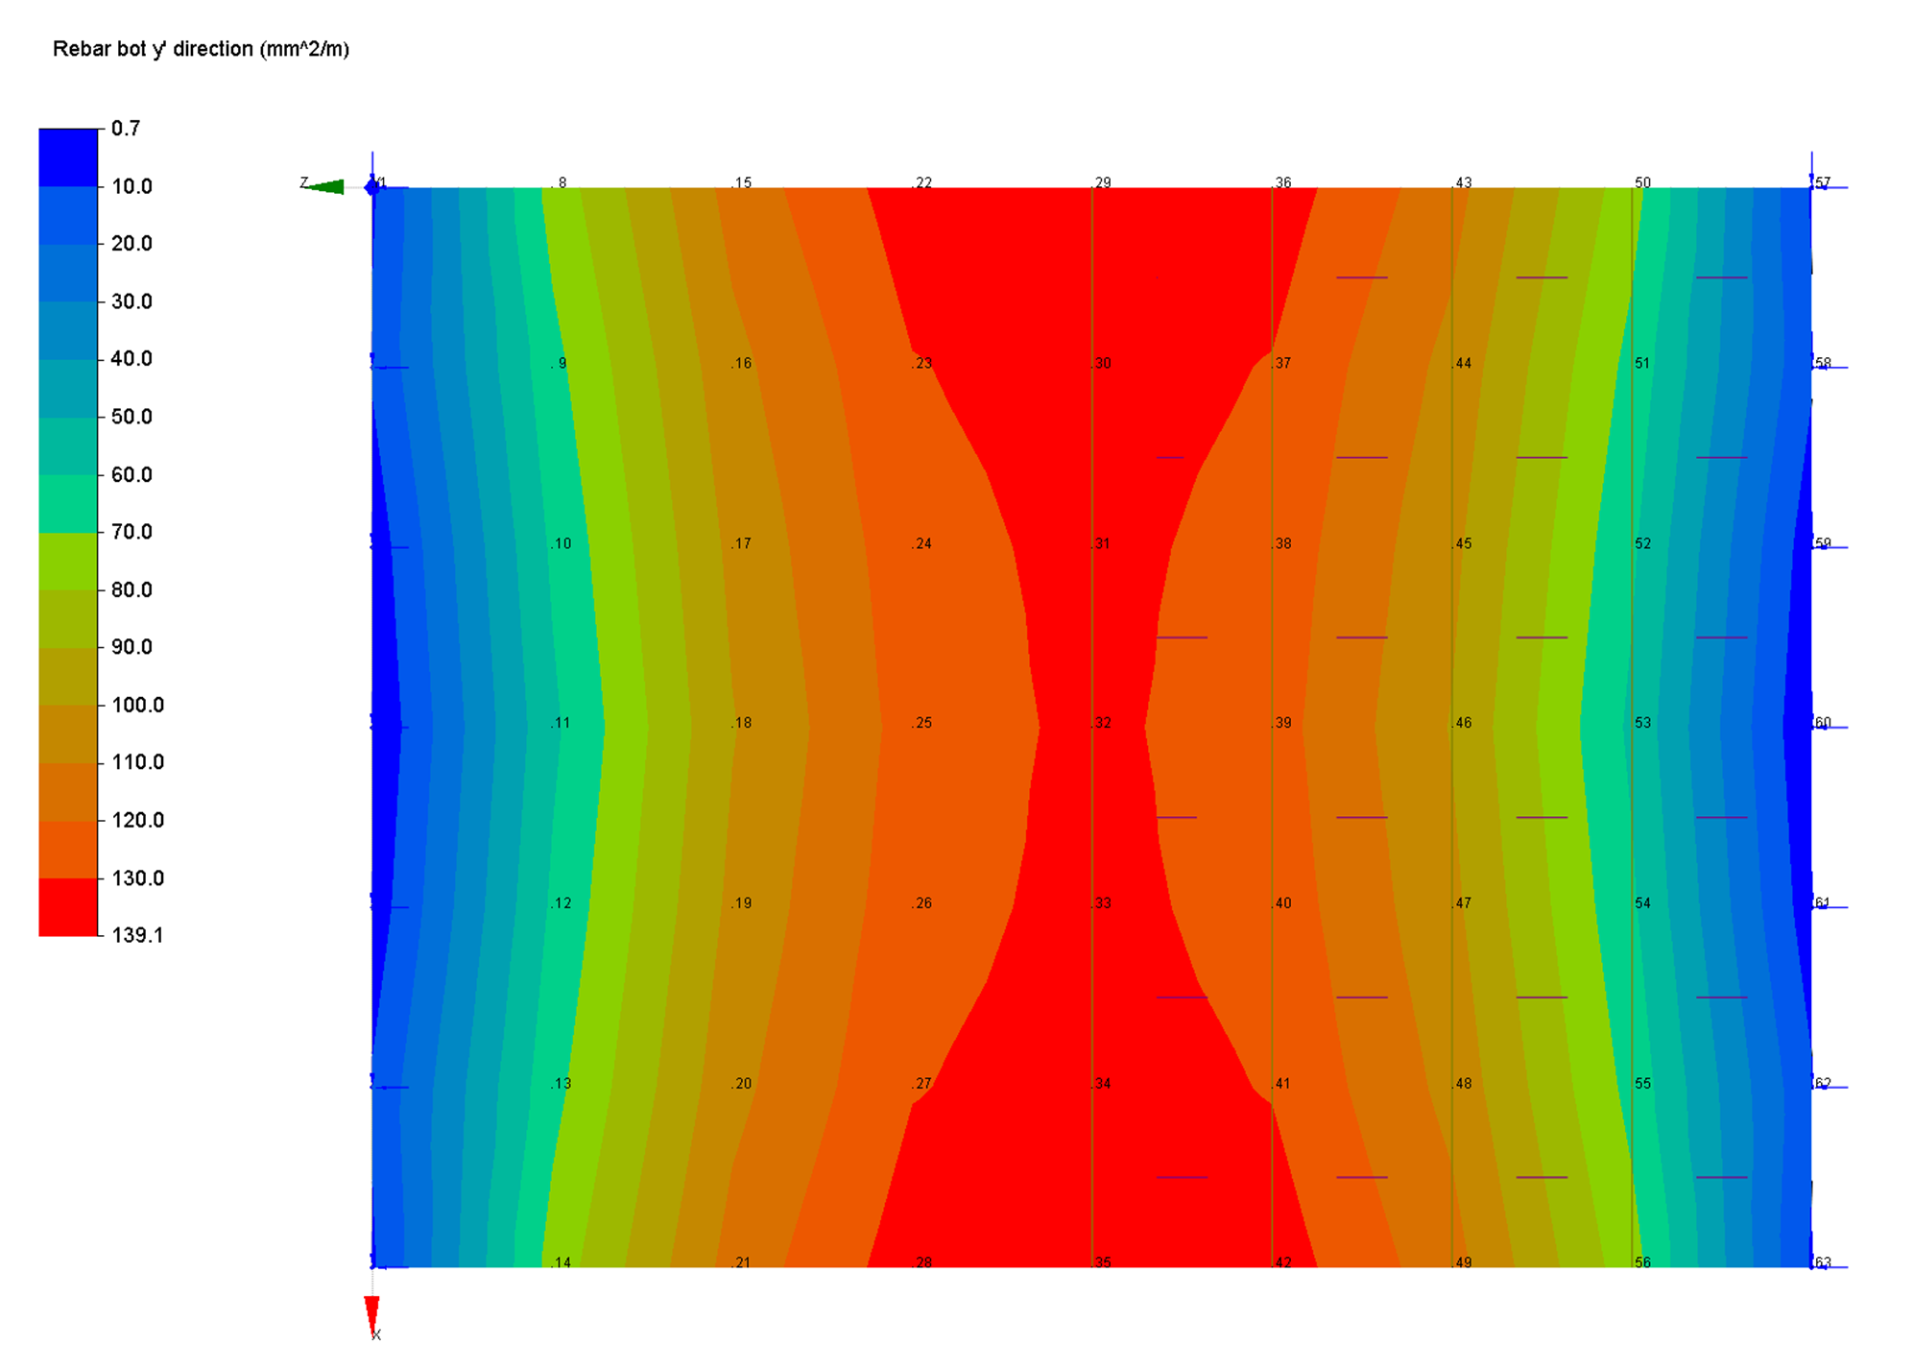

Design members and connections using one of the many PROKON design modules.
Results can be viewed and added to a Calcsheet in graphics format and analysis reports.
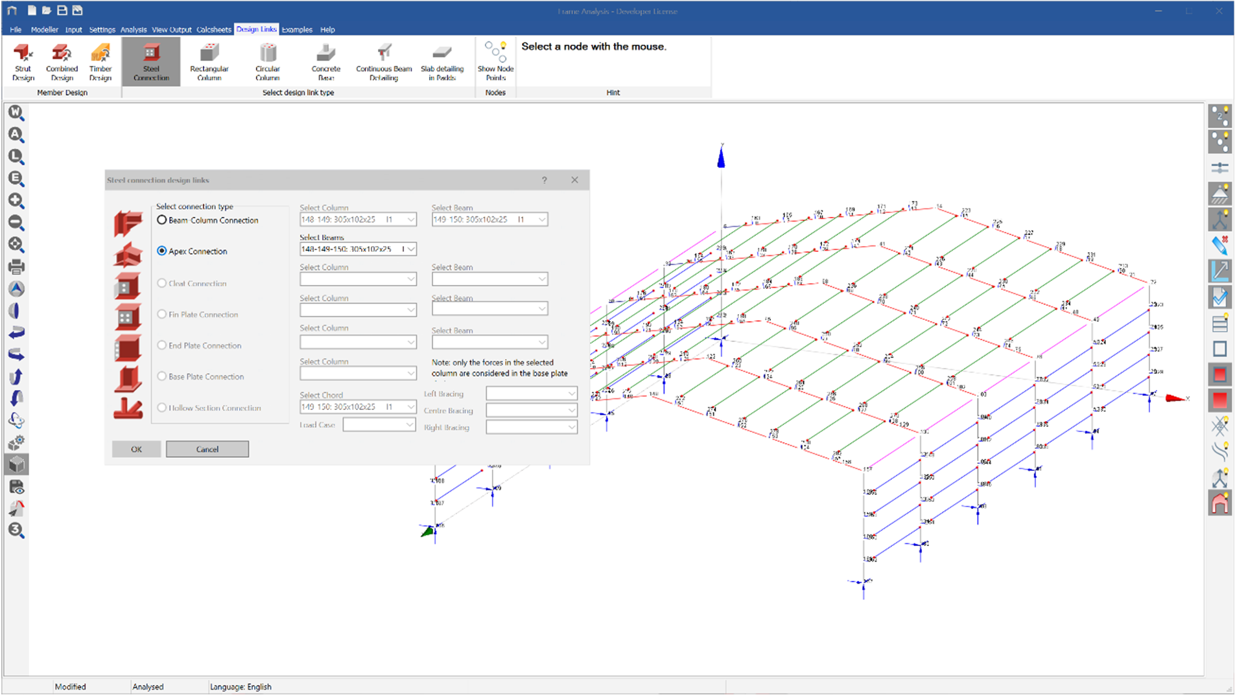

Workflow
Models can be created in Frame or imported from Revit using Prodesk. Design links to other modules can be used to accomplish detailed design.
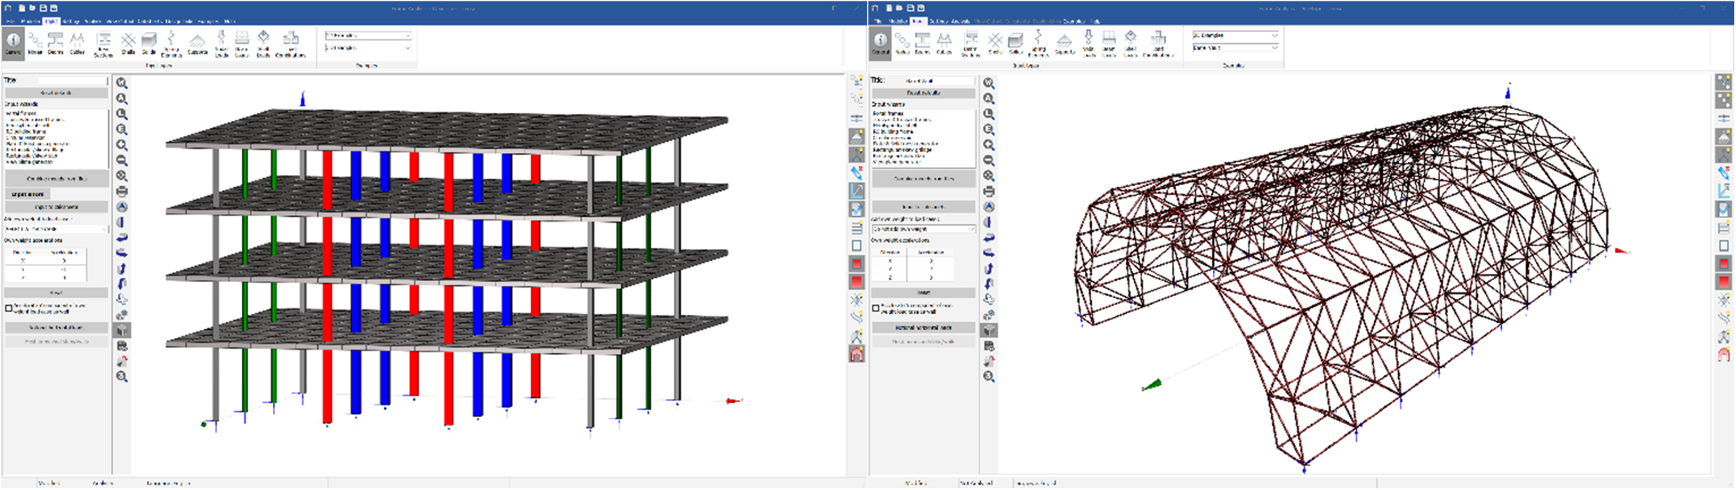

Key features
    - Beam, shell, and solid finite elements
    - Linear, second-order, non-linear, buckling, and stage analysis
    - Modal, harmonic, and seismic analysis
    - Reinforced concrete design
    - Design links
    - Input link from BIM tools

Supported Design Codes






Concrete Design Codes
Seismic Response Spectra
- TMH7 – 1981
- UBC – 1994
- SABS 0160 – 1989
- IS 1893-1 – 2002
- SANS 10160
- Eurocode 8
- NZS 1170.5 - 2004

      - ACI 318 – 1999
      - ACI 318 – 2005
      - ACI 318 - 2014
      - ACI 318 – 2011
      - ACI 318 – 2019
      - AS3600 – 2001
      - AS3600 – 2009
      - AS3600 - 2018
      - BS8110 – 1985
      - BS8110 – 1997
      - CP65 – 1999
      - CSA-A23.3:1994
      - CSA-A23.3-04 – 2010
      - Eurocode 2 -2004
      - HK Concrete – 2004
      - HK Concrete – 2013
      - IS:456 – 2000
      - NZ 3101 – 2006
      - SABS 0100 - 2000
      - SP 63.13330.2018

Summary
The Plane Stress module can perform finite element analysis of a membrane of any general geometry subjected to plane stress or strain. You can combine simple polygons to model complex geometries, and the program automatically generates a suitable mesh for the analysis. Multiple load cases comprising point loads and UDLs can be applied to the model's outline.
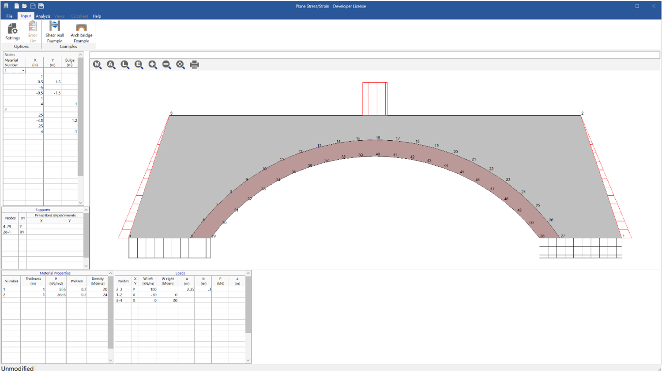
- Plane stress and plane strain problems can be solved
- Easy geometry input
- Automatic mesh generation
What makes this module special?

Detailed Description
Many complex three-dimensional problems are amenable to simplification to plane elasticity problems. For example, regions of a dam wall far away from the edges can be analysed as a slice of unit thickness. Plane strain problems, such as the dam wall example and plane stress problems, are the domain of Plane Stress.

You can deal with both classes of problems in either Sumo or Frame. Although plane strain requires modification of the elastic constants, the simplicity of Plane Stress makes it an attractive, lightweight alternative.

The structure can be defined by entering one or more shapes comprised of straight lines and arcs. When more than one shape is entered, it accumulates and forms one structure. A complicated section is often easily defined using more than one simple shape.

Point supports, distributed supports and prescribed displacements can be defined anywhere along the edges of the structure, as well as point loads and distributed loads. As many lines as necessary can be used to define the loads.

During the analysis, the program generates a rectangular grid of nodes in which rectangular and, where necessary, triangular finite elements are placed. The grid spacing can be set independently in the horizontal and vertical directions.

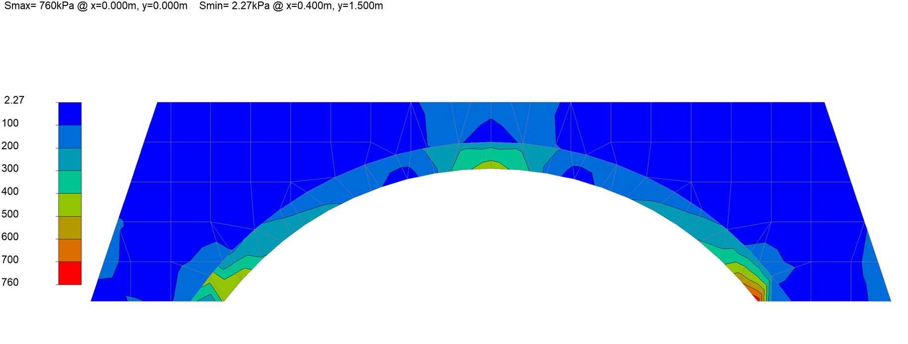
The following analysis results can be viewed and printed in tabular or graphic format under the View tab:
- Maximum elastic deflections
- Maximum and minimum stress
- Von Mises stresses
- Stress vectors

Key features
- Plane strain and plane stress
- Simple input
- Automatic mesh generation

Summary
The Single Span Beam module can be used to analyse a beam quickly. The beam can be a single-span beam or a single-span taken from a continuous beam with the appropriate end conditions.

The analysis results of steel beams can be post-processed with the steel member design module for combined stress.
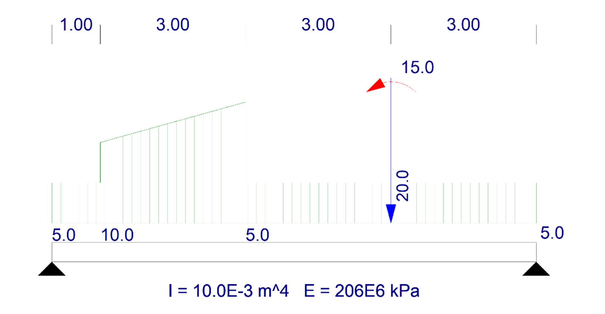

What makes this module special?

- Simple input
- Integrates with the Section Database and design modules.
- Produces an output file for Combine
- Unlimited number of loads

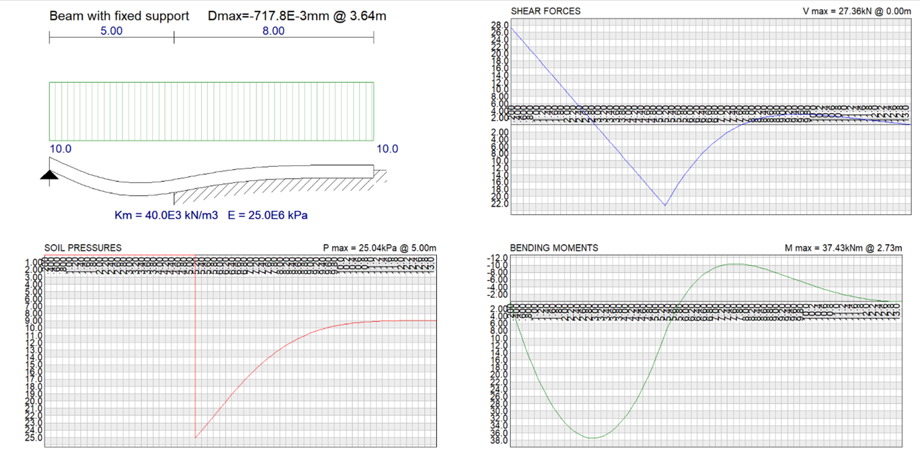

Detailed Description
The Single Span Beam module is one of the most essential tools in the structural engineer’s toolbox.
Single Span Beam avoids copying errors by importing beam sections directly from the section database and produces an output file for Combine that can be used to optimise the section size.

The analysis is restricted to in-plane bending due to point and distributed loads. Therefore, the input is much simpler than an equivalent model in Frame or Sumo. Loading input may be simple, but unlimited loads can be used.

Maximum values and distributions of shear forces, moments and deflections are instantly available.

Key features
- Simple input
- Integrates with section database and design modules
- An unlimited number of loads can be defined

Summary
Elastic Support Beam was developed to analyse a beam or slab on an elastic foundation rapidly. This module allows for analysing beams or slabs with varying cross-sections along their lengths. Elastic foundations may include variations or gaps in the elastic medium and rigid supports. An unlimited number of loads may be entered.
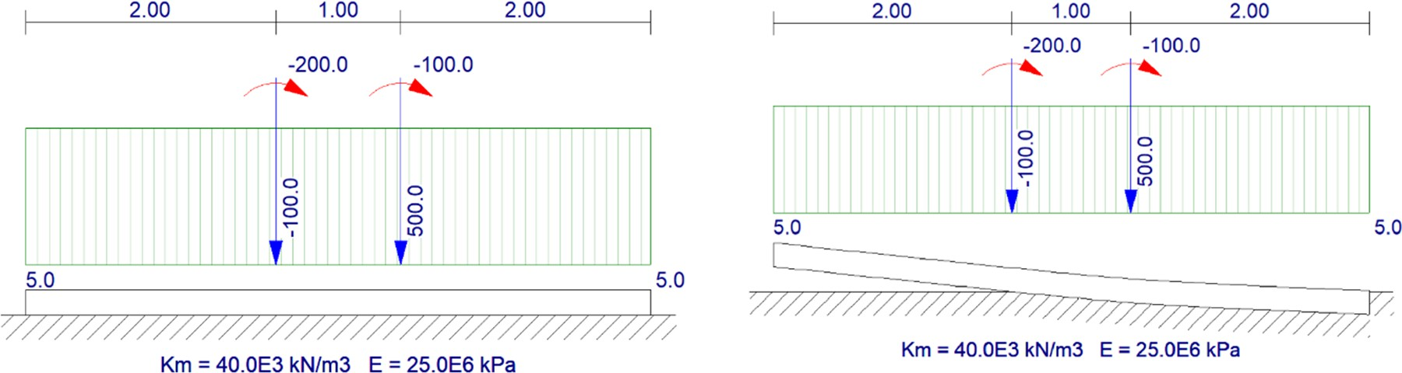
- Varying cross-section.
- Gaps and Rigid Supports.
- Unlimited number of loads.
What makes this module special?

Detailed Description
A linear analysis is performed in which the beam is modelled as a two-dimensional frame on a series of at least fifty closely spaced springs. Rigid supports are placed at the specified positions, and gaps in the elastic supports where the supporting width is set to zero. Nodes are taken at close intervals along the beam's length and at every support and load position.
There is an option to disallow negative pressures (i.e., uplift). The program will then remove springs with negative reactions and repeat the analysis. Likewise, previously removed springs are restored if downward deflections are calculated at those points.

The analysis procedure is repeated until the iteration converges to a stable solution. A beam will be considered unstable, i.e., to overturn under the applied load, if the analysis yields less than two springs with compressive forces.

The analysis output includes diagrams for soil pressure, bending moment and shear
force.
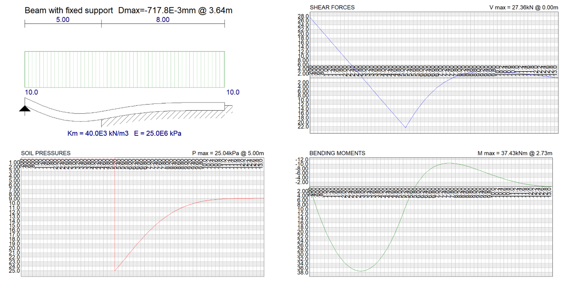

Key features
- Varying cross-section.
- Gaps and Rigid Supports.
- An unlimited number of loads.

Summary
Calculating cross-sectional properties of general shapes often involves solving equations that require numerical approaches. Prosec uses a finite difference procedure to calculate over 30 bending and torsional section properties.
- Evaluate any section geometry
- Bending and torsional properties
- CAD input
- Store properties in the PROKON section database
What makes this module special?

Detailed Description
Cross-sectional properties are essential when working with beams in a frame analysis. Prosec determines the cross-sectional properties of any general shape, which can be stored in a database for use in Sumo or Frame. The cross-section can be defined by coordinates or imported from a CAD program.
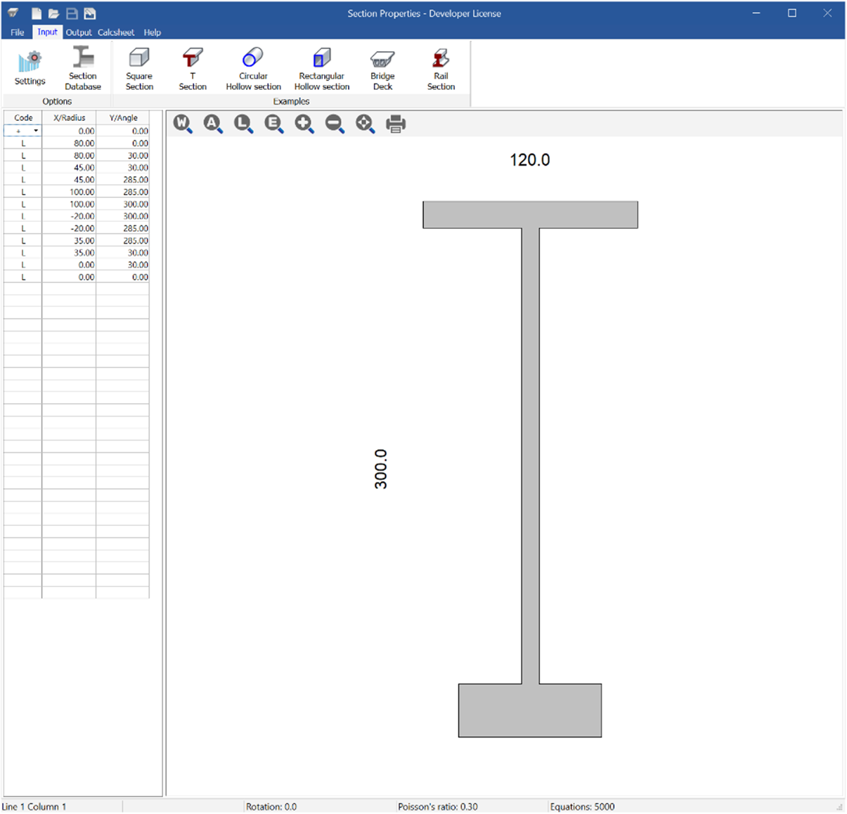

Prosec employs a finite difference method to calculate various section properties.
- Bending: area, location of centroid, orientation of major and minor axes, moments of inertia, elastic and plastic section moduli, radii of gyration, outside perimeter length, void ratio, and section efficiency factor.
- Torsional: normalised shear stress, effective shear area, location of the shear centre, St. Venant torsional constant, mono-symmetry constant, torsional modulus, and warping torsion constant.
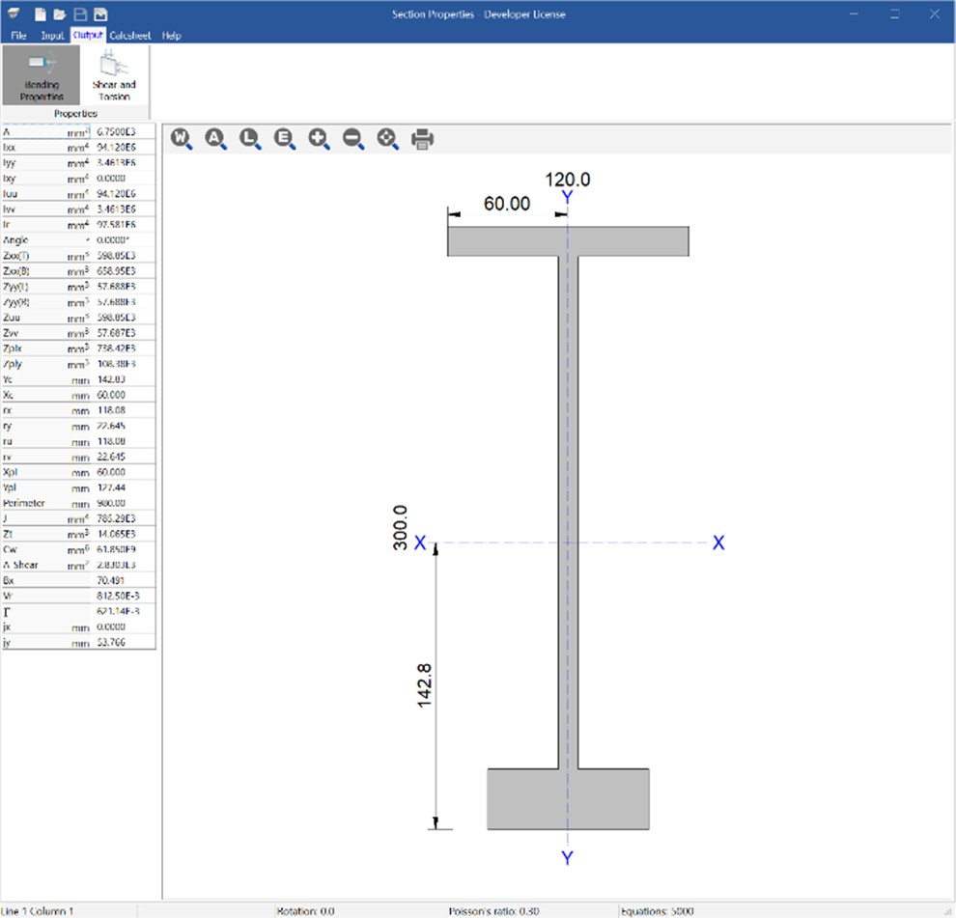
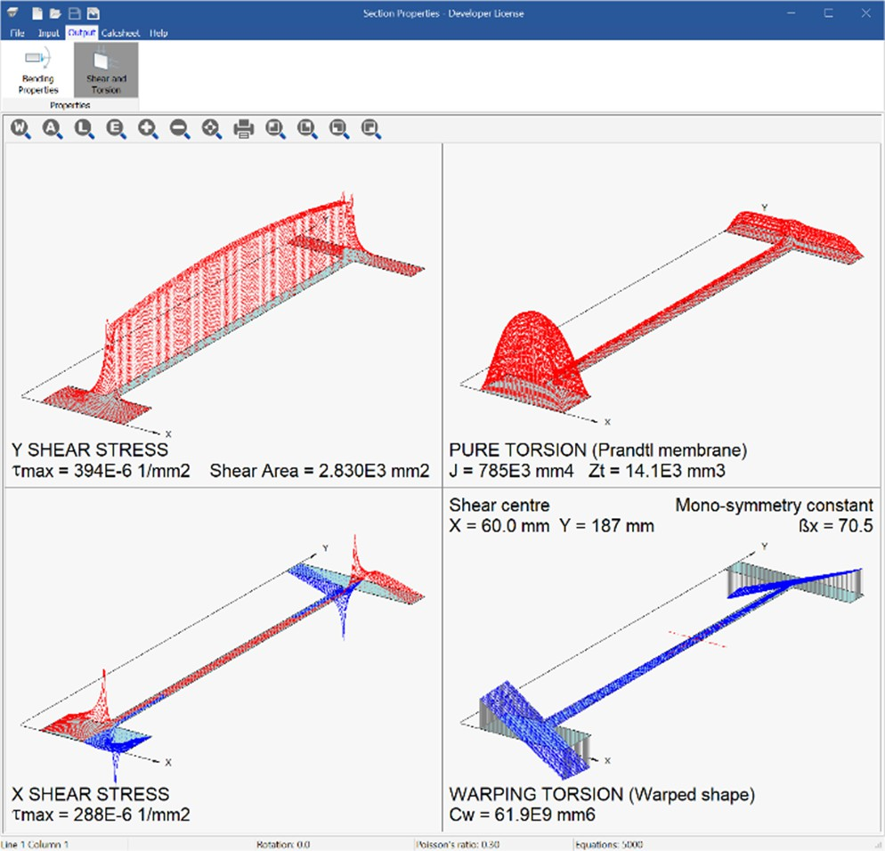

Summary
Wind calculates free stream velocity pressures and wind loads on various building geometries.
- Simplified input
- Dou-pitched and mono-pitched roofs
- Integrates with Sumo and Frame
What makes this module special?

Detailed Description
Wind eliminates the tedium of wind loading by computing the free stream velocity pressures, including frictional effects due to wind, on building structures based on a few simple inputs.

Three-dimensional depictions of input and output illustrate the wind direction and pressure vectors, thus reducing the effort of transferring wind loading to the correct regions of an analysis model. Mono-pitched and duo-pitched roofs are supported. Frame and Sumo integrate with Wind via the portal and trussed frame wizards.
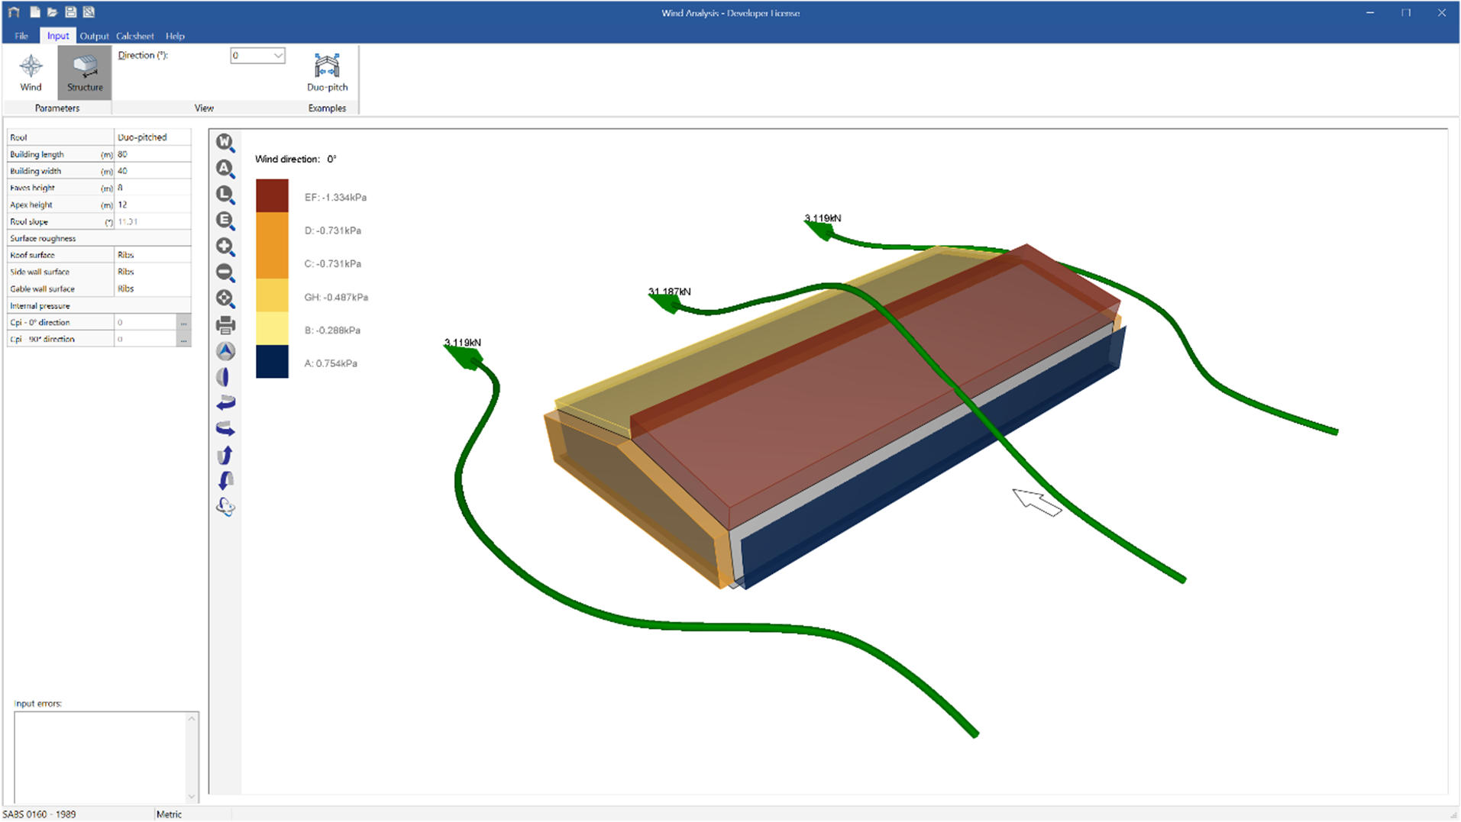

The output includes diagrams showing the pressure on critical zones for various wind
directions.
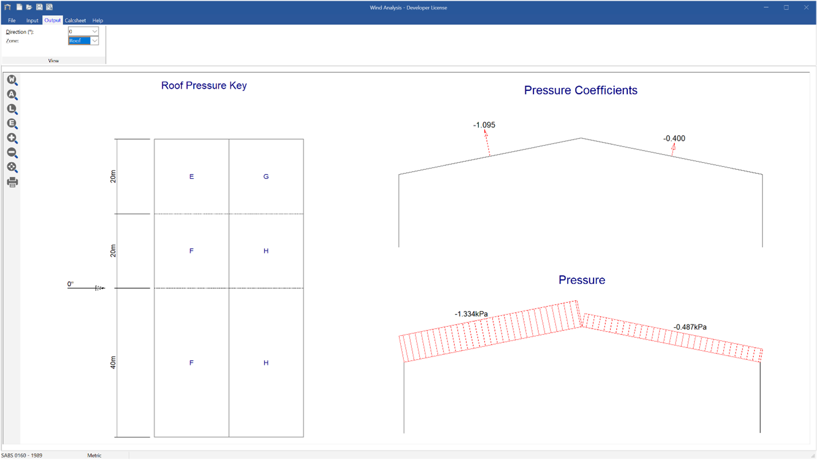

Workflow
Frame and Sumo integrate with Wind via the portal and trussed frame wizards.

Supported Design Codes


Design Codes
- AS/NZS1170.2:2011
- BS EN 1991-1-4:2005
- SABS 0160 – 1989
- SANS 10160-3:2011
- SANS 10160-3:2018
- SANS 10160-3:2019
- SP 20.13330.2016
- SS EN 1991-1-4:2009

Summary
The module designs gutters and downpipes that drain the roofs of building structures.
- Sizes gutters and downpipes
- Range of rainfall settings
- Clear results visualisation
What makes this module special?

Detailed Description
Using the requirements of BS EN 12056-3-2000, the module designs gutters and downpipes that drain roofs of building structures for specified rainfall intensities and design durations. The rainfall intensities can be picked from a list of regions in the United Kingdom and South Africa. Gutter offers a 3D visualisation of the roof segment under analysis, and a roof and gutter draining diagram eases result interpretation.
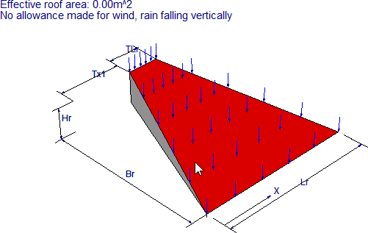
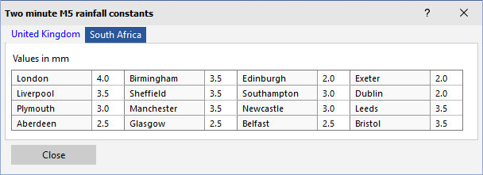

The outflow characteristics of each gutter segment and downpipe are summarised in
tabular form and detailed design calculations are also provided.

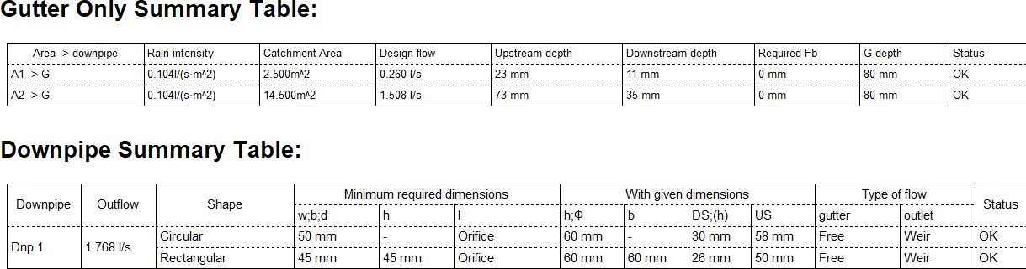

Supported Design Codes

Design Codes
- BS EN 12056-3 – 2000

