# Prokon Composite

The beam module allows you to design a composite section for flexure. Composite construction methods are becoming more popular globally due to the rapid construction potential and efficient use of materials. The module forms part of the PROKON structural analysis and design suit with the three other composite design modules.

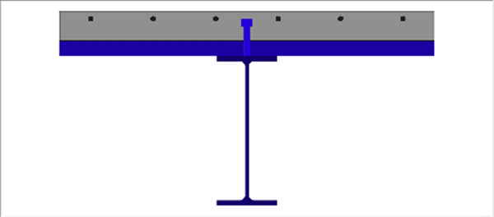

* Design a section for sagging and hogging moments and for shear
* Various deck layouts are supported
* Design checks indicate which failure mode governs
* Detailed equations

**What makes this module special?**

# Detailed Description

A composite beam usually combines a steel I-beam and a concrete slab cast on top. Shear connectors are welded to the top flange of the steel beam to ensure that the composite action is possible. Composite construction reduces the construction timeline because the contractors don’t have to wait for concrete beams to reach the required 28-day strength before removing formwork. With good planning, formwork can be avoided entirely, which allows for massive savings. The composite beam section design module allows you to design a composite section for flexure and shear. The module considers the case of sagging as well as hogging moments.

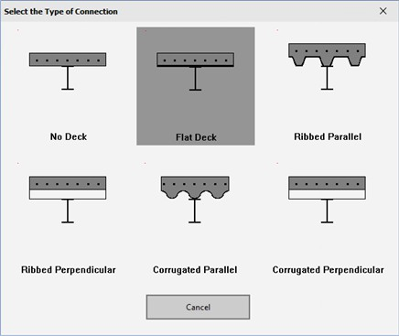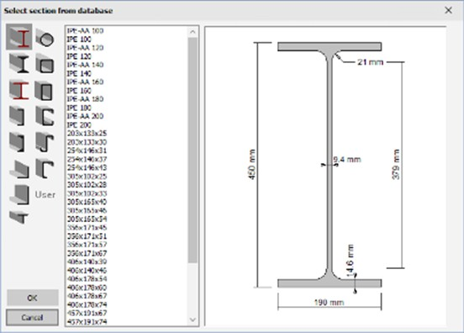Various deck layouts are possible:

1. No deck
2. Flat deck
3. Ribbed parallel to beam
4. Ribbed perpendicular to beam
5. Corrugated parallel to beam
6. Corrugated perpendicular to beam

The module reads sections from the **PROKON® Section Database,** which contains the steel sections used in most countries.

# Theory used in this module

The module calculates the sagging and hogging resistance of composite beam sections according to rigid-plastic theory in Section 6 of EN 1994-1-1:2004 (Eurocode 4). It can evaluate both full-shear connection and partial-shear connection designs using plastic theory.

The module verifies that the section is either a Class 1 or a Class 2 section as required for rigid-plastic theory design. It accounts for longitudinal reinforcement in compression (if present) for sagging resistance with the assumption that such reinforcement is fully anchored.

To calculate the plastic bending resistance of the section, the module determines the plastic neutral axis (PNA) location of the section. It does this by balancing the composite cross-section's contributing horizontal forces (based on plastic stresses).

In the shear connection calculations, the module checks headed studs for adherence to the ductility requirements for steel sections with equal flanges. It also checks resistance to vertical shear.

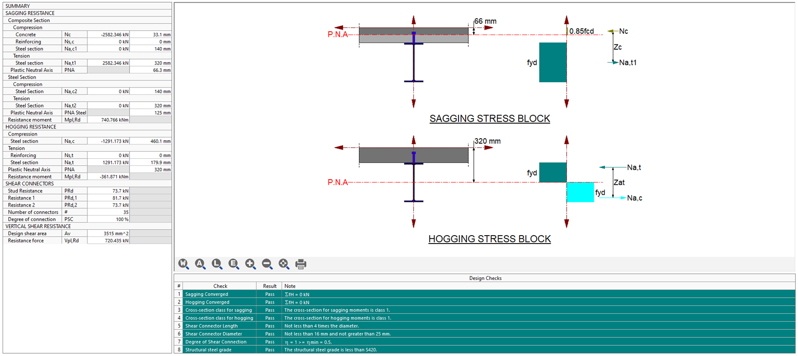

# Supported Codes



**Design Codes**

* AISC 360 – 16 (LRFD)
* Eurocode 4 – 2004
* SANS 10162-1:2011

**Summary**

The composite continuous beam design module designs multi-span composite beams. Composite construction methods are becoming more popular globally due to the rapid construction potential and efficient use of materials. The module forms part of the **PROKON** structural analysis and design suit with the three other composite design modules.

* Design of a section for both sagging and hogging
* Various deck layouts
* Multi-span composite beams
* Different construction methods
* Point loads & moments as well as distributed loads
* Output: elastic & long-term deflections, shear forces and bending moments
* Detailed equations

**What makes this module special?**

# Detailed Description

A composite beam usually combines a steel I-beam and a concrete slab cast on top. Shear connectors are welded to the steel beam's top flange to ensure the composite resistance is possible. Composite construction reduces the construction timeline because the contractors don’t have to wait for concrete beams to reach the required 28-day strength before removing formwork. With good planning, formwork can be avoided entirely, which allows for massive savings. The composite continuous beam design module allows you to design a composite section for bending and shear. The module considers the case of sagging as well as hogging moments.

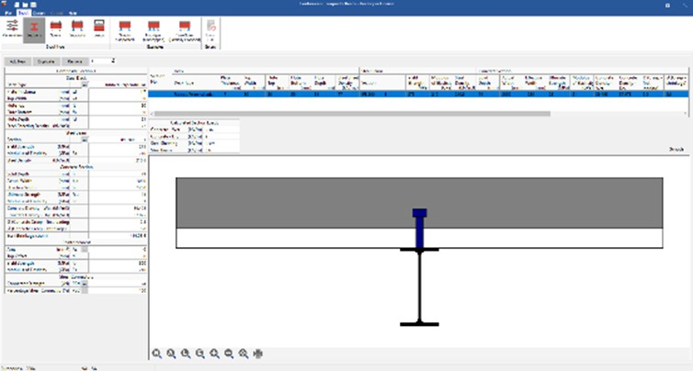Various deck layouts are possible:

1. No deck
2. Flat deck
3. Ribbed parallel to beam
4. Ribbed perpendicular to beam
5. Corrugated parallel to beam
6. Corrugated perpendicular to beam

Various spans can be defined, and each span can consist of more than one section. This

allows for economical design because you can have a section with reinforcing in the flange to be used in regions of hogging and another without reinforcing in the flange for sagging regions.

Construction loads and construction supports can be entered, affecting the construction phase’s analysis and design. When the construction phase is complete, and the concrete and steel can achieve composite action, the construction loads and supports are removed, and the beam is re-analysed and designed. This all happens automatically without any additional user input required.

The module reads sections from the **PROKON Section Database,** which contains the steel sections used in most countries.

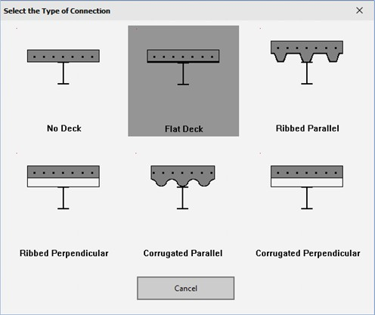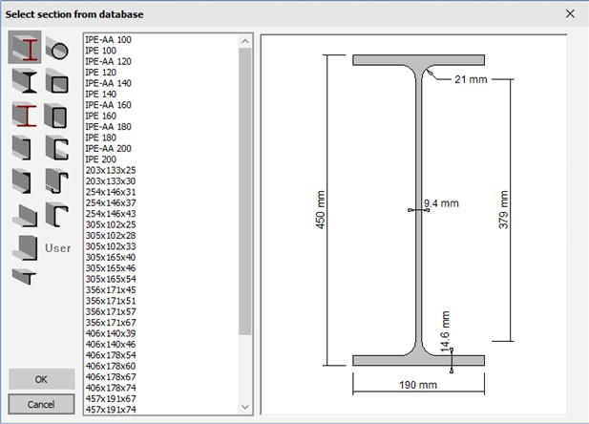

Possible ULS loads include distributed loads, point loads, and point moments at any point along the beam.

The design output includes elastic deflections, long-term deflections, shear forces and bending moment envelopes along the length of the beam.

# Theory used in this module

The module calculates the sagging and hogging resistance of composite beam sections according to rigid-plastic theory in Section 6 of EN 1994-1-1:2004 (Eurocode 4). It can evaluate both full-shear connection and partial-shear connection designs using plastic theory.

The module verifies that the section is either a Class 1 or a Class 2 section as required for rigid-plastic theory design. It accounts for longitudinal reinforcement in compression (if present) for sagging resistance with the assumption that such reinforcement is fully anchored.

To calculate the plastic bending resistance of the section, the module determines the

plastic neutral axis (PNA) location of the section. It does this by balancing the composite cross-section's contributing horizontal forces (based on plastic stresses).

In the shear connection calculations, the module checks headed studs for adherence to the ductility requirements for steel sections with equal flanges. It also checks resistance to vertical shear.

# Summary

The composite-filled column module designs compression members of steel and concrete materials. This module considers rectangular or circular hollow sections filled with reinforced concrete.

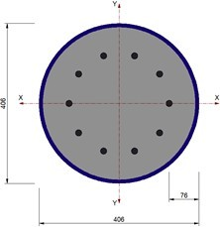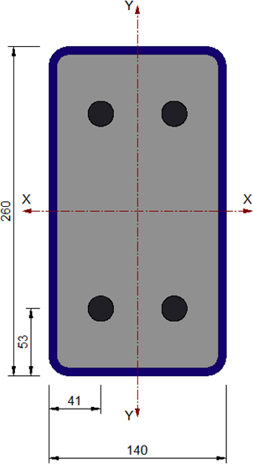

* Section resistance calculation, including second-order effects and material non- linearity.
* Composite column design, including steel section, concrete, and rebar.
* Interactive interaction charts for both design axes.
* Detailed equations.

**What makes this module special?**

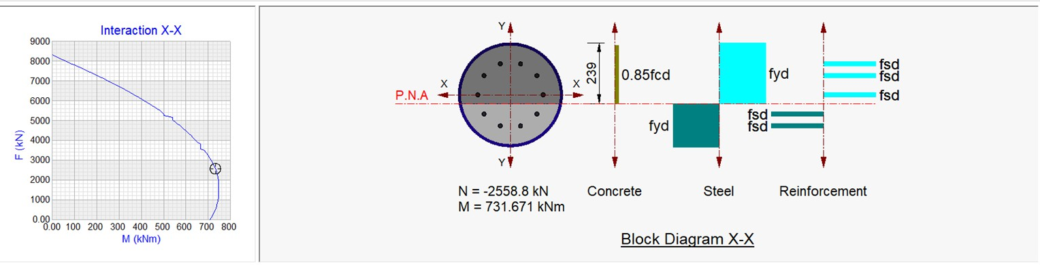

# Detailed Description

The composite-filled column module designs compression members made up of either rectangular or circular hollow sections filled with concrete and with reinforcement present. The module follows the rigid plastic theory set out in the Eurocode. Rather than using simplified interaction curves, the module generates full X-X and Y-Y interaction charts, which can be viewed interactively to display the resistance at different graph points.

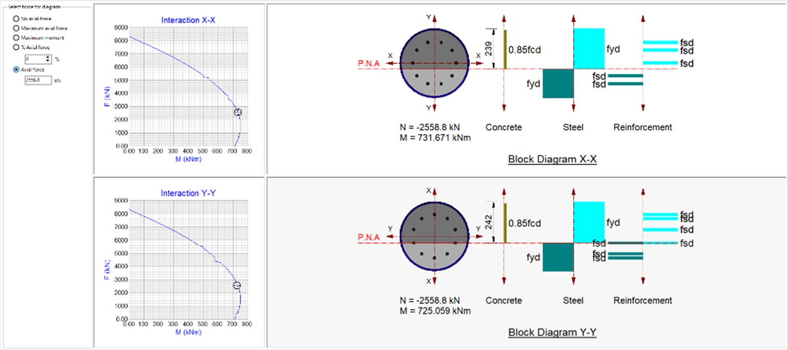

# Theory used in this module

The module determines the plastic neutral axis location by balancing the contributing forces in the composite column cross-section based on the allowed plastic stresses.

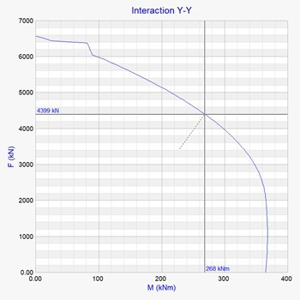Design results for individual materials are tabulated in detail, and a summary table is generated to show whether the design checks pass or fail. Multiple load cases can be entered to compare with the section capacity, and the comparisons are displayed in tabular form.

More importantly, a summary table for the critical load cases for each of the design

checks (uniaxial and biaxial bending, axial force, shear forces) are given.

The module generates full X-X and Y-Y interaction charts, which can be viewed interactively to display the section resistance for different combinations of axial forces and bending moments. Detailed equations are included with all assumptions stated, and relevant calculations are shown with the necessary references to the active design code.

# Summary

The encased column module designs compression members of steel and concrete materials. This module considers rolled steel profiles encased in reinforced concrete.

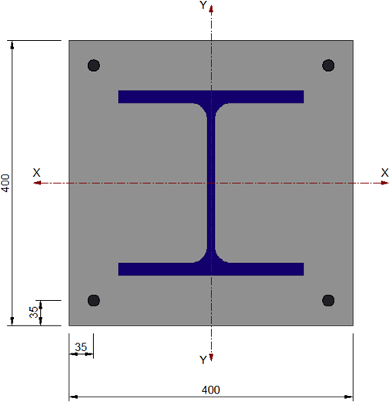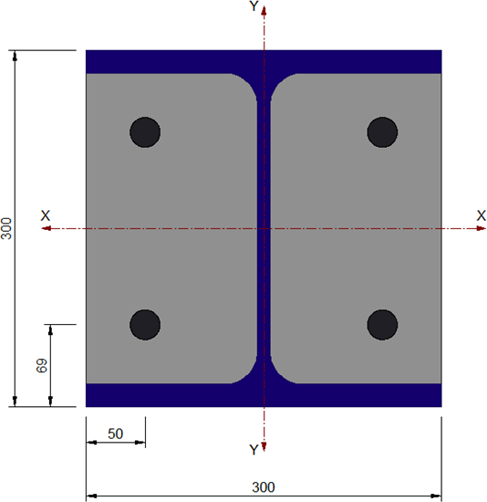

* Section resistance calculation, including second-order effects and material non- linearity
* Composite column design, including steel section, concrete, and rebar
* Interactive interaction charts for both design axes
* Detailed equations

**What makes this module special?**

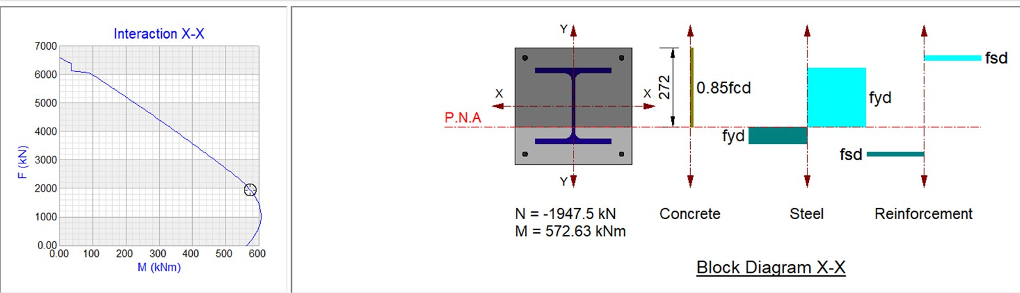

# Detailed Description

The composite encased column module designs compression members comprising either partially or fully encased I or H-sections and with reinforcement present. The module follows the rigid plastic theory set out in the Eurocode. Rather than using

simplified interaction curves, the module generates full X-X and Y-Y interaction charts

which can be viewed interactively to display the resistance at different points on the graphs.

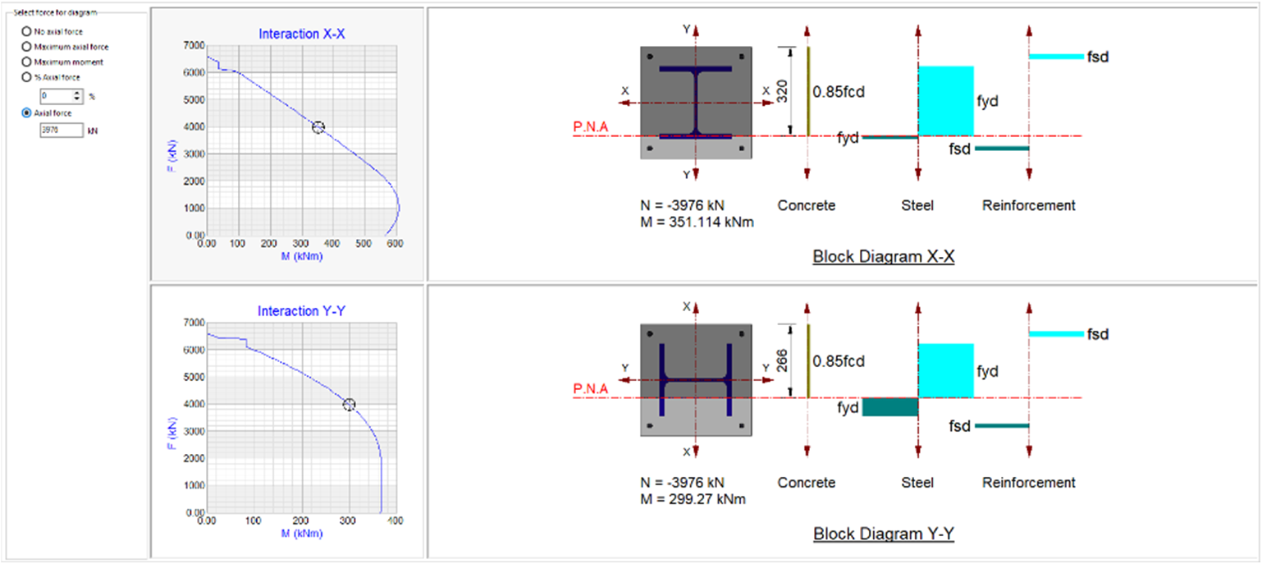

# Theory used in this module

The module determines the plastic neutral axis location by balancing the contributing forces in the composite column cross-section based on the allowed plastic stresses.

Design results for individual materials are tabulated in detail, and a summary table is generated to show whether the design checks pass or fail. Multiple load cases can be entered to compare with the section capacity, and the comparisons are displayed in tabular form.



More importantly, a summary table for the critical load cases for each design check (uniaxial and biaxial bending, axial force, and shear forces) is given.

The module generates full X-X and Y-Y interaction charts, which can be viewed

interactively to display the section resistance for different combinations of axial forces and bending moments. Detailed equations are included with all assumptions stated, and relevant calculations are shown with the necessary references to the active design code.