## Prokon Continuous Beam

Design single and multi-span reinforced concrete beams and slabs, with rectangular, T, L, or I shaped, and inverted T and L-sections, as well as tapered sections. You can analyse sub-frames and the module automates the pattern loading of dead and live loads at ultimate limit state.

**Continuous Beam** allows redistribution of moments and shear to a user specified percentage. This module can be used on its own or as a post-processor for **Sumo**. Generate complete bending schedules for beams and slabs.

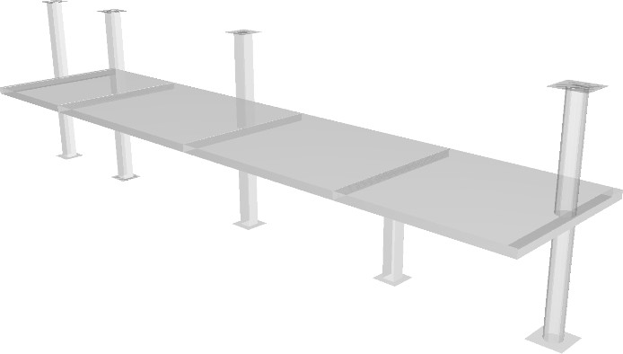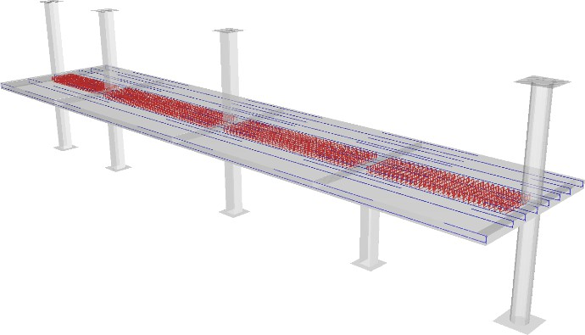

* Automated pattern loading
* Post-processing from **Sumo**
* Generate complete bending schedules

**What makes this module special?**

## Detailed Description

**Continuous Beam** allows you to easily design multi-span reinforced concrete beams and slabs. Spans can be supported with or without rotational restraints, i.e., columns above and below. Sections that can be defined are rectangular, T, L, or I shaped, as well as inverted T and L-sections. Sections can be tapered along the span of the beam.

The module can analyse sub-frames (including columns) and automates the pattern loading of dead and live loads. At ultimate limit state, moments and shears can be redistributed to a user specified percentage. Both short-term (elastic) and long-term deflections are calculated. The long-term deflection calculations consider concrete

cracking, shrinkage, and creep. For beams and one-way spanning slabs, you can

manipulate long-term deflections by editing the steel reinforcement.

**Continuous Beam** can save a lot of time by conveniently using the module on its own or as a post-processor for **Sumo**. Using the Design Links, you can import beams complete with geometry, moment, and shear force envelopes for detailed design and reinforcement detailing.

After the analysis you can generate complete bending schedules for beams and slabs. A 3D picture helps you position the bars accurately and identify any possible conflicts. The module automatically adjusts the reinforcement detailing rules according to the mode selected, e.g., beam or column strip of a flat slab. Using the rebar editor, it is easy to modify the main and shear reinforcement – diagrams display the entered reinforcement together with the required amounts at ULS and minimum amounts required by the design code. You can open the generated bending schedules in **Padds** or **Probar 2D** for final editing and printing.

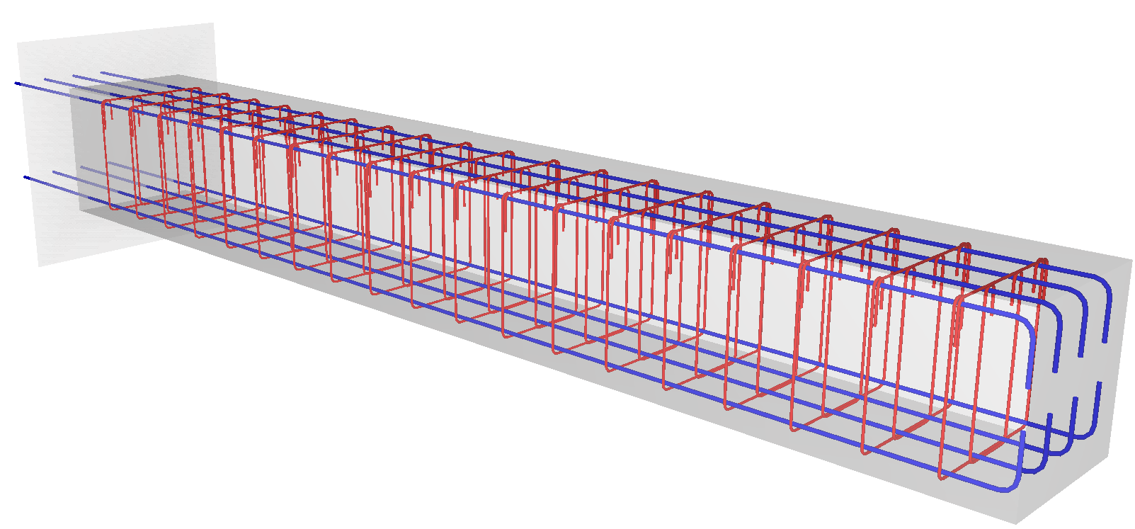

## Theory used in this module

Entered dead and live loads are automatically applied as pattern loads during the analysis. At ultimate limit state, moments and shear are redistributed to a specified percentage. The module constructs a 2D frame model of the beam/slab and any specified columns. It performs analyses at SLS and ULS:

It uses the gross uncracked concrete sections in the analysis; separate adjustments are made for cracking in the assessment for long-term deflections.

The module can redistribute bending moments at ultimate limit state. It does this by adjusting the support moments downward with the specified percentage. If you set the method of moment redistribution is set to *optimised*, the module will further minimise the design moments by redistributing the sagging span moments upward as well. Shear forces are adjusted appropriately to maintain equilibrium.

The various design codes follow similar proportions for dividing flat slabs into column and middle strips. The module follows a rational approach by using the column and middle strip proportions specified in BS 8110 - 1997, and then adjusting the strips widths to simplify reinforcement detailing.

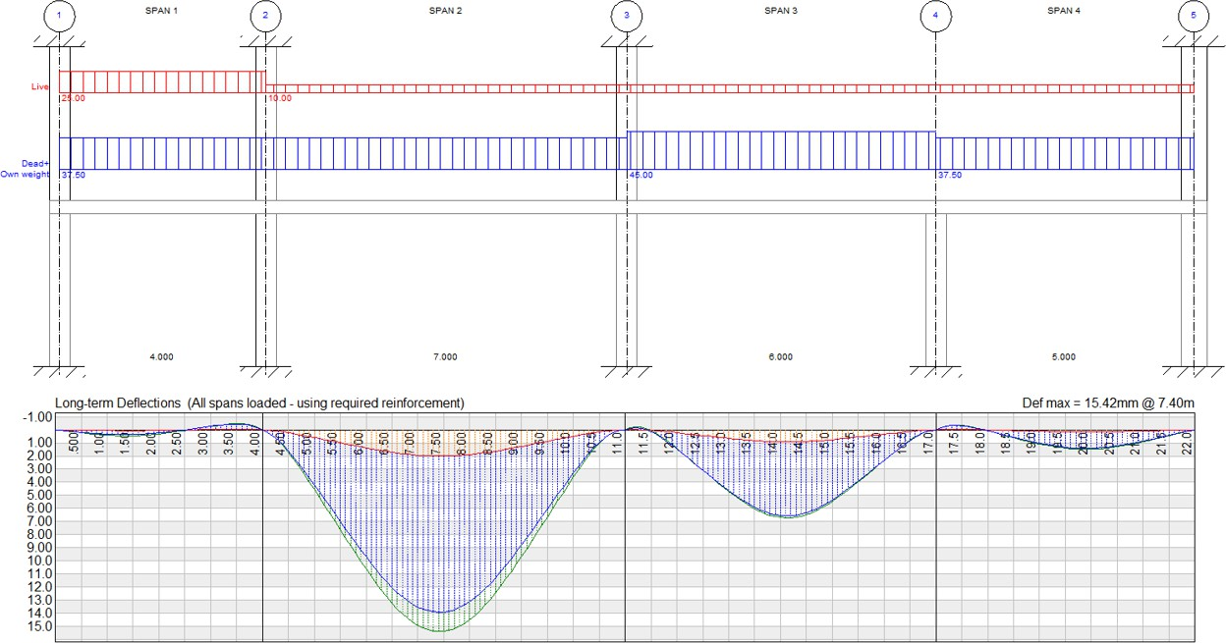

Continuous Beam calculates elastic (short-term) and long-term deflections. In both cases, it uses the SLS loading with no moment redistribution. Adjustments are made for concrete cracking in the long-term deflection calculation.

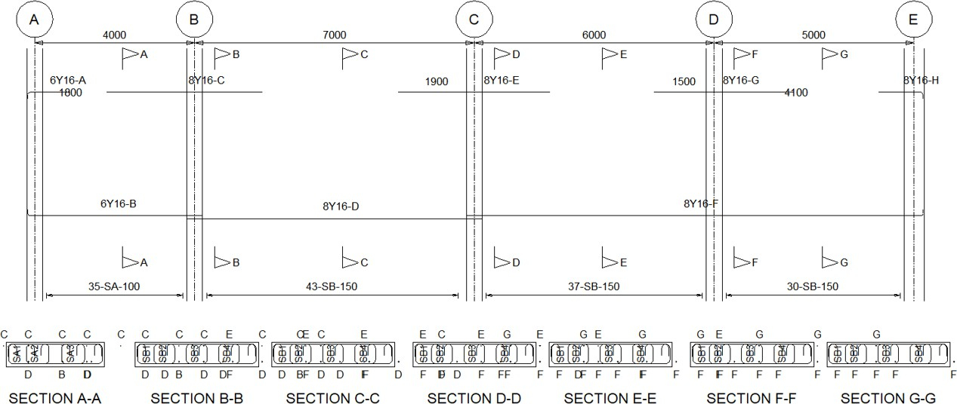

## Workflow

You can either create your beam in the module or use the Design Links in **Sumo** to send data from your structural model to **Continuous Beam**.

## Features

* Automated pattern loading
* Long-term deflection calculations
* Post-processing from **Sumo**
* Generate complete sending schedules

## Supported Design Codes

**Design Codes**



* + ACI 318 – 1999
  + ACI 318 – 2005
  + ACI 318 – 2011
  + ACI 318 – 2014
  + ACI 318 – 2019
  + AS3600 – 2001
  + AS3600 – 2009
  + AS3600 – 2018
  + BS8110 – 1985
  + BS8110 – 1997
  + CP65 – 1999
  + CSA-A23.3:2019
  + CSA-A23.3-04 - 2010
  + Eurocode 2 -2004
  + HK Concrete – 2004
  + HK Concrete – 2013
  + IS:456 – 2000
  + NZ 3101 – 2006
  + SABS 0100 – 2000
  + SP 63.13330.2018

**Summary**

**Captain** (Computer Aided Post Tensioning Analysis Instrument) designs most types of continuous prestressed beam and slab systems from single span to twenty-spans, encountered in typical building projects. Cross sections can include a mixture of rectangular, I, T and L-sections as well as user defined sections and tapered sections.

The module automatically applies pattern loading to entered dead and live loads. At ultimate limit state, moments and shears are redistributed to a specified percentage.

Captain can calculate estimates for quantities and tendon profile schedules can be generated for use with **Padds**. Schedules can be edited and printed using **Padds.**

* Automatic pattern loading and moment redistribution
* Complex cross sections
* Quantities and schedules output

**What makes this module special?**

## Detailed Description

Most types of continuous prestressed beam and slab systems, encountered in typical building projects, can be designed with **PROKON®’s Captain** module. The workings of **Captain** are similar to that of **Continuous Beam**, but it adds additional design features such as bonded systems, e.g., bridge decks, and unbounded systems, e.g., flat slabs.

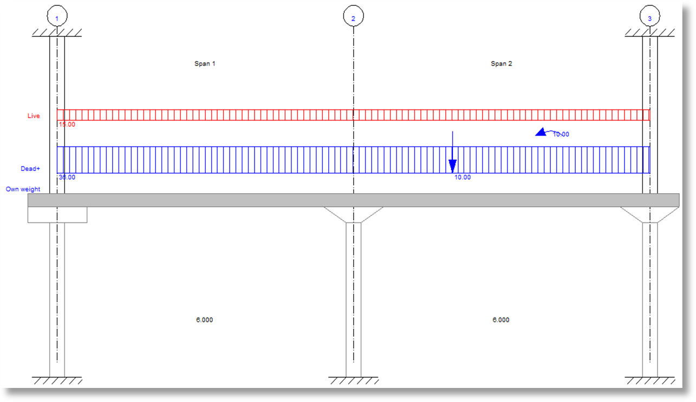

It also automatically applies pattern loading to entered dead and live loads. At ultimate limit state, moments and shears are redistributed to a specified percentage.

Cross-sections can include a mixture of rectangular, I, T, and L-sections. More complex sections, e.g., box bridge decks, can be modelled with the aid of the section properties calculation module, **Prosec**. Spans can also have constant or tapered sections.

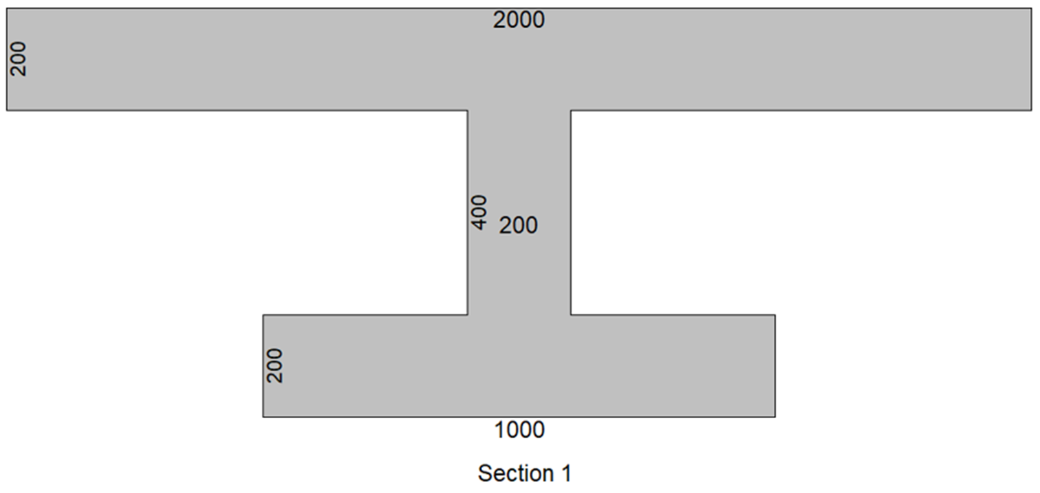

The module allows you to specify the characteristics of the prestressing tendons/cables and use parabolic or harped shaped profiles. It includes a function for automatic generation of tendon profiles that are based on balancing a specified percentage of dead load.

You can also place additional (conventional) steel reinforcement to contain cracking, control long-term deflection, and increase flexural or shear capacity at ULS. The module can also perform punching shear design checks for slabs and include the ability to use column heads (drop panels).

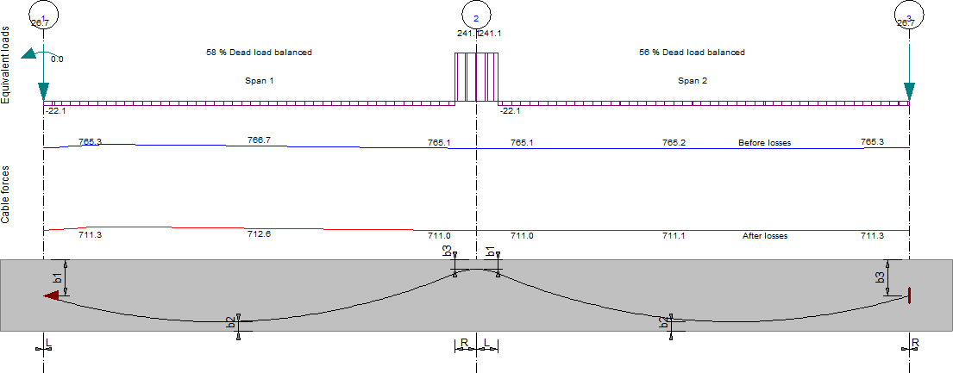

**Key Features**

* + - Automatic pattern loading and moment redistribution.
    - Complex cross-sections.
    - Quantities and schedules.

## Supported Design Codes

**Design Codes**



* + - * ACI 318 - 1999
      * ACI 318 - 2005
      * ACI 318 - 2011
      * ACI 318 – 2014
      * ACI 318 - 2019
      * BS 8110 - 1985
      * BS 8110 - 1997
      * CP 65 - 1999
      * Eurocode 2 - 2004
      * HK Concrete - 2004
      * HK Concrete - 2013
      * NZ 3101 - 2006
      * SABS 0100 - 2000

## Summary

Design rectangular reinforced concrete flat slab panels with a variety of edge supports.

You can enter multiple load cases comprising of point loads, line loads, and UDLs, and combine these with ULS load factors.

The module calculates steel reinforcement using the formulae stipulated in the relevant design codes. Reinforcement is automatically added to the slab.

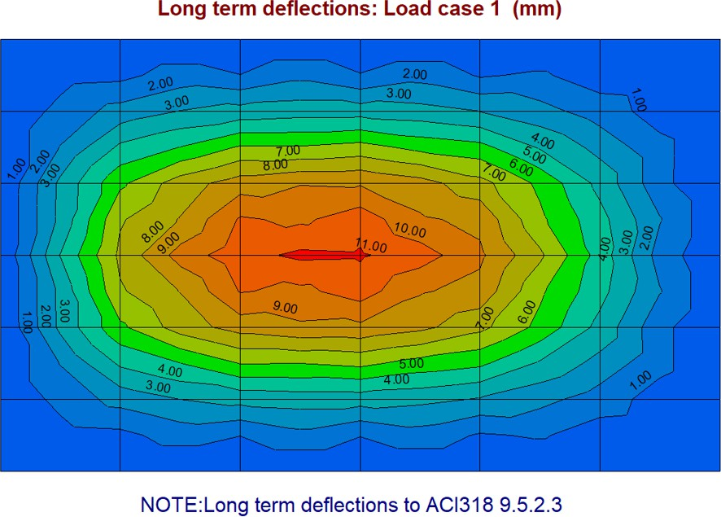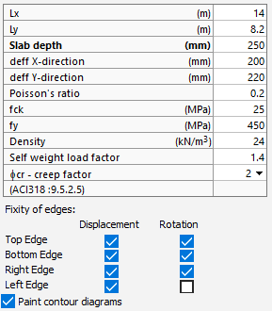

**What makes this module special?**

* Variety of edge supports
* Enter multiple load cases
* Automated bending schedule

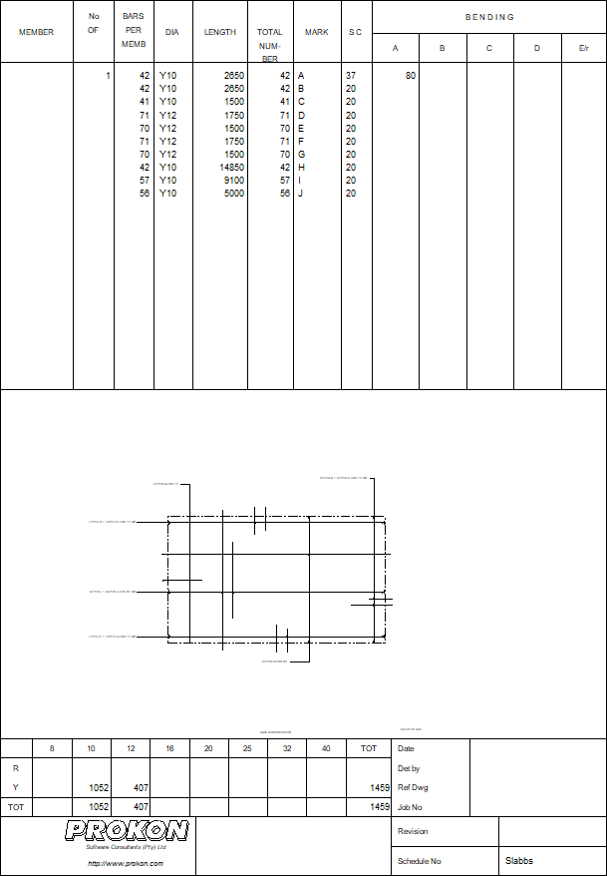

## Detailed Description

**Rectangular Slab** designs rectangular or square reinforced concrete flat slab panels with a variety of edge supports to choose from, e.g., free, simply supported, or continuous. The module is suitable for designing slab panels with approximately rectangular or square layouts (use Sumo to design slabs with irregular panel layouts and openings).

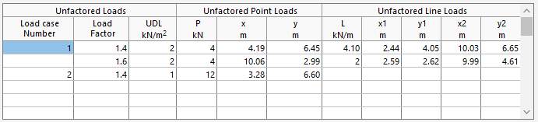

Bending stresses and elastic deflection is calculated through a finite element analysis. When calculating the design bending moments, the module transforms the bending and torsional moments using the Wood and Armer equations.

## Theory used in this module

The module calculates bending stresses and elastic deflection through a finite element analysis. Steel reinforcement is calculated using the formulae stipulated in the relevant design codes.

Elastic short-term deflections are calculated using the gross uncracked concrete section of the slab. When calculating long-term deflections, the module adjusts the stiffness of the slab based on the level of cracking, creep, and shrinkage. The calculation procedure is based on the approach in the American design code, ACI 318, which uses a time-depended factor and for estimating creep behaviour.

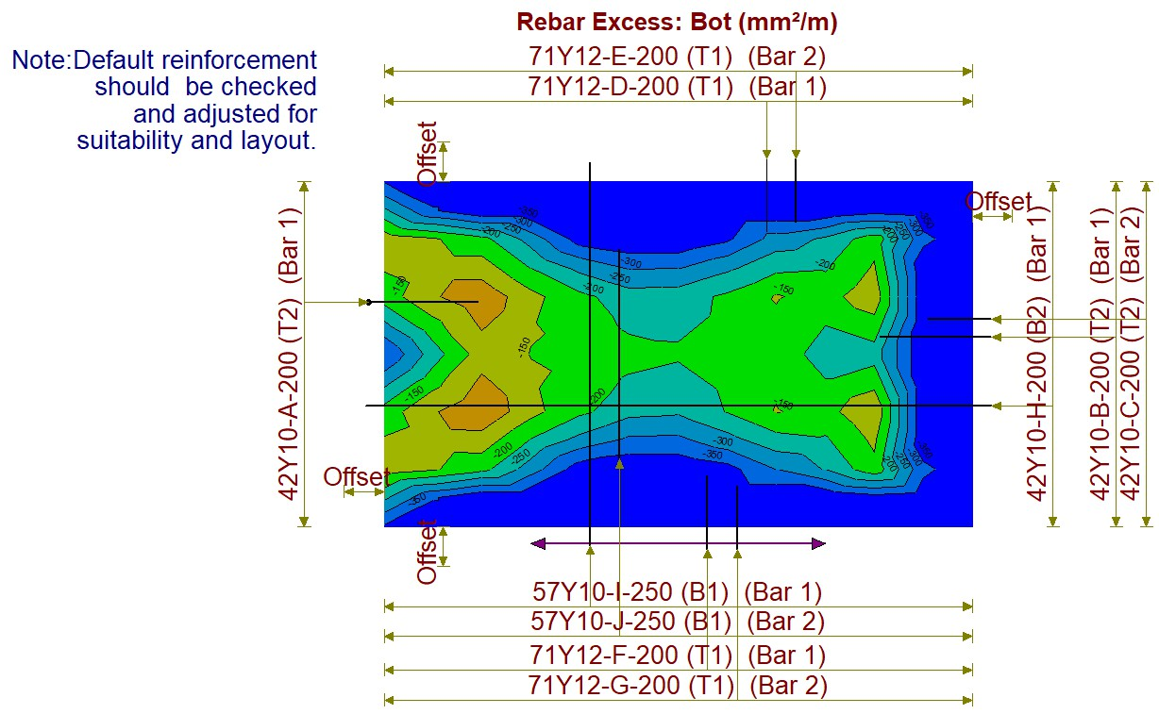

## Key Features

* Variety of edge supports
* Enter multiple load cases
* Automated Reinforcement
* Long term deflection

## Supported Design Codes

**Design Codes**



* + ACI 318 - 1999
  + ACI 318 - 2005
  + ACI 318 - 2011
  + ACI 318 - 2014
  + ACI 318 – 2019
  + AS 3600 - 2001
  + AS 3600 - 2009
  + AS 3600 - 2018
  + BS 8110 - 1985
  + BS 8110 - 1997
* CP 65 - 1999
* CSA A23.3-04 - 2010
* CSA-A23.3: 2019
* Eurocode 2 - 2004
* HK Concrete - 2004
* HK Concrete - 2013
* IS:456 - 2000
* NZ 3101 – 2006
* SABS 0100 - 2000
* SP 63.13330.2018

## Summary

**Rectangular Column** designs solid rectangular concrete columns subjected to axial forces and bi-axial bending moments. The simplified design approach set out in most codes is used for the design.

The module can be used independently, or as a Design Link from **Sumo**. The Design Links automate data entry by linking analysis results and geometry with the design module.

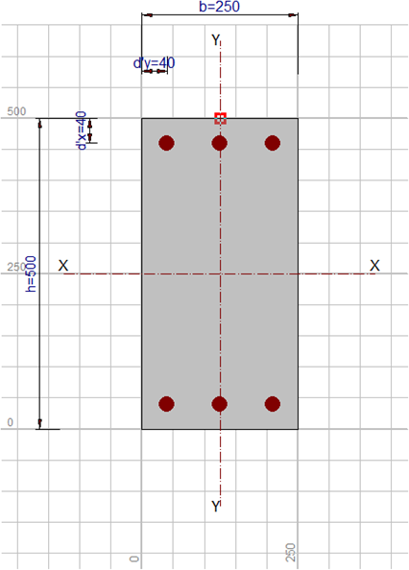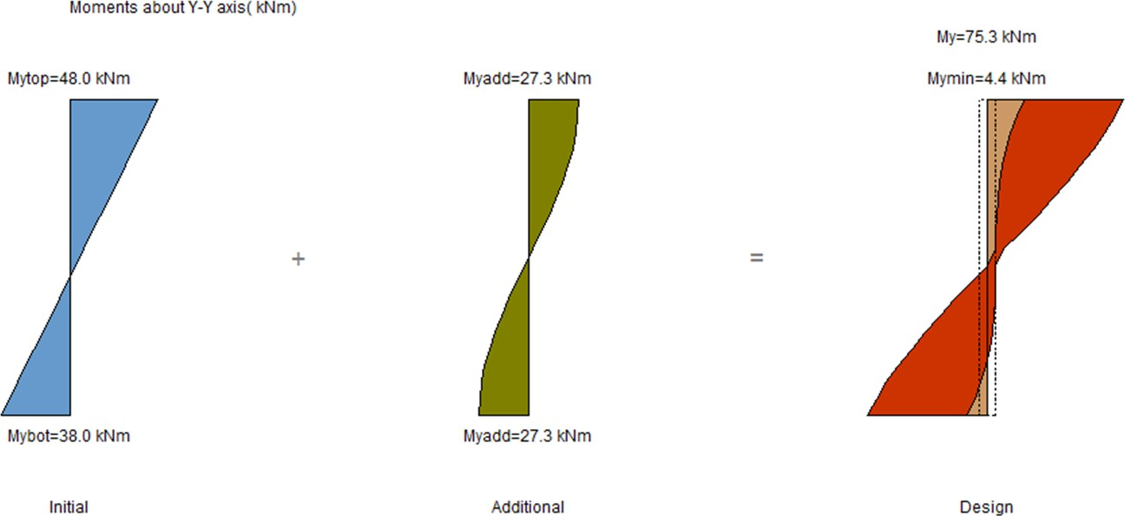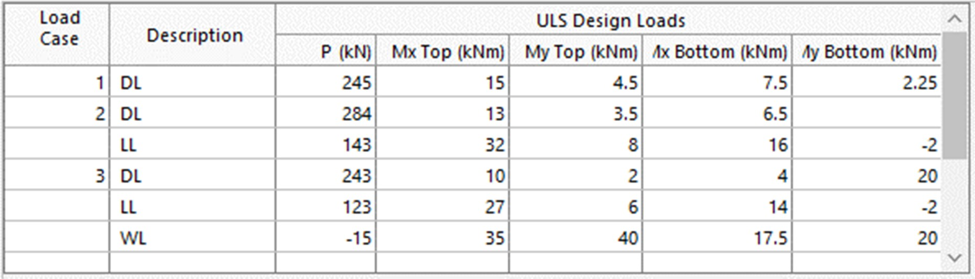

* Automated bending schedules
* Axial forces and bi-axial bending are considered for the design
* Groups of columns analysed in **Sumo** can be linked into these modules for rapid design and detailing

**What makes this module special?**

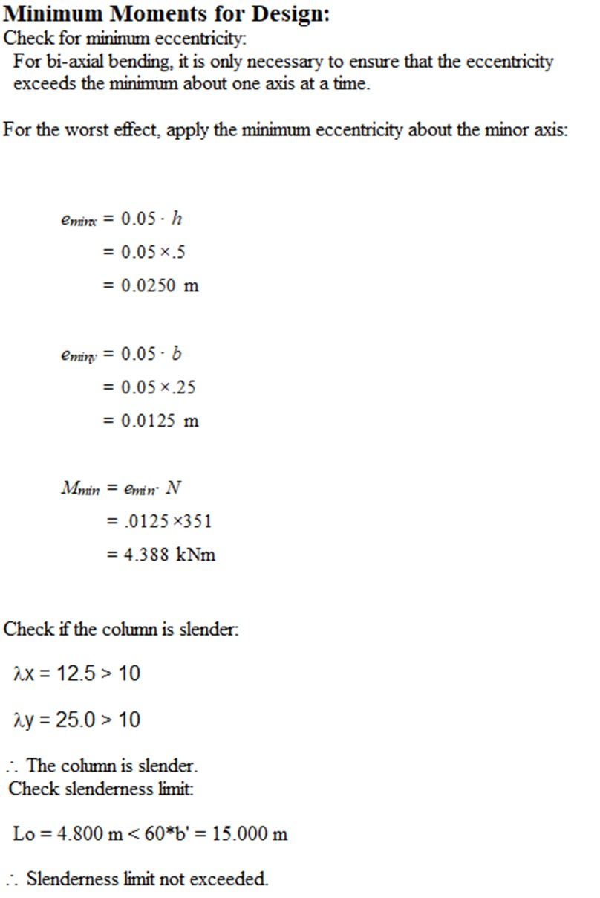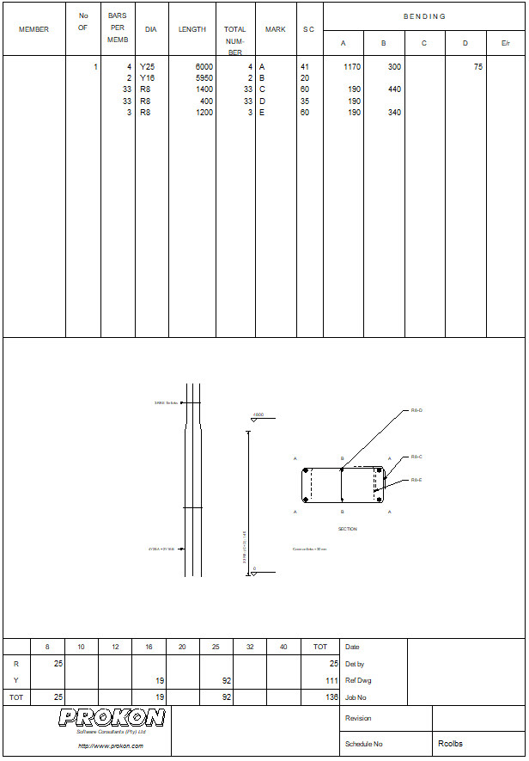

## Detailed Description

Design and detail solid rectangular concrete columns. Columns can be short or slender in one or both directions, and different fixity conditions at the bottom and top. You can enter multiple load cases comprising of axial loads and moments about one or both axes at the bottom or top of the column. The module compiles column design charts and provides complete design calculation sheets. Generating reinforcement bending schedules is easy; the main bars and the stirrups can be customised. You can open the bending schedules in **Padds** or **Probar 2D** for final editing and printing.

## Theory used in this module

* + The design codes give simplified procedures for designing columns of which the ratio of the larger to the smaller dimension does not exceed 1:4.
  + The procedure used for the design of rectangular columns is applied to the design of circular columns.
  + The reinforcement layout is assumed to be symmetrical.

## Workflow

Columns and their applied loading and properties can either be defined in the module or imported from **Sumo**.

## Comments

For columns of general shapes see **General Column**.

## Supported Design Codes

**Design Codes**



* + - ACI 318 - 1999
    - ACI 318 - 2005
    - ACI 318 - 2011
    - ACI 318 - 2014
    - AS 3600 - 2001
    - AS 3600 - 2009
    - AS3600 - 2018
    - ACI 318 – 2019
    - BS 8110 - 1985
    - BS 8110 - 1997
    - CP 65 - 1999
    - CSA A23.3-04 - 2010
    - CSA-A23.3:2019
    - Eurocode 2 - 2004
    - HK Concrete – 2004
    - HK Concrete - 2013
    - IS:456 - 2000
    - NZ 3101 – 2006
    - SABS 0100 – 2000
    - SP 63.13330.2018

## Summary

**Circular Column** designs solid circular concrete columns subject to axial forces and bi- axial bending moments. The simplified design approach set out in most codes is used for the design.

The module can be used independently, or as a Design Link from **Sumo**. The Design Links automate data entry by linking analysis results and geometry with the design module.

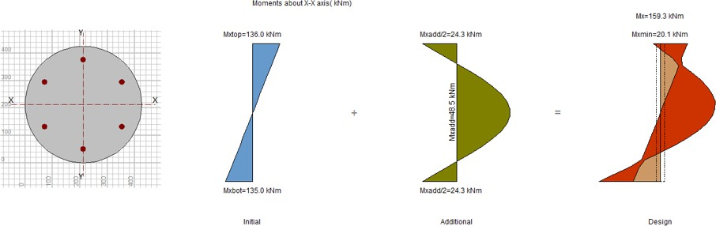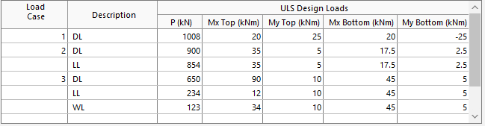

**What makes this module special?**

* Automated bending schedule
* Axial forces and bi-axial bending are considered for the design
* Groups of columns analysed in **Sumo** can be linked into these modules for rapid design and detailing

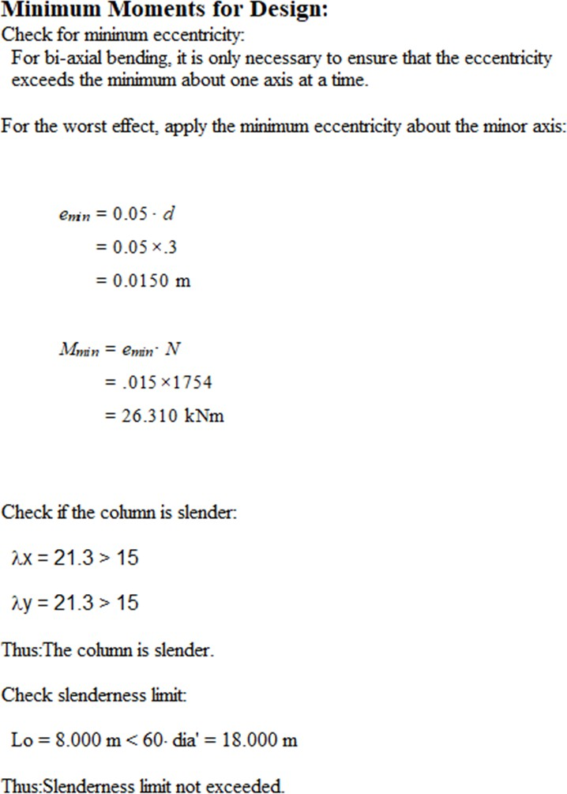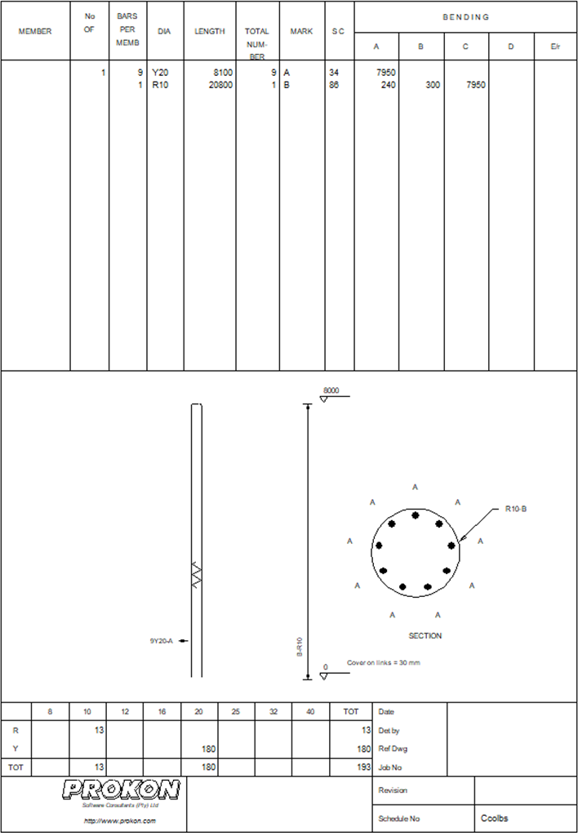

## Detailed Description

Design and detail solid circular concrete columns. Columns can be short or slender in one or both directions, and different fixity conditions at the bottom and top. You can enter multiple load cases comprising of axial loads and moments about one or both axes at the bottom or top of the column. The module compiles column design charts and provides complete design calculation sheets. Generating reinforcement bending schedules is easy; the main bars and the stirrups can be customised. You can open the bending schedules in **Padds** or **Probar 2D** for final editing and printing.

## Theory used in this module

* + - * The design codes give simplified procedures for designing columns of which the ratio of the larger to the smaller dimension does not exceed 1:4.
      * The procedure used for the design of rectangular columns is applied to the design of circular columns.
      * The reinforcement layout is assumed to be symmetrical.

## Workflow

Columns and their applied loading and properties can either be defined in the module or imported from **Sumo**.

## Comments

For columns of general shapes see **General Column**.

## Supported Design Codes

**Design Codes**



* + - * + ACI 318 - 1999
        + ACI 318 - 2005
        + ACI 318 - 2011
        + ACI 318 – 2014
        + ACI 318 – 2019
        + AS 3600 - 2001
        + AS 3600 - 2009
        + AS3600 - 2018
        + BS 8110 - 1985
        + BS 8110 - 1997
    - CP 65 - 1999
    - CSA A23.3-04 - 2010
    - CSA-A23.3:2019
    - Eurocode 2 - 2004
    - HK Concrete – 2004
    - HK Concrete - 2013
    - IS:456 - 2000
    - NZ 3101 – 2006
    - SABS 0100 – 2000
    - SP 63.13330.2018

## Summary

**General Column** designs columns with any general shape. Rather than using the simplified design approach set out in most codes, **General Column** designs the column section from first principles.

* Custom sections
* Evaluate column capacity for entered bars
* Generation of bending schedules

**What makes this module special?**

## Detailed Description

Design and detail concrete columns with any general shape. Enter the column outline and any openings, as well as the position and size of each longitudinal reinforcement bar.

**General Column** designs columns that do not necessarily fall inside the scope of the codes’ simplified design method requirements. The module therefore reverts to basic principles, e.g., strain compatibility and equilibrium, to analyse columns.

During the design, you have the option of evaluating the column capacity for the reinforcement bars as entered, or to calculate the minimum bar size required to resist the design loads. You can generate a reinforcement bending schedule that you can edit and print with **Padds**.

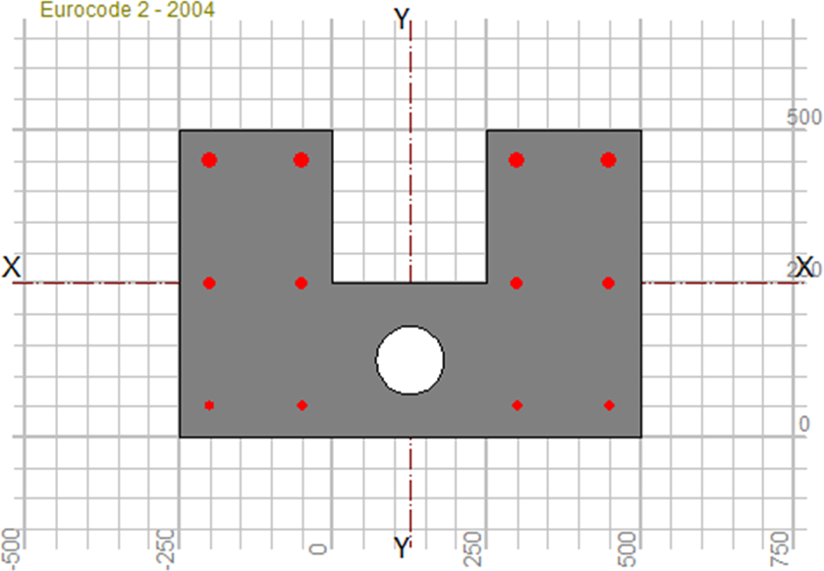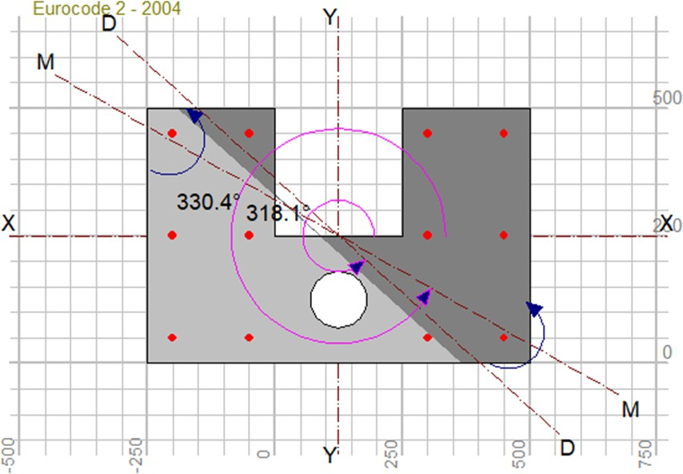

## Theory used in this module

* + - * The section properties are calculated, and the column slenderness evaluated.
      * For a slender column, the additional slenderness moment is calculated and applied about the weak axis. The output gives the X and Y axis components.
      * The design moment and axis are determined by taking the vector sum of the applied and additional moments.
      * An iterative solution is obtained using strain compatibility and equilibrium as criteria.

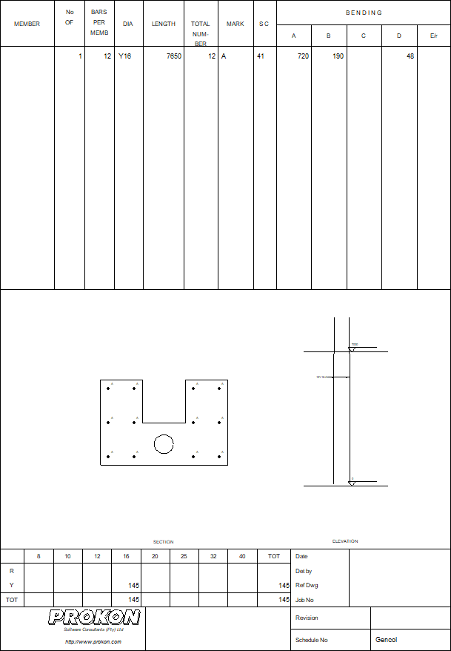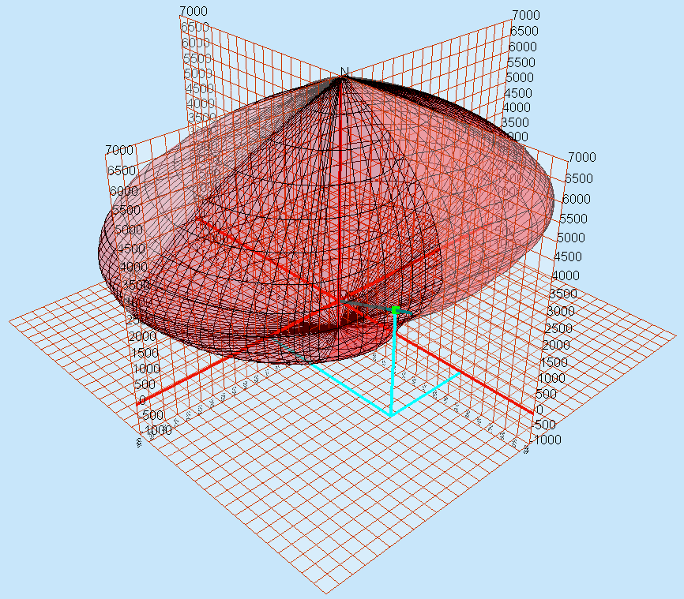

## Workflow

Columns and their applied loading and properties can either be defined in the module or imported from Sumo.

## Key Features

* + - * Generation of bending schedules
      * Custom Sections with general column design
      * Evaluate column capacity for entered bars

## Supported Design Codes

**Concrete Design Codes**



* ACI 318 - 1999
* ACI 318 - 2005
* ACI 318 - 2011
* ACI 318 – 2014
* ACI 318 - 2019
* AS 3600 - 2001
* AS 3600 - 2009
* AS3600 - 2018
* BS 8110 - 1985
* BS 8110 - 1997
* CP 65 - 1999
* CSA A23.3-04 – 2010
* CSA A23.3: 2019
* Eurocode 2 - 2004
* HK Concrete - 2004
* HK Concrete - 2013
* IS:456 - 2000
* NZ 3101 – 2006
* SABS 0100 - 2000
* SP 63.13330.2018

## Summary

Analyse concrete retaining walls for normal soil and surcharge loads. The module can design most conventional retaining walls, including cantilever, simply supported, and propped cantilever walls.

Analyse walls with complex geometries like backward or forward sloping walls as well as walls that have a varying thickness through their height. Optionally include a toe in the base.

Choose between the Rankine and Coulomb theories and incorporate seepage in the analysis. A water table can also be specified.

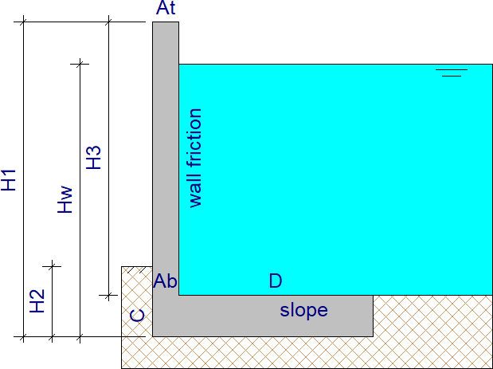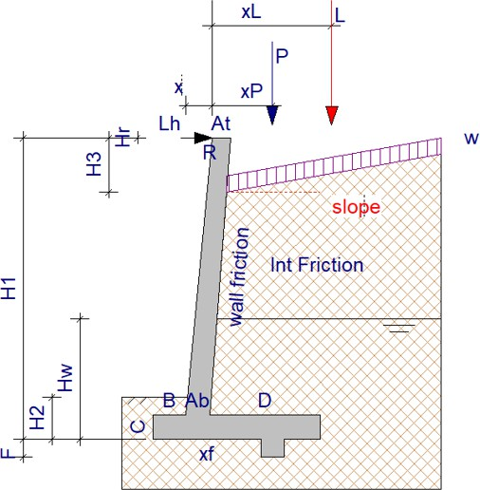

* Analyse different load conditions
* Enter walls with complex geometries
* Different analysis theories
* Adjustable water Table
* Customise the theory
* Automated bending schedule

**What makes this module special?**

## Detailed Description

**Retaining Wall** is used to analyse concrete retaining walls for normal soil and surcharge loads or seismic load conditions. The module can design most conventional retaining walls, including cantilever, simply supported, and propped cantilever walls.

**Retaining Wall** offers a host of input parameters allowing you to enter complex geometries like backward or forward sloping walls and toes, as well as walls that have a varying thickness though their height. Line loads, point loads, and distributed loads can be placed on the backfill.

The module allows you to choose between the Rankine and Coulomb theories and can also incorporate seepage into the analysis. A water table can be specified; it may even be defined above the soil surface to model a liquid retaining wall. If required, the soil pressure coefficients can be adjusted manually.

Retaining walls are checked for stability (overturning and sliding at both SLS and ULS) as well as for strength (flexure and shear at various positions in the wall and base).

The most common use of the module is to analyse a wall with dimensions as entered. However, functions are available to optimise certain wall dimensions, e.g., the depth of the toe needed to resist sliding.

The module uses the calculated design moments in the wall and base to determine the required reinforcement. Furthermore, generate a bending schedule that can be edited and printed with **Padds** or **Probar 2D**.

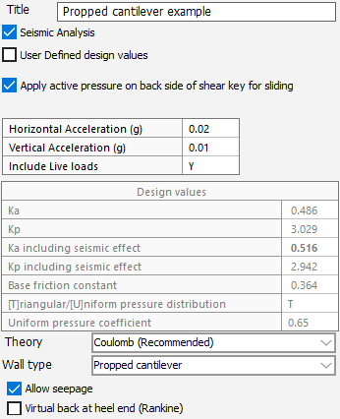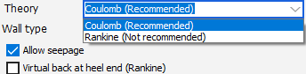

## Theory used in this module

The modules support both static and seismic load conditions and use the Coulomb and the Rankine theories.

## Key Features

* Analyse different load conditions
* Enter walls with complex geometries
* Different analysis theories

## Supported Design Codes

**Design Codes**



* + ACI 318 - 1999
  + ACI 318 - 2005
  + ACI 318 - 2011
  + ACI 318 - 2014
  + ACI 318 – 2019
  + AS 3600 - 2001
  + AS 3600 - 2009
  + AS 3600 - 2018
  + BS 8110 - 1985
  + BS 8110 - 1997
* CP 65 - 1999
* CSA A23.3-04 - 2010



**Detailing Codes**

* BS 4466 - 1989
* BS 8666 - 2005
* SANS 282 - 2004
* SANS 282 - 2011
* CSA-A23.3:2019
* Eurocode 2 - 2004
* HK Concrete - 2004
* HK Concrete - 2013
* IS:456 - 2000
* NZ 3101 - 2006
* SABS 0100 – 2000
* SP 63. 13330.2018

**Summary**

Design rectangular concrete column footings for stability and strength. The module allows you to design footings with up to two columns, stub columns, or no columns: each with multiple load cases.

Use **Sumo’s** Design Links to link analysis results with the **Pad Footing** module.

The output diagrams include the bearing stress distribution, safety factors for slip and overturning, linear shear and punching shear checks, as well as required reinforcement for flexure. A reinforcement bending schedule generator creates drawings that can be opened and printed with **Padds** or **Probar 2D**.

* Various column layout options
* Links with Sumo
* Automated rebar generation

**What makes this module special?**

## Detailed Description

**Pad Footing** designs rectangular concrete column footings for stability and strength. The module allows you to design footings with up to two columns, stub columns, or no columns: each with multiple load cases. If the pad footing forms part of a larger structure that has been analysed in Sumo, you can link the analysis results with the **Pad Footing** module; this will extract the support reactions and insert them as load cases.

The design output includes diagrams of the bearing stress distribution, safety factors for slip and overturning (for SLS and ULS), linear shear and punching shear checks, as well as required reinforcement for flexure. A simple-to-use reinforcement bending schedule generator creates drawings with rebar cutting lists that you can open and print with **Padds** or **Probar 2D**.

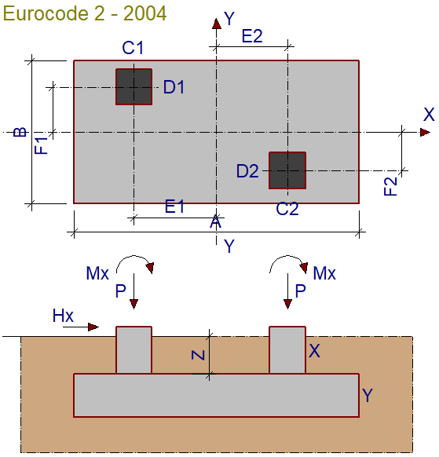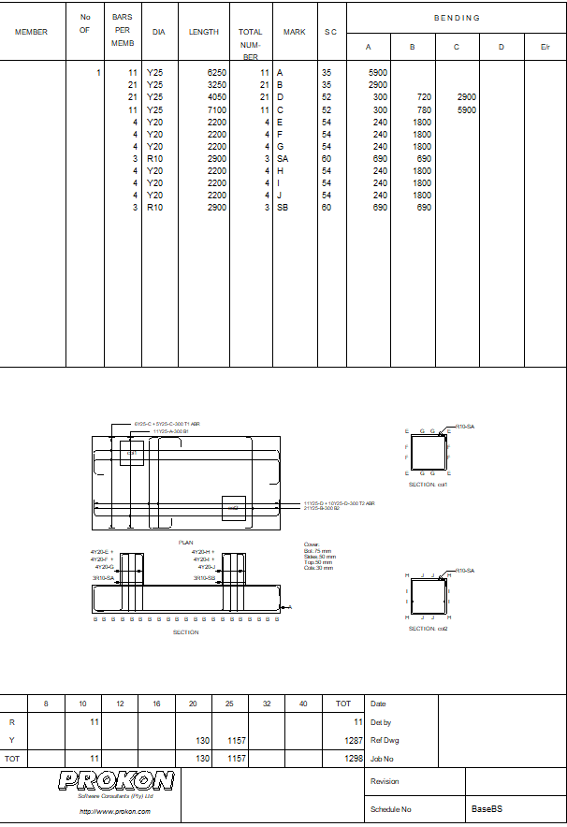

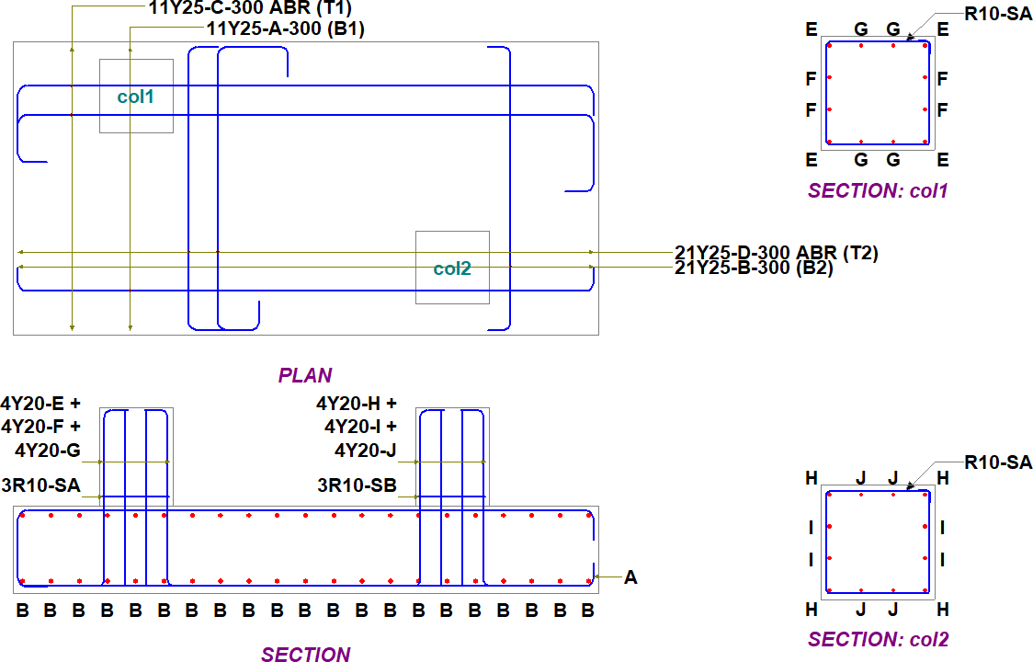

## Theory used in this module

The module designs rectangular concrete column footings subjected to vertical force and bi axial bending moment:

* + **Stability**: The module also verifies the stability requirements for overturning and bearing pressure. Stability checks can be performed at ULS and SLS.
  + **Strength:** The module designs the footing at ultimate limit state for flexure and shear.
  + **Optimisation:** You can use the module to optimise the dimensions of the footing to yield the most economical design.

**Workflow**

You can either define your pad footing, its loading, and properties in the design module or if the footing forms part of a larger structure that you have analysed in **Sumo**, you can link the analysis results with the **Pad Footing** module; this will extract the support reactions and insert them as load cases.

## Supported Design Codes

**Design Codes**



* + - ACI 318 - 1999
    - ACI 318 - 2005
    - ACI 318 - 2011
    - ACI 318 – 2014
    - ACI 318 - 2019
    - AS 3600 - 2001
    - AS 3600 – 2009
    - AS 3600 - 2018
    - BS 8110 - 1985
    - BS 8110 - 1997
    - CP 65 - 1999
    - CSA A23.3-04 - 2010



**Detailing Codes**

* BS 4466 - 1989
* BS 8666 - 2005
* SANS 282 - 2004
* SANS 282 - 2011
  + - CSA-A23.3:2019
    - Eurocode 2 - 2004
    - HK Concrete - 2004
    - HK Concrete - 2013
    - IS:456 - 2000
    - NZ 3101 - 2006
    - SABS 0100 - 2000
    - SP 63.13330.2018

## Summary

Design reinforced concrete sections to meet specific crack requirements. Both rectangular beam and slab sections can be designed to resist the effects of axial tension, bending moment and temperature and the combination thereof. Temperature effects are also included to evaluate early cracking and long-term thermal cracking.

The module accounts for concrete shrinkage due to hydration by a combination of the thermal expansion coefficient and the restraint factor. The design method employed by the codes is ideally suited for non-temperate regions like Europe.

* Multiple section types
* Evaluate early and long-term cracking
* Multiple sets of bars calculated

**What makes this module special?**

## Detailed Description

**Crack Width** can be used to design reinforced concrete sections to meet specific crack requirements. Both rectangular beam and slab sections can be designed to resist the effects of axial tension, bending moment and temperature and the combination thereof.

Up to four sets of suggested bar configurations are calculated for slab sections. Each set has a different diameter and spacing to comply with the crack width requirements. A fifth column is provided where you could enter a bar configuration of choice.

For beams, up to four sets of suggested bar configurations are calculated. The bar diameters are chosen to not differ by more than one size.

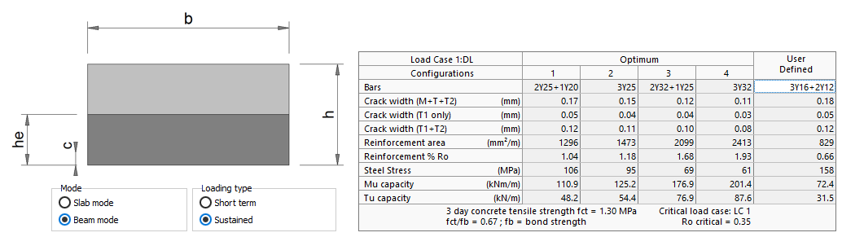

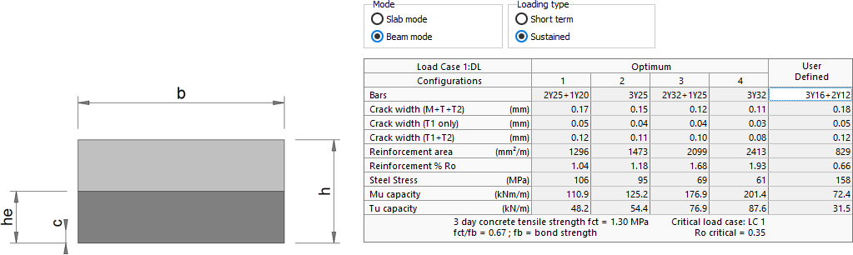

The module accounts for concrete shrinkage due to hydration by a combination of the thermal expansion coefficient and the restraint factor. The design method employed by the codes is ideally suited for non-temperate regions like Europe.

## Theory used in this module

Concrete cracking has traditionally been correlated with the prevailing tensile steel stress. BS8007 - 1984 also takes account of the type of reinforcement, i.e., bond between concrete and reinforcement.

## Supported Design Codes



**Design codes**

* BS8007 – 1987
* Eurocode 2 – 2004
* NZS 3101 – 2006
* SP 63.13330.2018
* AS 3600 - 2018

**Summary**

The **Beam Section** module is a simple utility for designing concrete sections for combined bending, shear, and torsion. The module accommodates rectangular and T- sections. The single input table makes it quick and easy to enter the section geometry and ultimate loading.

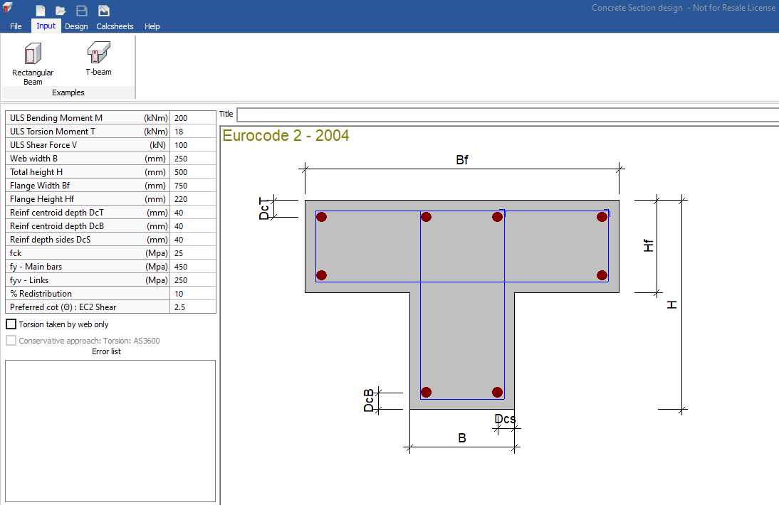

* Simplified input
* Suggested reinforcement output
* Detailed calculations

**What makes this module special?**

## Detailed Description

Use the **Beam Section** module to design a concrete section subjected to moment, shear, and torsion forces.

The design calculates moment, shear, and torsional stresses in web and flange, and required reinforcement for each.

Some reinforcement configurations are also suggested in the output as guidelines. The section design output can be grouped on a **Calcsheet** for printing or sending to **Calcpad**. Various settings can be made with regards to the inclusion of design results and pictures.

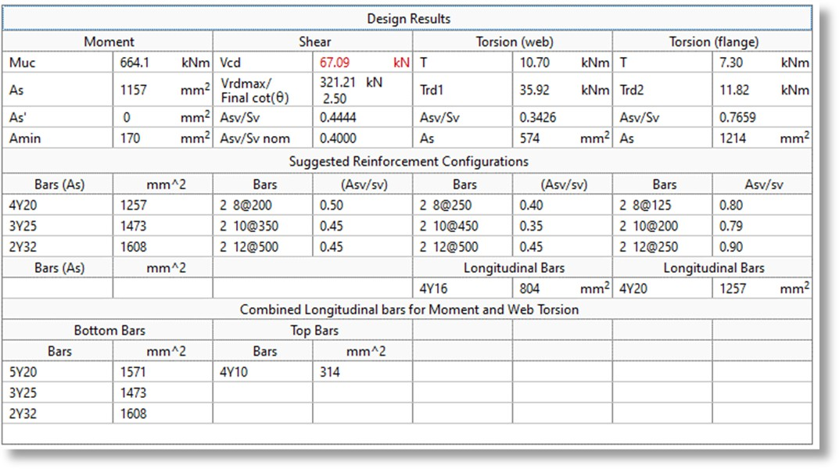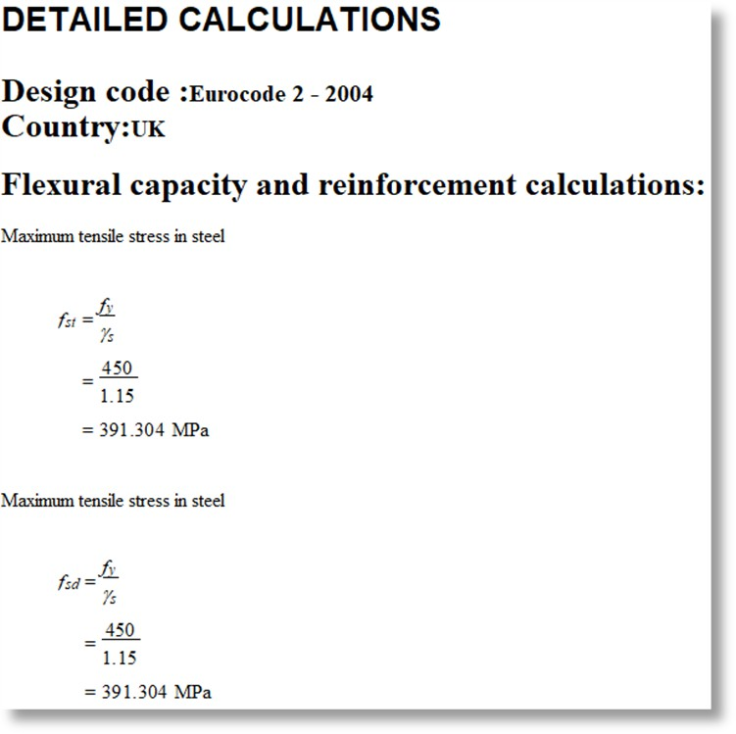

## Theory used in this module

The normal code formulae apply when calculating flexural reinforcement for rectangular sections and for flanged sections where the neutral axis falls inside the flange. If the neutral axis falls outside the flange, the section is designed as two separate sub sections:

* The first sub section consists of the flange without the central web part of the section and the remaining central portion defines the second sub-section.
* By considering the total section, the moment required to put the flange portion in compression can be calculated using the normal code formulae. This moment is then applied to the flange sub section and the required reinforcement calculated using the effective depth of the total section.
* The same moment is then subtracted from the total applied moment, the resulting moment is applied to the central sub section and the reinforcement is calculated.

The tension reinforcement for the actual section is then taken as the sum of the calculated reinforcement for the two sub sections. If compression reinforcement is required for the central sub section, it is used as the required compression reinforcement for the entire section.

The module assumes that shear is resisted by the web portion of the section only. Shear stress is therefore calculated using the web area and checked not to exceed the ultimate allowable shear stress given in the code. The shear capacity is calculated using the required bending reinforcement and the shear reinforcement calculated using the normal code formulae.

Depending on the option chosen, torsion can be resisted by the section as a whole or by the web portion only. For flanged beams, the torsion is calculated separately for the flange and web along the guidelines given in the code. The torsional shear stresses are checked to not exceed the ultimate allowable shear stress. Reinforcement requirements are also evaluated separately for the flange and web using the normal code formulae. For the Eurocode, the strut-and-tie model is used, and the angle of the struts can be specified within the limits of the code.

## Supported Design Codes

**Design Codes**



* + ACI 318 - 1999
  + ACI 318 - 2005
  + ACI 318 - 2011
  + ACI 318 – 2014
  + ACI 318 - 2019
  + AS 3600 - 2001
  + AS 3600 – 2009
  + AS 3600 - 2018
  + BS 8110 - 1985
  + BS 8110 - 1997
* CP 65 - 1999
* CSA A23.3-04 - 2010
* CSA-A23.3:2019
* Eurocode 2 - 2004
* HK Concrete - 2004
* HK Concrete - 2013
* IS:456 - 2000
* NZ 3101 - 2006
* SABS 0100 – 2000
* SP 63.13330.2018

## Summary

Design reinforced concrete flat slabs for punching shear at internal, edge, and corner columns by specifying the distance from the support to the slab edge; the module automatically determines the shear perimeters.

You can enter the amount of longitudinal reinforcement present at the critical perimeters, in the two main directions.

The design output gives the critical load case with corresponding amounts of punching shear reinforcement needed for each perimeter, as well as suggested reinforcement configurations and detailed calculations.

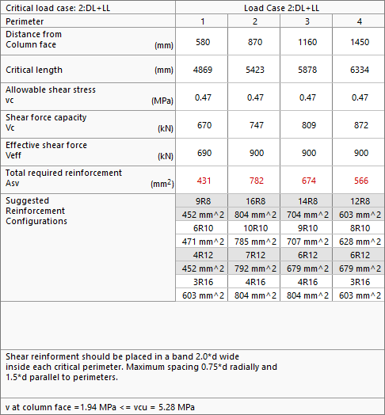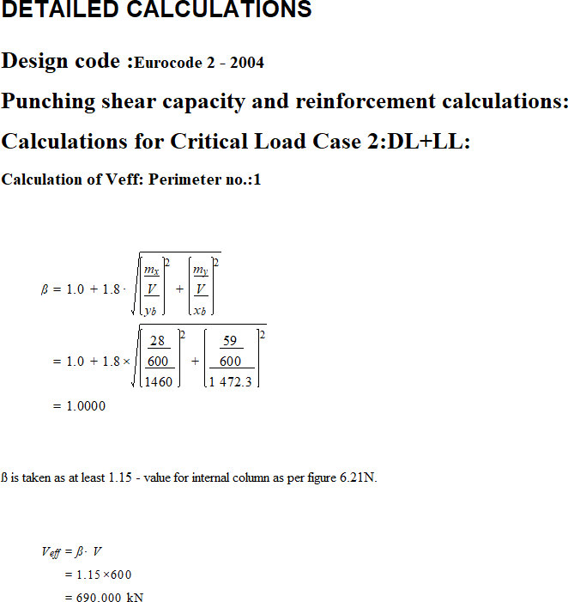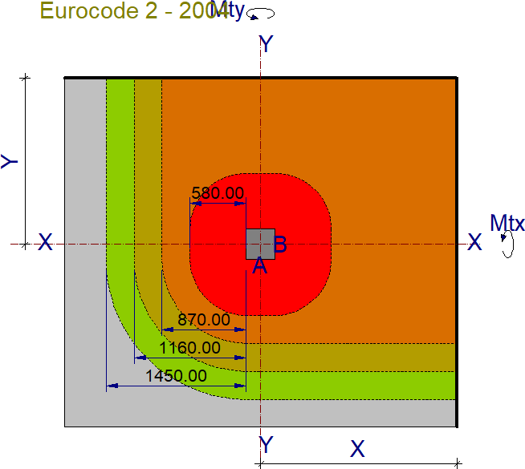

**What makes this module special?**

* Various column positions allowed
* Detailed design calculations
* Suggested reinforcement configurations

## Detailed Description

**Punching Shear** designs reinforced concrete flat slabs for punching shear (two-way shear action). You can design slabs at internal, edge, and corner columns by specifying the distance from the column to the slab edge; the module automatically determines the shear perimeters.

The module adjusts the effective shear force and shear capacity for the column moment and slab edge distance as dictated by the relevant design code. You can enter the amount of longitudinal reinforcement in the two main directions, crossing each perimeter. The module also gives the detailed calculations with relevant sections of the code.

## Supported Codes

**Design Codes**



**Detailing Codes**

* BS 4466 - 1989
* BS 8666 - 2005
* SANS 282 - 2004
* SANS 282 - 2011
  + ACI 318 - 1999
  + ACI 318 - 2005
  + ACI 318 - 2011
  + ACI 318 - 2014
  + ACI 318 – 2019
  + AS 3600 - 2001
  + AS 3600 - 2009
  + AS3600 – 2018
  + BS 8110 - 1985
  + BS 8110 - 1997
* CP 65 - 1999
* CSA A23.3: 2019
* CSA A23.3-04 - 2010
* Eurocode 2 - 2004
* HK Concrete - 2004
* HK Concrete - 2013
* IS:456 - 2000
* NZ 3101 - 2006
* SABS 0100 - 2000
* SP 63.13330.2018