# Prokon Geotech

Bishop Slope is used to evaluate the stability of soil slopes. It uses Bishop’s Modified Method of analysis to evaluate the stability of generalised slopes.

* Deterministic and probabilistic analysis
* Analysis results grouped on a Calcsheet

**What makes this module special?**

# Detailed Description

Bishop Slope uses Bishop's Modified Method (1955) of analysis to evaluate the stability of generalised soil slopes. The analysis method uses the ratio of mobilising and resisting moments on individual slices to determine the factor of safety.

The program gives a broad base of input options which include:

* The slope may be subjected to external loadings which include line loads and uniformly distributed imposed loads.
* The force profile of the anchor reinforcement.
* Reinforcement of the slope with metal strips or geofabric, it may be clad with for example a masonry block wall or stabilised with anchors.
* Multiple layers of materials with differing shear strength properties.
* Water pressures are accounted for by phreatic surfaces.
* Consideration of horizontal and vertical seismic forces.

There is the option of either searching for the critical minimum factor of safety or inserting a user defined circle.

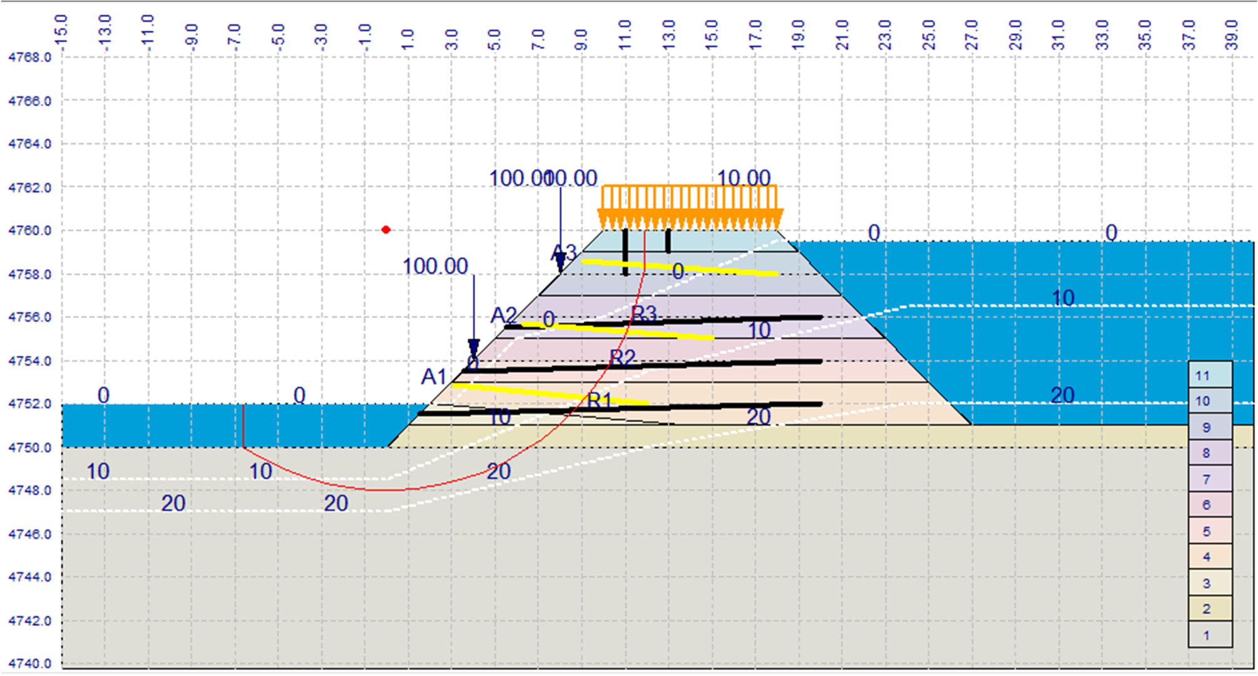

# Theory used in this module

This module can perform a deterministic as well as a probabilistic analysis. With a probabilistic analysis you can consider variations in material properties and other parameters.

Distribution types that can be applied to material properties in a probabilistic analysis include uniform, triangular, exponential, normal, log normal and beta distributions. You can set the number of analysis iterations to be performed and the required probability limit.

4768.0

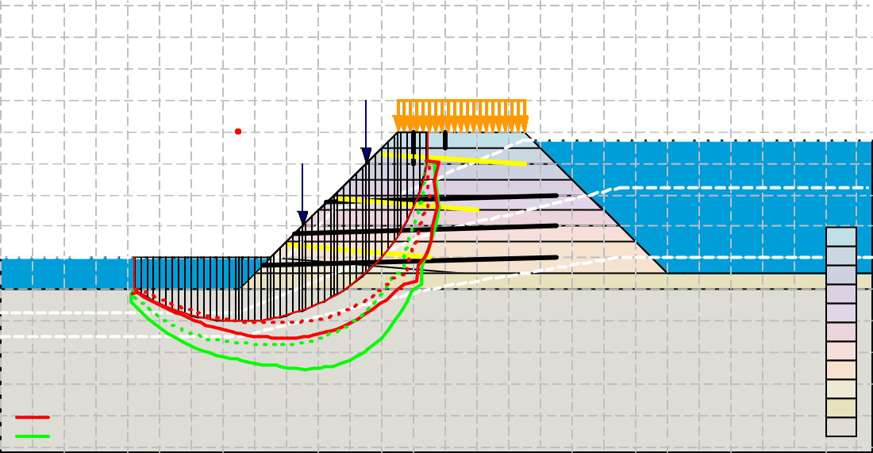

100.10**0**.00

10.00

100.00

A3

A2 0

0

0

0

R3 R2

10

10

0

10

0

A1 0

10

20

R1

20

20

20

10

20

Tangential Stress

Normal Stress

11

10

9

8

7

6

5

4

3

2

1

-15.0

-13.0

-11.0

-9.0

-7.0

-5.0

-3.0

-1.0

1.0

3.0

5.0

7.0

9.0

11.0

13.0

15.0

17.0

19.0

21.0

23.0

25.0

27.0

29.0

31.0

33.0

35.0

37.0

39.0

4766.0

4764.0

4762.0

4760.0

4758.0

4756.0

4754.0

4752.0

4750.0

4748.0

4746.0

4744.0

4742.0

4740.0

# Summary

Non Circular Slip can be used for the evaluation of the stability of soil slopes. It predicts the factor of safety of general shape surfaces using the non-vertical slice method.

* Deterministic and Probabilistic Analysis
* Analysis results grouped on a Calcsheet

**What makes this module special?**

# Detailed Description

Non-Circular Slip predicts the factor of safety of general shape surfaces using the non- vertical slice method, as proposed by Sarma (1979). Due to non-vertical boundaries, the module also allows you to include structural features such as faults or discontinuity planes. To make the analysis as general as possible, water pressures, external loadings and reinforcement are included.

600.0



8

7

6

0

0

0

0

5

0

4

0 3

2

10

0

0

2

1

-150.0

-100.0

-50.0

0.0

50.0

100.0

150.0

200.0

250.0

300.0

350.0

400.0

450.0

500.0

550.0

600.0

650.0

700.0

750.0

800.0

850.0

900.0

950.0

1000.0

550.0

500.0

450.0

400.0

350.0

300.0

250.0

200.0

150.0

100.0

50.0

0.0

-50.0

-100.0

# Theory used in this module

This module can perform a deterministic as well as a probabilistic analysis. With a probabilistic analysis you can consider variations in material properties and other parameters.

Distribution types that can be applied to material properties in a probabilistic analysis include uniform, triangular, exponential, normal, log normal and beta distributions. You can set the number of analysis iterations to be performed and the required probability limit.

Factor of Safety: 1.58

-150.0

-100.0

-50.0

50.0

100.0

150.0

200.0

250.0

300.0

350.0

400.0

450.0

500.0

550.0

600.0

650.0

700.0

750.0

800.0

850.0

900.0

950.0

1000.0

600.0



8

7

6

0

0

0

0

5

0

4

0 3

2

10

0

0

2

1

0.0

550.0

500.0

450.0

400.0

350.0

300.0

250.0

200.0

150.0

100.0

50.0

0.0

-50.0

-100.0

# Summary

Wedge Analysis can be used for the evaluation of the stability of soil slopes. It calculates the F.O.S for a tetrahedral wedge that may form in a rock

* Deterministic and Probabilistic Analysis
* Analysis results grouped on a Calcsheet

**What makes this module special?**

# Detailed Description

A tetrahedral wedge may form in a rock slope by the intersection of two planar discontinuities, the slope face, and the upper slope with or without a tension crack in the upper slope. The deterministic analysis mode is supplemented by a probabilistic mode to evaluate the effect that the range of input values have on the FOS. The probability density function of the FOS is obtained using simulation techniques.

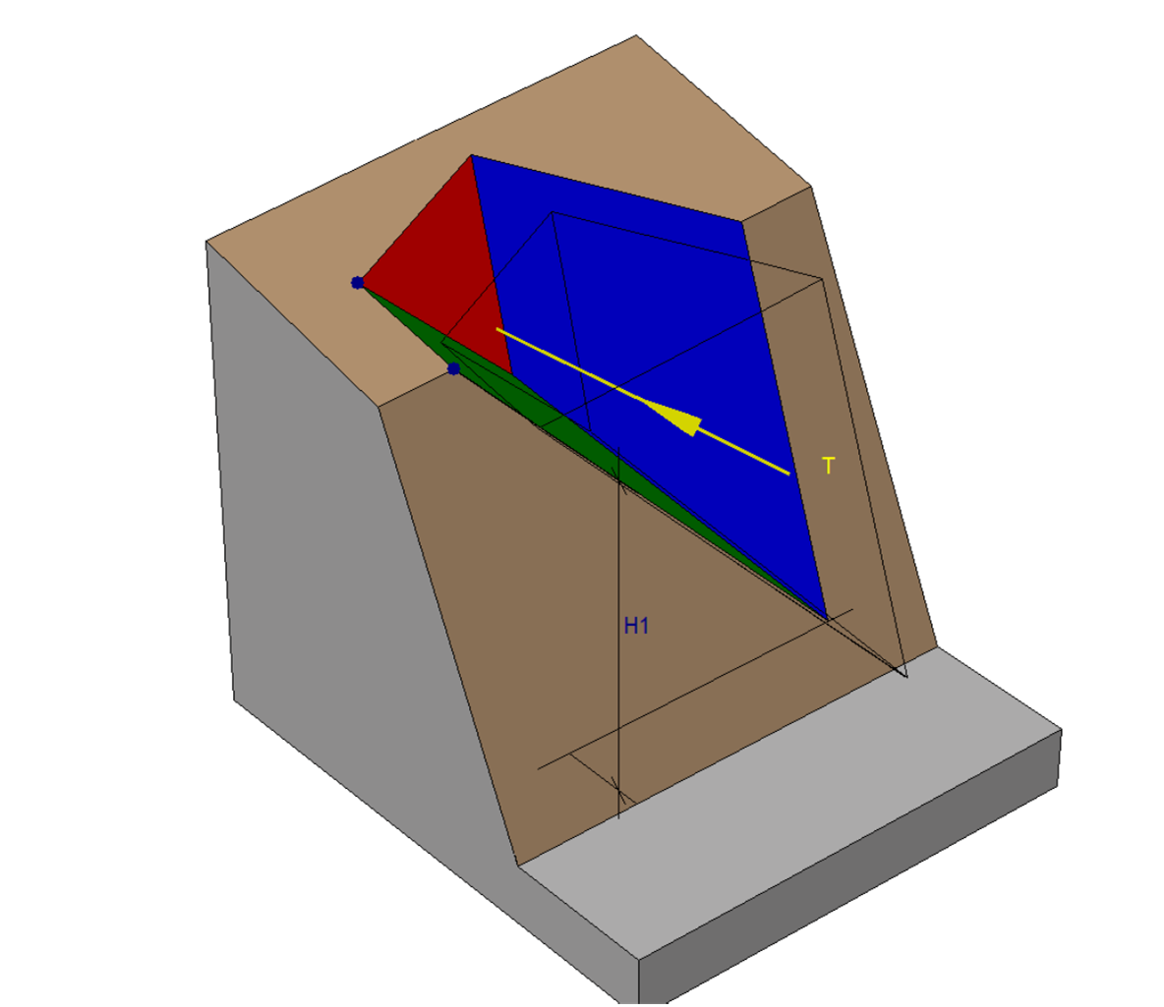

# Theory used in this module

This module can perform a deterministic as well as a probabilistic analysis. With a probabilistic analysis you can consider variations in material properties and other parameters.

Distribution types that can be applied to material properties in a probabilistic analysis include uniform, triangular, exponential, normal, log normal and beta distributions. You can set the number of analysis iterations to be performed and the required probability limit.

Factor of safety probability distribution

95% Probability limit: 1.26

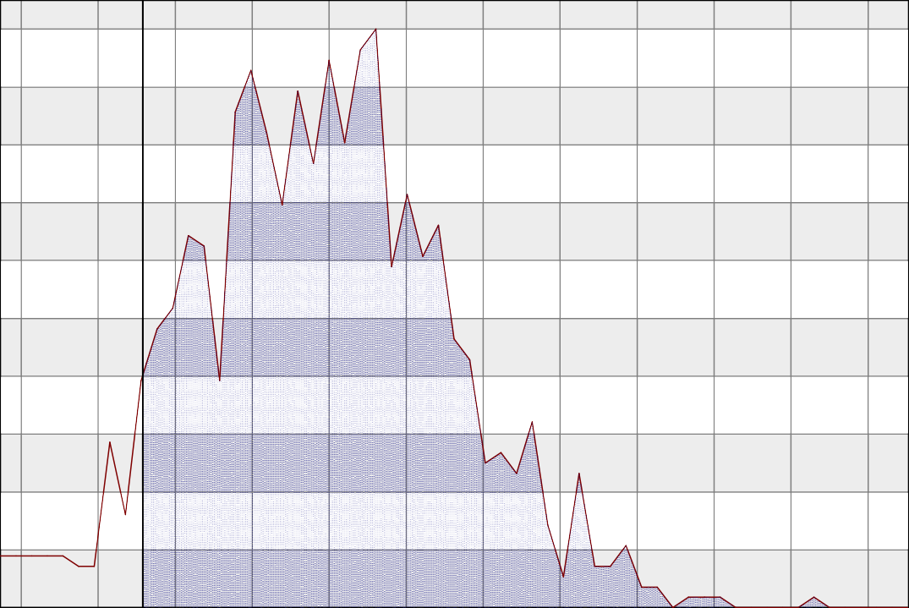1.00

.900

.800

.700

Normalized frequency ()

.600

.500

.400

.300

.200

.100

1.10

1.20

1.30

1.40

1.50

1.60

1.70

1.80

1.90

2.00

2.10

2.20

Factor of safety value ()

**Summary**

Rock Slope determines the factor of safety of a planar failure in rock.

* Deterministic and Probabilistic Analysis
* Graphical output
* Analysis results grouped on a Calcsheet

**What makes this module special?**

# Detailed Description

Rock Slope determines the factor of safety (FOS) of a planar failure in rock. The deterministic analysis mode is supplemented by a probabilistic mode to evaluate the effect that the range of input values have on the FOS. The module obtains the probability density function of the FOS by using simulation techniques.

Z



E

ß

T

☺u

Hp

☺p

Zw

Hc

☺c

# Theory used in this module

Except for the Pile Bearing module, all modules can perform deterministic analyses as well as a probabilistic analysis. With a probabilistic analysis you can consider variations in material properties and other parameters.

Distribution types that can be applied to material properties in a probabilistic analysis include uniform, triangular, exponential, normal, log normal and beta distributions. You can set the number of analysis iterations to perform and the required probability limit.

# Summary

Bearing Capacity evaluates the ultimate bearing capacity of shallow foundations for drained and undrained conditions.

* Deterministic and probabilistic analysis
* Graphical output
* Detailed output

**What makes this module special?**

# Detailed Description

Bearing Capacity can be used to evaluate the ultimate bearing capacity of shallow foundations. Rectangular and circular foundation shapes are supported, and an angled ground slope can be defined. Bi-directional forces and moments can be applied, and the drained and undrained conditions are evaluated.

The formulae for the calculation of the ultimate bearing capacity of shallow foundations are taken from the publication of the American Petroleum Institute (1987). They are based on the procedures as described by AS Vesic (1975) in the Foundation Engineering Handbook as edited by HF Winterkorn and HY Fang.

# Theory used in this module

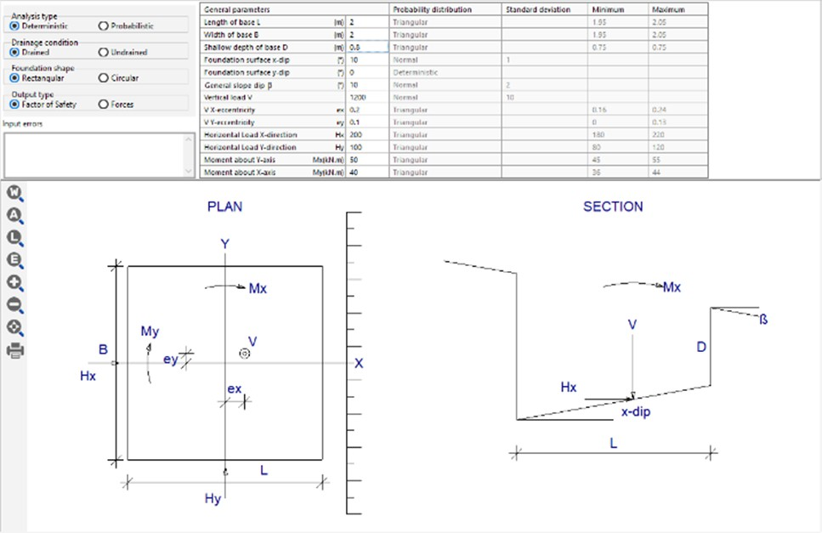This module can perform a deterministic as well as a probabilistic analysis. With a probabilistic analysis you can consider variations in material properties and other parameters.

Distribution types that can be applied to material properties in a probabilistic analysis include uniform, triangular, exponential, normal, log normal and beta distributions. You can set the number of analysis iterations to be performed and the required probability limit.

# Summary

Jointed Rock Masses (Shear strength of jointed rock masses): Most rock masses, exhibit non-linear shear strength/ normal stress failure envelopes, Jointed Rock Masses evaluates this non-linear shear strength envelope for a range of input parameters.

* **Deterministic and Probabilistic Analysis:** A probabilistic analysis lets you take variations in material properties and other parameters into account.
* **Graphical output:** Analysis results displays various graphs.
* **Analysis results grouped on a Calcsheet**: For printing or sending to PROKON Calcpad. Various settings are available to include input and design diagram and tabular result.

**What makes this module special?**

# Detailed Description

Most rock masses, some granular soils and some dense sands, exhibit non-linear shear strength/ normal stress failure envelopes. PROKON’s Jointed Rock Masses evaluates this non-linear shear strength envelope for a range of input parameters. The analysis output may consist of instantaneous cohesion and friction values or the actual shear strength for a given normal stress. Both deterministic and probabilistic modes are supported.

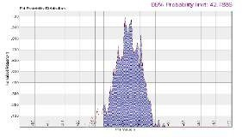

# Theory used in this module

Except for the Pile Bearing module, all modules can perform deterministic analyses as well as a probabilistic analysis. With a probabilistic analysis you can consider variations in material properties and other parameters.

Distribution types that can be applied to material properties in a probabilistic analysis include uniform, triangular, exponential, normal, log normal and beta distributions. You can set the number of analysis iterations to perform and the required probability limit.

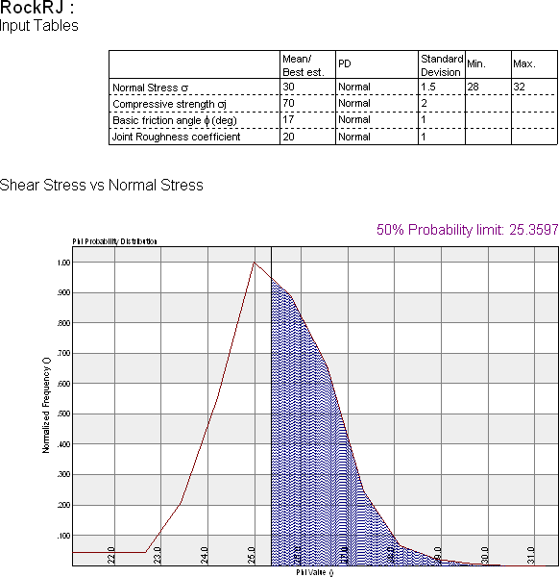

# Summary

Rock Rough Joints evaluates the shear strength failure envelope for rough joints in rock.

* Deterministic and Probabilistic Analysis
* Graphical output
* Analysis results grouped on a Calcsheet

**What makes this module special?**

# Detailed Description

The Rock Rough Joints module evaluates the shear strength failure envelope for rough joints in rock. It gives the option of performing the analysis in either deterministic or probabilistic mode. By using the probabilistic mode, the module generates the range of input parameters by using simulation techniques to generate a probability density distribution of the output shear strength.

# Theory used in this module

The user is presented with the choice of two theories as advanced by Ladanyi and Archambault (1970) and Barton (1971a/b,73).

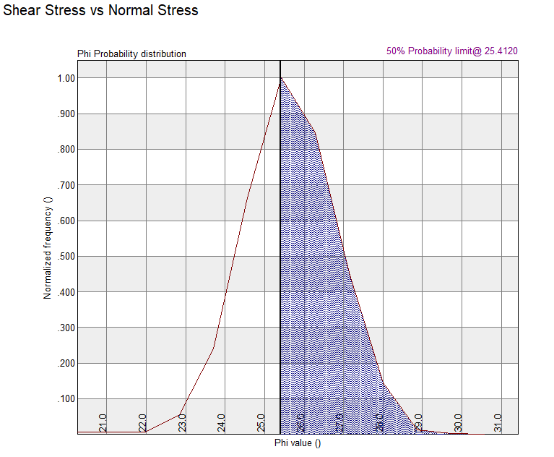

# Summary

Pile Bearing can calculate the bearing capacity of piles considering the effects of pile length and diameter, installation type and soil conditions.



**What makes this module special?**

* Circular and Square pile design
* Graphical output
* Analysis results grouped on a Calcsheet

# Detailed Description

Pile Bearing can calculate the bearing capacity of piles considering the effects of pile length and diameter, installation type and soil conditions. The load transfer functions comprise two components: a side shear transfer function and an end bearing transfer function.

2.00 m

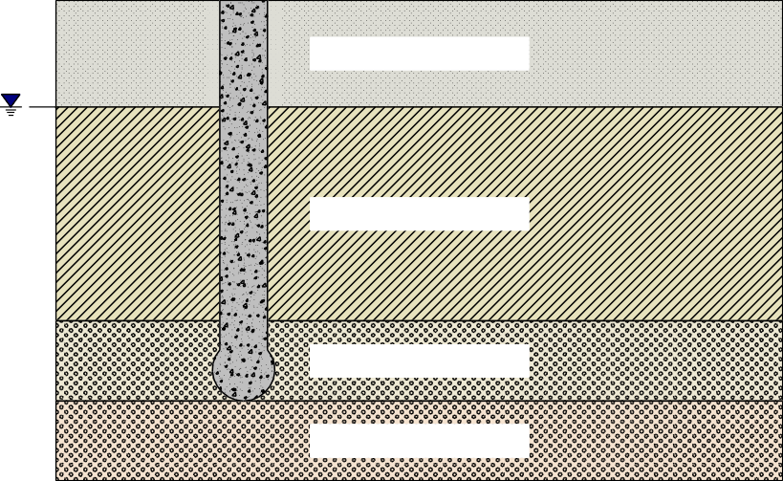

Very Dense Sand f= 11.90 kPa

2.00 m

Soft Clay f= 18.03 kPa

6.00 m

Very Soft Rock f= 200.00 kPa

7.50 m

Soft Rock f= 400.00 kPa

9.00 m

An analysis output table provides a summary of the friction and end bearing forces for each layer, for the allowable pile capacities, as well as the totals. A summary of the SLS and ULS settlements is also given. Additionally, the pile capacity vs pile length and the pile load vs deflection graphs are plotted.

12E3

11E3

10E3

9000

8000

Load (kN)

7000

6000

5000

4000

3000

2000

1000

PILE SETTLEMENT kN max = 12223kN @ 25.0mm

|  |  |  |  |  |  |  |  |  |  |  |  |  |  |  |  |  |  |  |  |  |  |  |  |  |  |
| --- | --- | --- | --- | --- | --- | --- | --- | --- | --- | --- | --- | --- | --- | --- | --- | --- | --- | --- | --- | --- | --- | --- | --- | --- | --- |
|  |  |  |  |  |  |  |  |  |  |  |  |  |  |  |  |  |  |  |  |  |  |  |  |  |  |
|  |  |  |  |  |  |  |  |  |  |  |  |  |  |  |  |  |  |  |  |  |  |  |  |  |  |
|  |  |  |  |  |  |  |  |  |  |  |  |  |  |  |  |  |  |  |  |  |  |  |  |  |  |
|  |  |  |  |  |  |  |  |  |  |  |  |  |  |  |  |  |  |  |  |  |  |  |  |  |  |
|  |  |  |  |  |  |  |  |  |  |  |  | To | tal |  |  |  |  |  |  |  |  |  |  |  |  |
|  |  |  |  |  |  |  |  |  |  |  |  | E | nd |  |  |  |  |  |  |  |  |  |  |  |  |
|  |  |  |  |  |  |  |  |  |  |  |  |  |  |  |  |  |  |  |  |  |  |  |  |  |  |
|  |  |  |  |  |  |  |  |  |  |  |  |  |  |  |  |  |  |  |  |  |  |  |  |  |  |
|  |  |  |  |  |  |  |  |  |  |  |  |  |  |  |  |  |  |  |  |  |  |  |  |  |  |
|  |  |  |  |  |  |  |  |  |  |  |  |  |  |  |  |  |  |  |  |  |  |  |  |  |  |
|  |  |  |  |  |  |  |  |  |  |  |  |  |  |  |  |  |  |  |  |  |  |  |  |  |  |
| 00 | 00 | 00 | 00 | 00 | 00 | 00 | 00 | 00 | .0 | .0 | .0 | Si | de | .0 | .0 | .0 | .0 | .0 | .0 | .0 | .0 | .0 | .0 | .0 | .0 |
| 1. | 2. | 3. | 4. | 5. | 6. | 7. | 8. | 9. | 10 | 11 | 12 | 13. | 14. | 15 | 16 | 17 | 18 | 19 | 20 | 21 | 22 | 23 | 24 | 25 | 26 |

Deflection (mm)

0

0

-.500

-1.00

-1.50

-2.00

-2.50

Pile Length (m)

-3.00

-3.50

-4.00

-4.50

-5.00

-5.50

-6.00

-6.50

-7.00

-7.50

PILE CAPACITY (ULTIMATE) Frict Cap max = -7.500m @ 1119kN

Capacity (kN)

1000

2000

3000

4000

5000

6000

7000

8000

9000

10E3

11E3

12E3

13E3

14E3

15E3

16E3

17E3

18E3

19E3

20E3

21E3

# Theory used in this module

One of the simplest and most elegant methods to predict load/deformation curves is that proposed by Everett J.P. "*Load Transfer Functions and Pile Performance Modelling, Geotechnics in the African Environment" (1991)*”. The load transfer functions comprise two components: a side shear transfer function and an end bearing transfer function.