# Prokon Interop

Bulk upgrade folders containing Revit® Families; Projects; or Templates to the latest

**Revit** version.

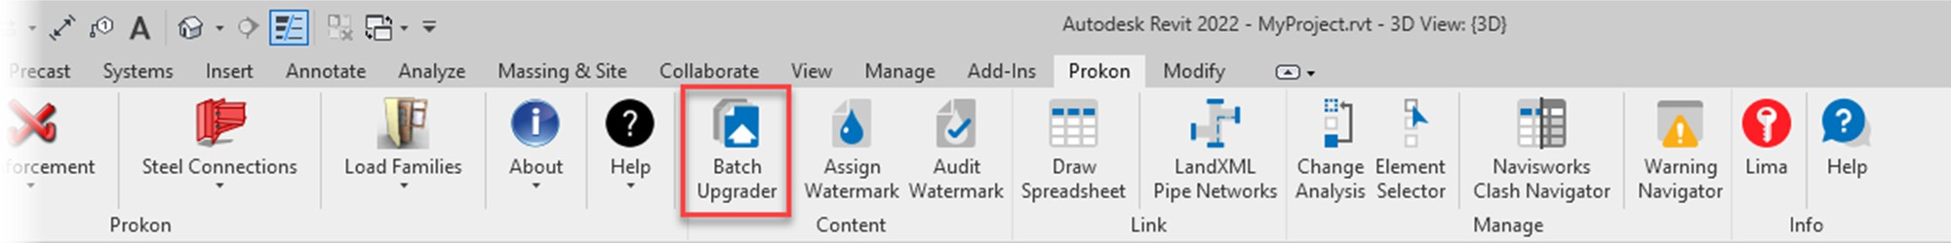

* Batch upgrade Revit files
* Search for specific folders

**What makes this module special?**

# Detailed Description

With every major release of **Revit**, older files need to be upgraded before use in the latest version. This add-in takes care of the tedious task of upgrading files.

The Batch File Upgrader will upgrade:

* Revit Projects (.rvt)
* Revit Families (.rfa)
* Revit Templates (.rte)

It does so by scanning all relevant files in the selected folder. You may also limit the search and upgrade process to folders containing a specified string value.

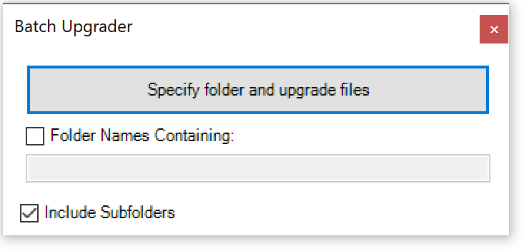

# Summary

Assign unremovable watermarks to **Revit®** content to help protect your intellectual property. The **Watermark** tool may be used at any time to audit **Revit** content and verify ownership.

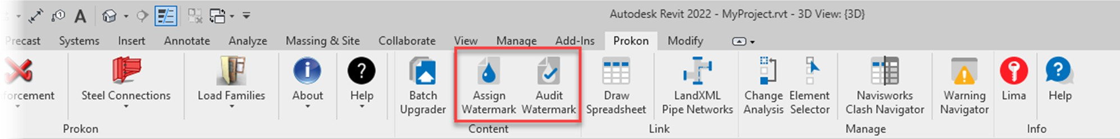

* Protect intellectual property
* Verify ownership

**What makes this module special?**

# Detailed Description

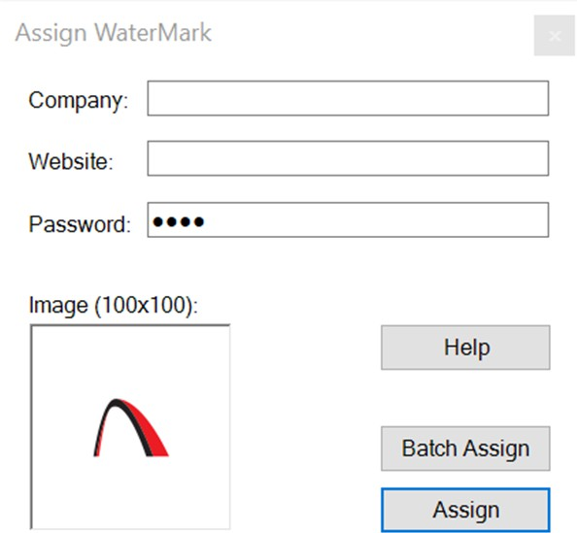This add-in allows you to attach a watermark to project / family elements. Watermark data includes a logo, company name, website, date, and password.

The add-in could also be used to audit existing **Watermark** data (if available) in the current project/family.

A matching password is required to overwrite existing element **Watermark** data – this prevents the removal of existing **Watermarks** without authorisation. Passwords may have any characters but should not exceed 30 characters in length.

A valid license is required to specify your own **Watermark** data. Without a license, the

**Watermark** data is locked.

# Summary

Import and insert/link **MS Excel** spreadsheets (.xlsx; .xls or .csv) into **Revit®** Drafting Views without linking to **Revit** Schedules.

* Insert MS Excel spreadsheet in Revit drafting view

**What makes this module special?**

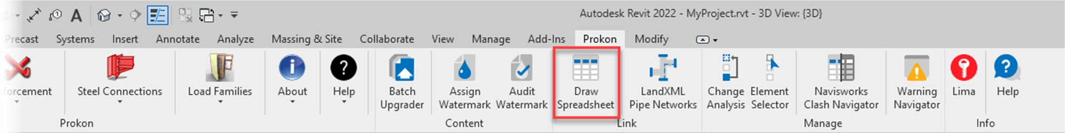

# Detailed Description

This add-in allows you to open a spreadsheet using the .xlsx or .csv file format, and then define a selection or region to insert into an active **Revit** Drafting view by either:

1. Drawing the elements using **Revit** lines and text elements
2. Creating an external link (using DXF), then inserting it as an external link into the active Drafting view

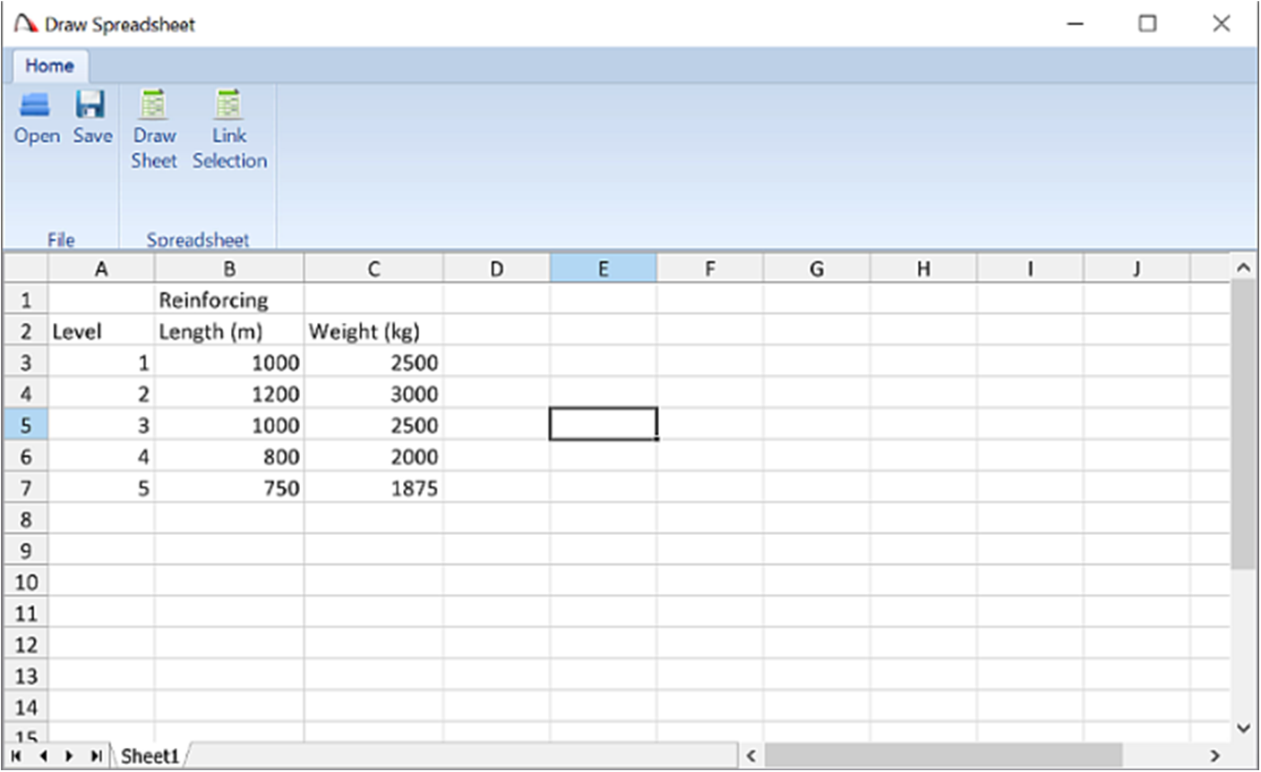

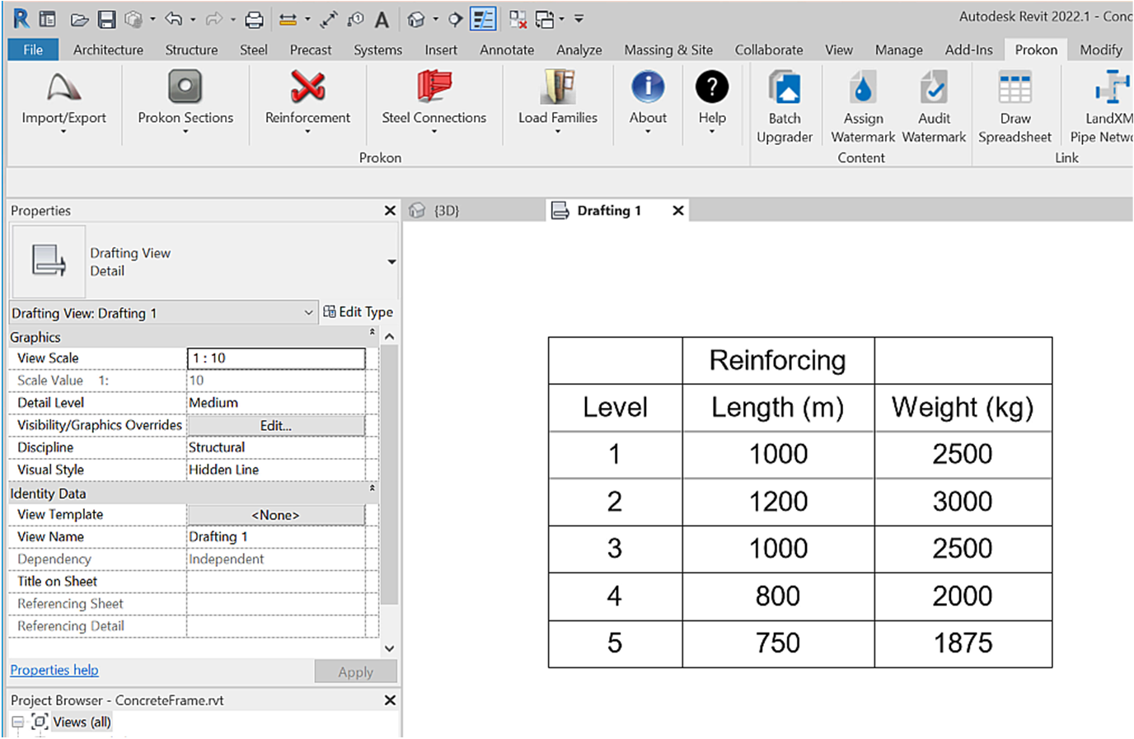

Use this add-in to add spreadsheet data to a **Revit** project without using the built-in schedule facility.

# Summary

Import **Civil 3D®** Pipe Networks through LandXML format to generate native **Revit®** objects within your **Revit** projects. This is useful for model federation and model coordination.

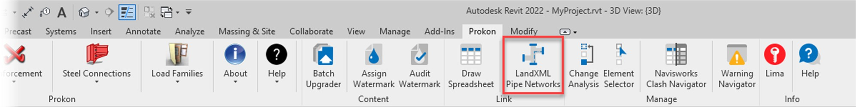

* Insert **MS Excel** spreadsheet in **Revit** drafting view

**What makes this module special?**

# Detailed Description

This add-in was designed to work with **Civil 3D** LandXML exports of pipe networks. LandXML exports from other applications cannot be guaranteed but may also work.

1. Export the pipe network to LandXML

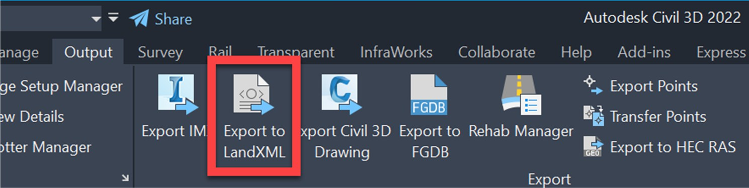

1. Import to **Revit**

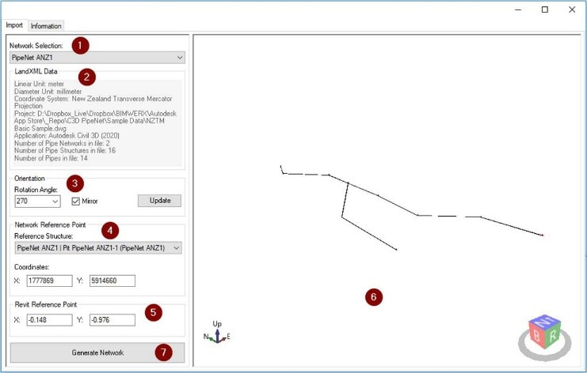

1. Pipe network in **Revit**

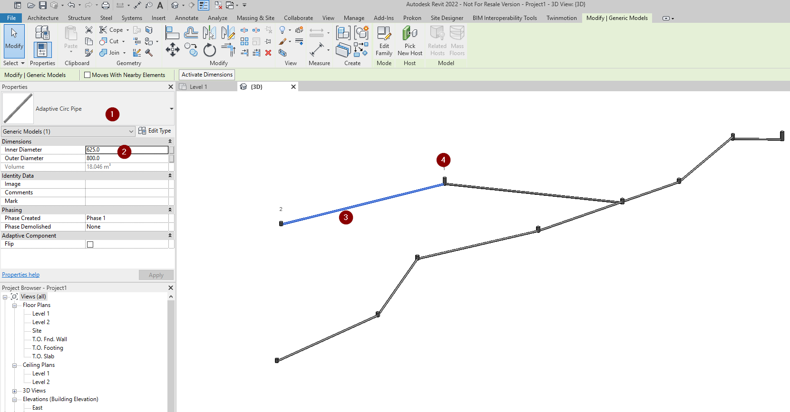

Use this tool to collaborate with civil engineers on your next project.

# Summary

Perform advanced analyses between two version of the same model. Choose which elements to compare and what tolerances to verify. The change management tool also features a dynamic coordination tool that enables model coordinators to manage model changes and keep track of issues with elements in question.

* Compare version of the same file and highlight changes

**What makes this module special?**

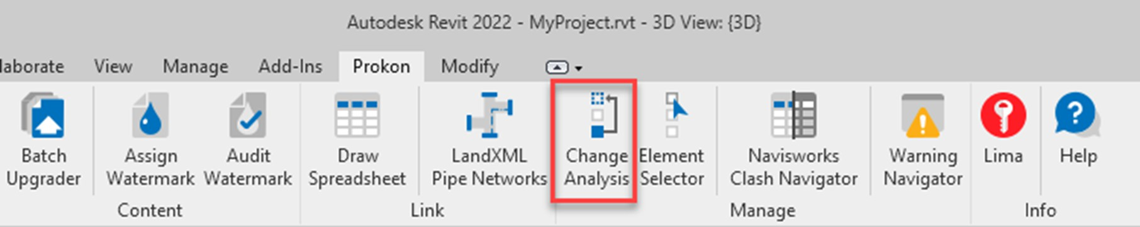

# Detailed Description

Change Analysis is an advanced **Revit®** project comparison utility. This tool compares two versions of the same project. It analyses user-specified changes between the two models, comparing model elements and displaying them in a colour-coded 3D view, together with a dynamic element finder floating dialogue.

Analysed data can be stored and shared with other users who can use the recorded changes to dynamically focus on elements in the model(s) that have been added, removed, or modified.

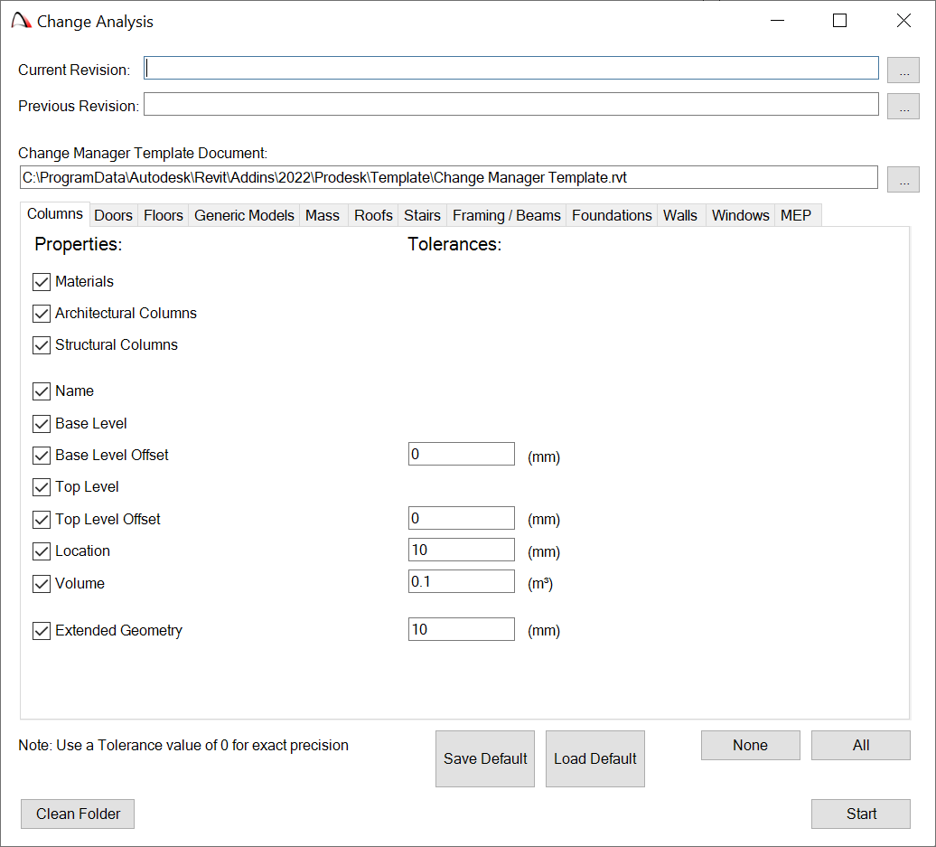

# Summary

Manage **Navisworks®** clashes directly in **Revit®**, without the need for **Navisworks**. The tool requires a Navisworks Clash report (generated through **Navisworks**), after which it enables model coordinators to manage, find, and solve model clashes directly in the **Revit** environment, using the Clash Navigator.

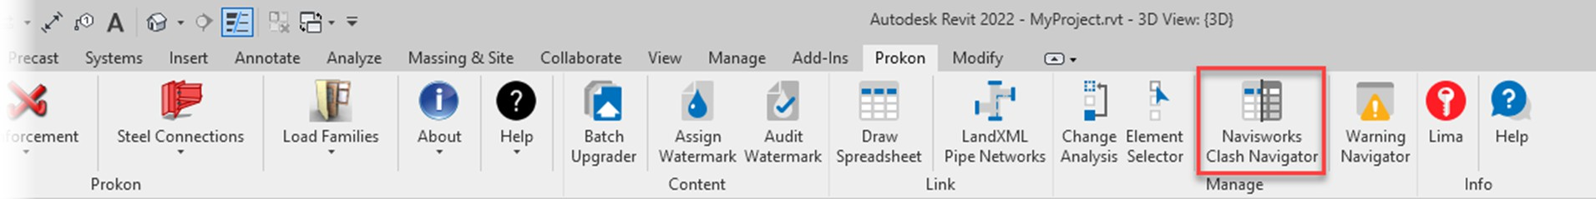

* Solve model clashes in **Revit**

**What makes this module special?**

# Detailed Description

This tool works with the **Revit** element IDs that were used in **Navisworks** to perform the clash report. It is therefore important that the same elements still exist in the **Revit** project.

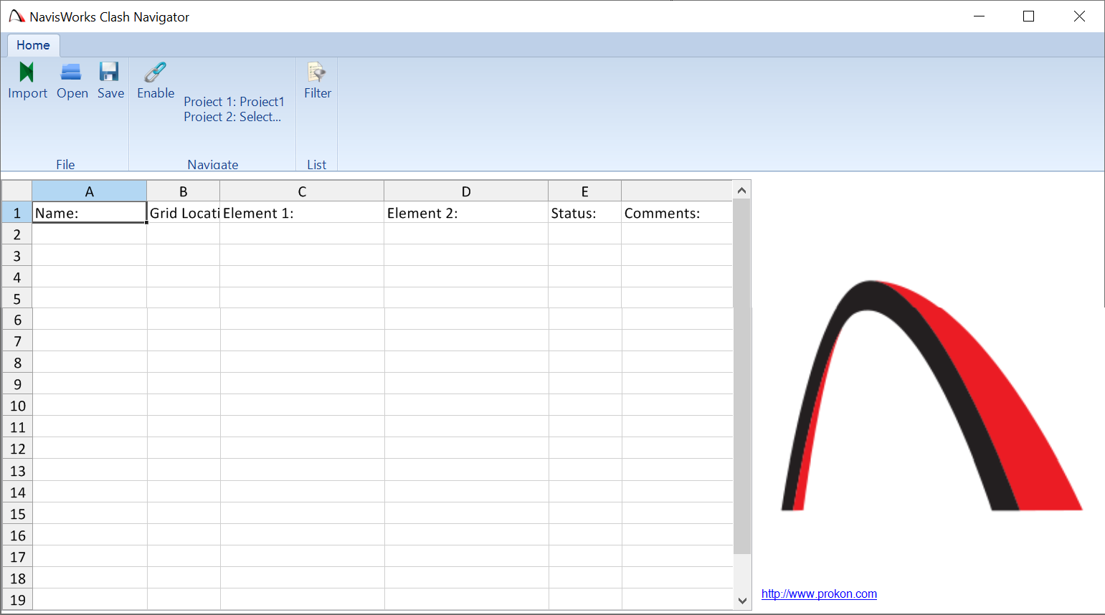Export a text formatted clash report from **Navisworks** Manage.

# Summary

Extract **Revit®** warnings into a manageable interface. Useful for model coordinators to solve model issues or perform model audits.

* Extract warnings into a manageable interface

**What makes this module special?**

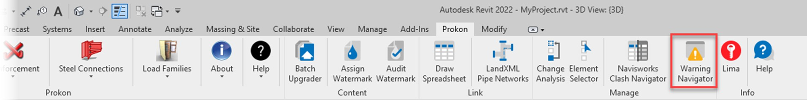

# Detailed Description

Use this add-in for **Revit** to dynamically navigate **Revit** Warnings and to manage and communicate warning reports.

1. 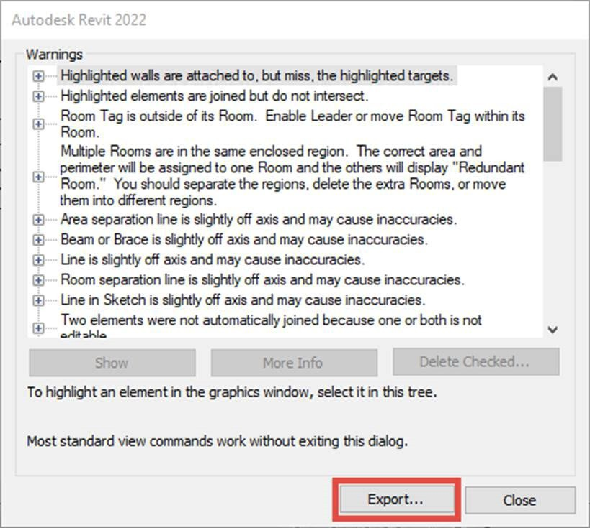**Revit** Warnings are exported in HTML
2. Raw HTML data:

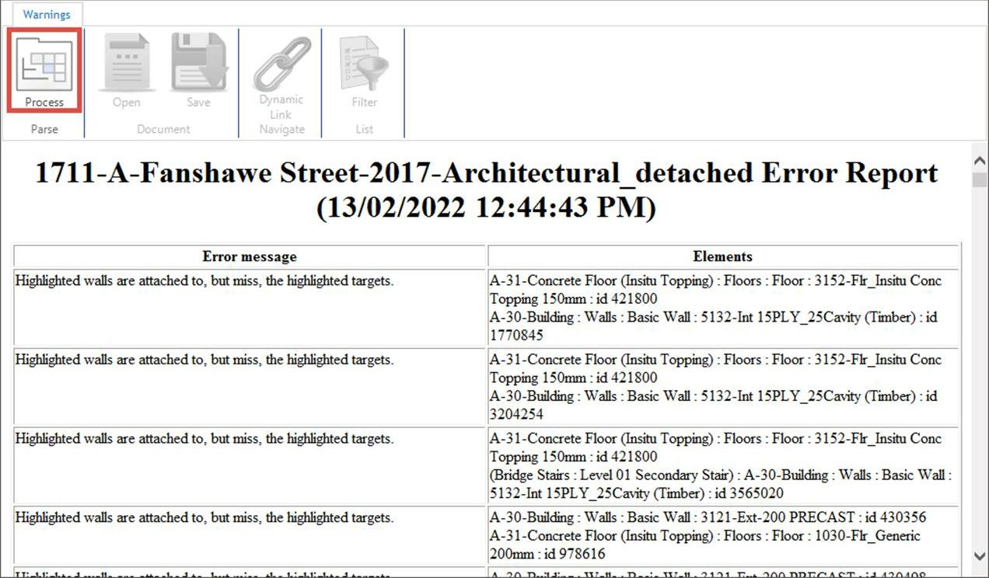

1. Parsed HTML data viewed in a spreadsheet

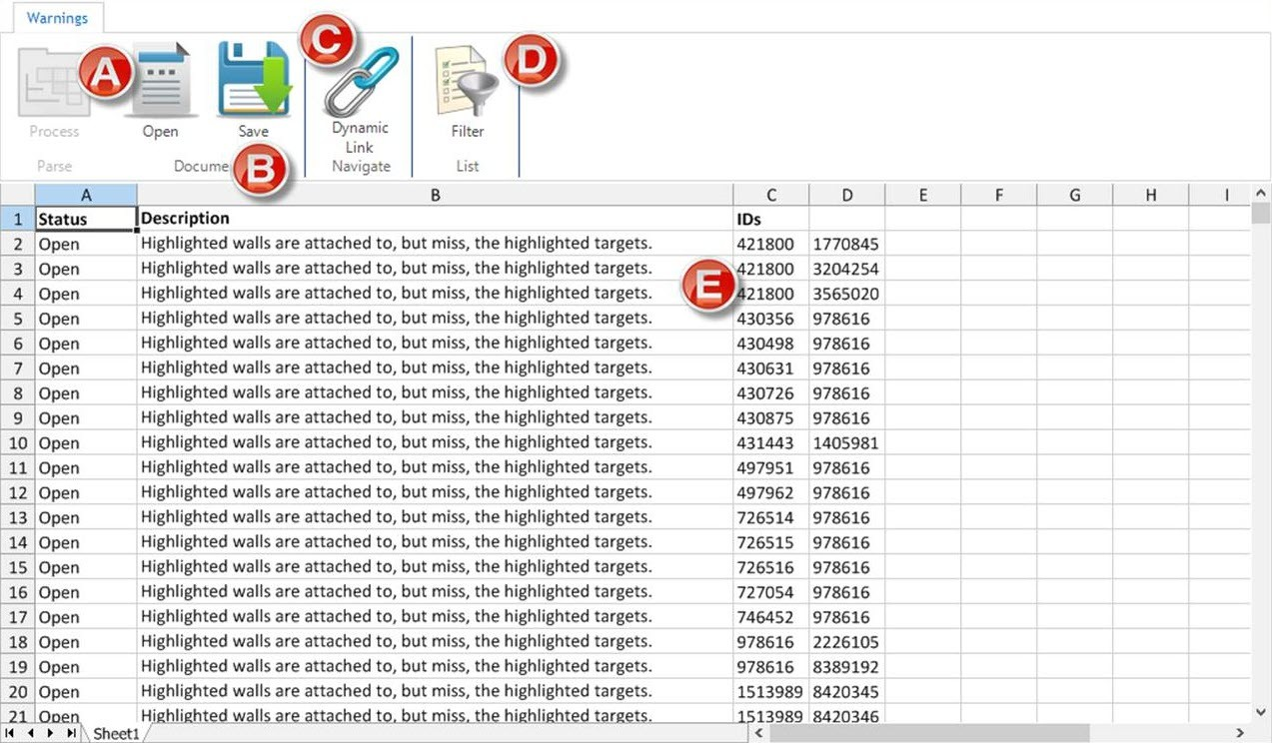

The report can be saved to XLSX for use in **MS Excel**.