# Prokon Masonry

**Masonry Section** is used to design reinforced masonry beams that span large openings in walls.

* 3D representation of the wall section
* Detailed calculation output

**What makes this module special?**

# Detailed Description

**Masonry Section** verifies the resistance of a reinforced masonry beam at a critical section. It is assumed that the loads imposed on the beam cause uniaxial bending and shear.

The following wall types are supported:

* Single leaf
* Collar jointed
* Grouted cavity

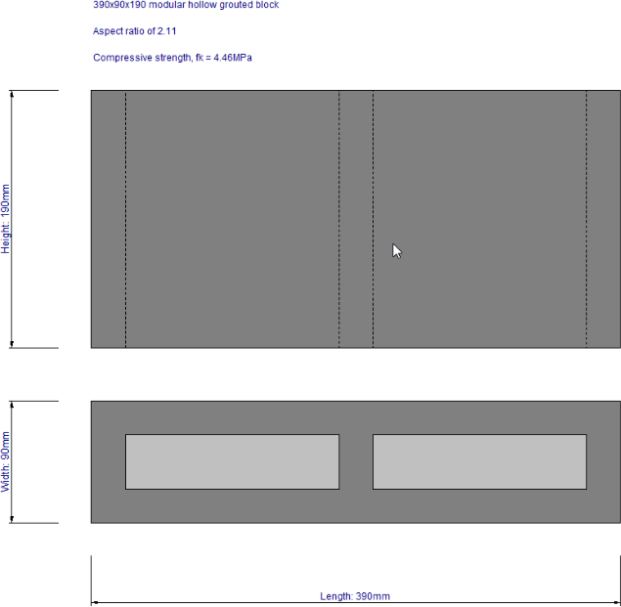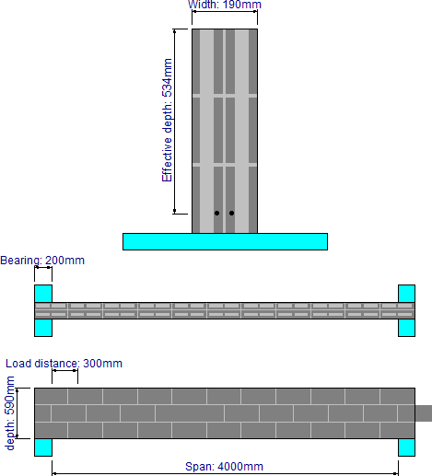

The design output shows the two failure modes: compression and tension.

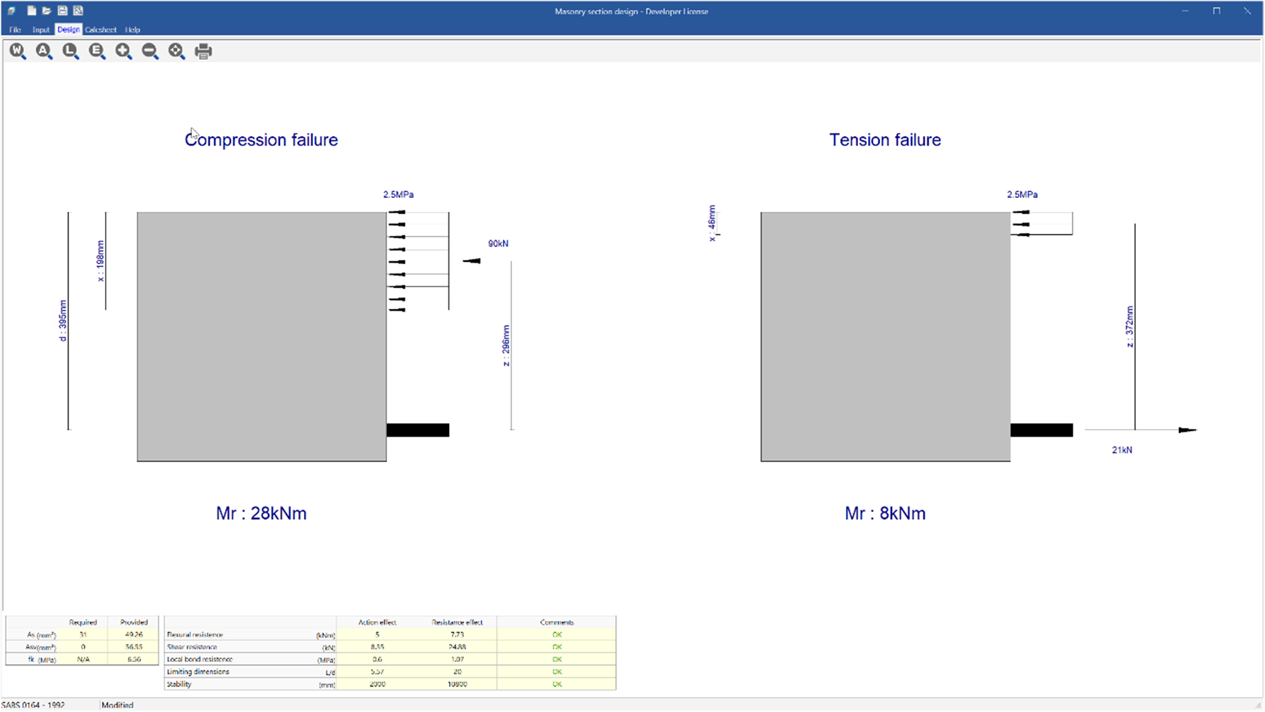

# Supported Design Codes



**Design Codes**

* SABS 0164 - 1992

**Summary**

**Masonry Wall** is used to design various types of load bearing masonry walls.

* 3D representation of the wall section
* Detailed calculation output

**What makes this module special?**

# Detailed Description

**Masonry Wall** determines the resistance of an unreinforced masonry wall, subjected to in-plane axial or out-of-plane loading causing bi-axial bending.

The module supports the following wall types:

* + Single leaf
  + Collar jointed
  + Grouted cavity

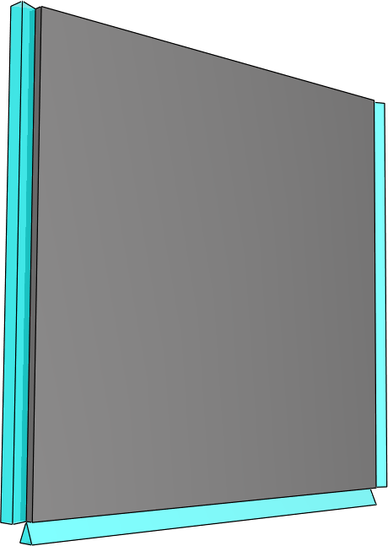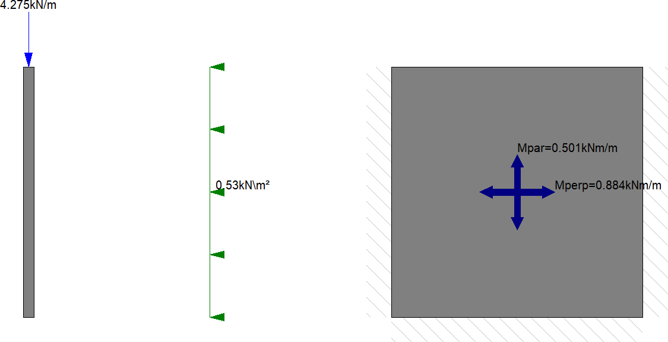

The design output provides a tabular and diagrammatic summary of the design.

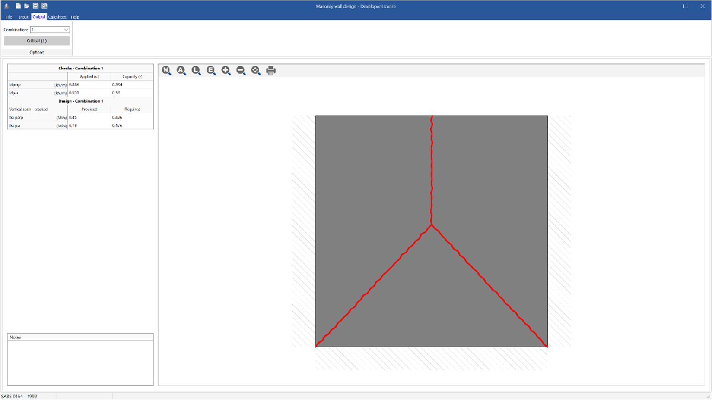

# Supported Design Codes



**Design Codes**

* BS 5628 - 2005
* SABS 0164 - 1992

**Summary**

**Masonry Free Wall** can be used to verify the lateral load resistance of wall panels away from wall ends.

* 3D representation of the wall section
* Detailed calculation output

**What makes this module special?**

# Detailed Description

**Masonry Free Wall** is used to evaluate masonry walls subject to out-of-plane loads. This module is a standalone program, i.e., it does not post-process results from any of the other analysis modules.

The following wall types are supported:

* Solid
* Solid with piers on one side
* Solid with piers on both sides
* Staggered

Along with multiple load combinations of UDLs, line loads and point loads.

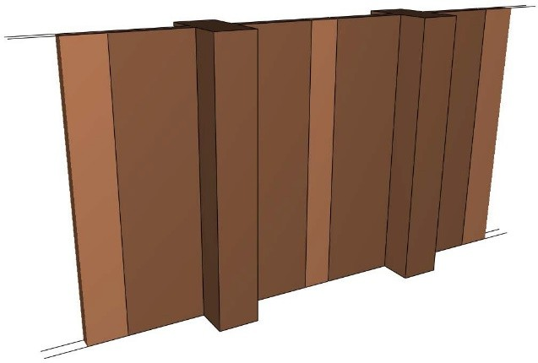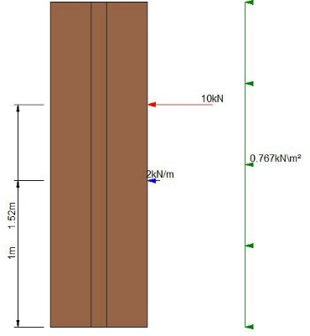

The design output provides a tabular and diagrammatic summary of the design.

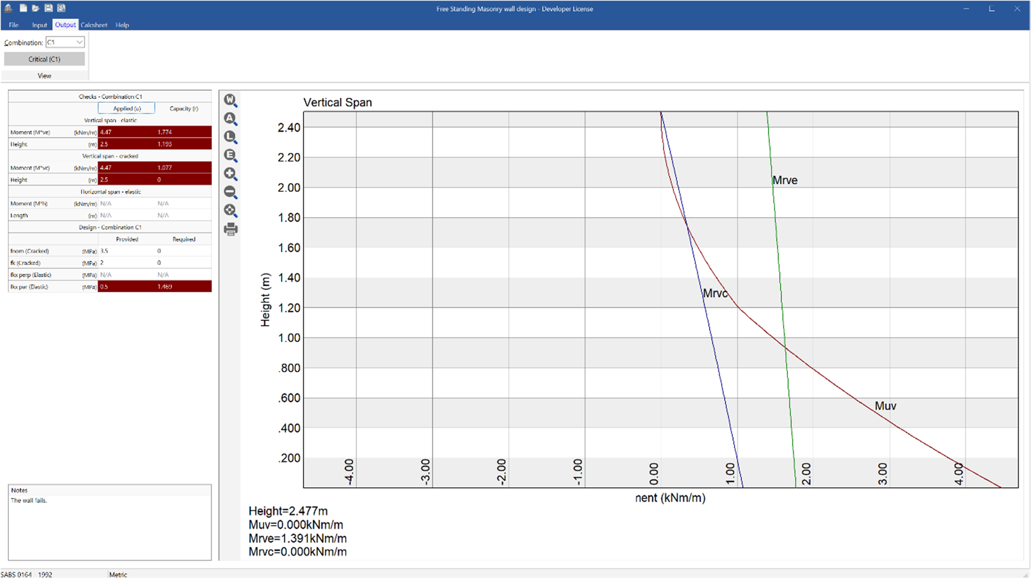

**Supported Design Codes**



**Design Codes**

* BS 5628 - 2005
* SABS 0164 - 1992