# Prokon Padds

**Padds**, short for Parametric Drawing and Detailing System, was developed specifically for structural engineers and their draughting personnel. With its intuitive and uncomplicated interface, new users can be productive within the first couple of hours of using the program. Without the bloat of modern CAD systems, all that remains is a lean and powerful tool for drawing and structural detailing.

|  |
| --- |
| What makes this module special? |
| * Automatic scheduling * Edit reinforcing drawings created by PROKON design modules * Generate complex input for PROKON modules * Read and write DWG & DXF files |

# Detailed Description

All the basic CAD procedures are available to create or edit drawings. Entities like lines, arcs, circles, splines, text, hatch, dimensions, blocks, and construction lines are all supported with a host of editing functions. Using an innovative approach to layers and scales, laying out details on a drawing sheet is very easy.

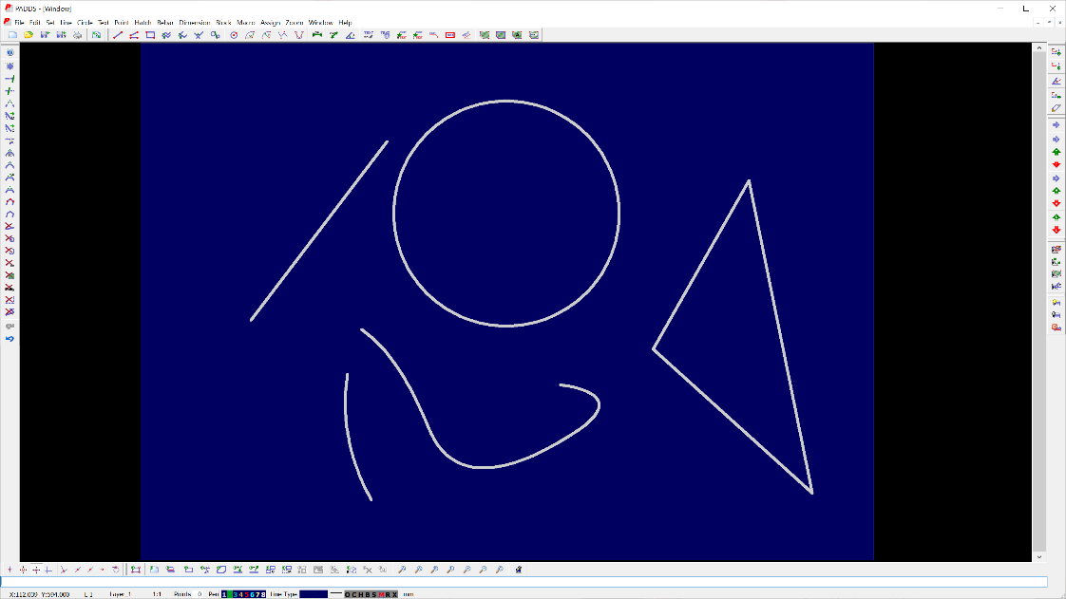

The program ships with various reinforcements detailing functions. Among them, the ability to add multiple bars, alternate bars reversed, staggered bars, and fanned zones.

The scheduler keeps track of all rebar entities in the drawing and displays their properties in the schedule. The reinforcement detailing functionality of **Padds** is also available in **Probar 2D**, an extension for **Autodesk Autocad**. **Padds** is further complemented by the free **PaddView** drawing viewer.

**Padds** can supply input to **PROKON** design modules as well as meshes for **Frame**.

**Padds** includes macro and scripting facility based on the Pascal programming language which allows you to develop your own commands. Included macro functions include a complete staircase detailing function, and a function to combine multiple bending schedules (A4 or letter size) onto a larger sheet.

**Padds** links with the **PROKON Section Database** to enable you to draw standard profiles in section, elevation, or plan. Creating welding details is also easy, given the included library of welding symbols.

These features gear **Padds** for basic detailing of structural steel.

# Detailing Codes

* BS 4466 – 1989
* BS 8666 – 2005
* SANS 282 – 2004
* SANS 282 - 2011

**Detailing Codes**