# Prokon Prodesk

**Prodesk** makes BIM possible – it transfers information between **Autodesk® Revit®** and

**Sumo**.

* Transfer models between **Revit** and **Sumo**
* Bi-directional data transfer
* Custom Families

**What makes this module special?**

# Detailed Description

The power of BIM lies in the fact that you’re not drawing lines in CAD but instead modelling objects like beams, slabs, and columns. Detailed information about these objects is stored in a model database.

**Revit** is a multi-discipline BIM software that allows engineers to model buildings with much detail. The information relevant to structural engineers can be transferred to **Sumo** using **Prodesk**. After the detailed analysis and design, the model can be returned to **Revit** to update the existing model.

If PROKON families are used for modelling in **Revit**, beams and columns are transferred directly with their correct section profiles and orientations. However, if default **Revit** families are used, the Revit families can be mapped to the corresponding section in the **PROKON Section Database**.

**Prodesk** allows you to transfer an entire model or selected portions only.

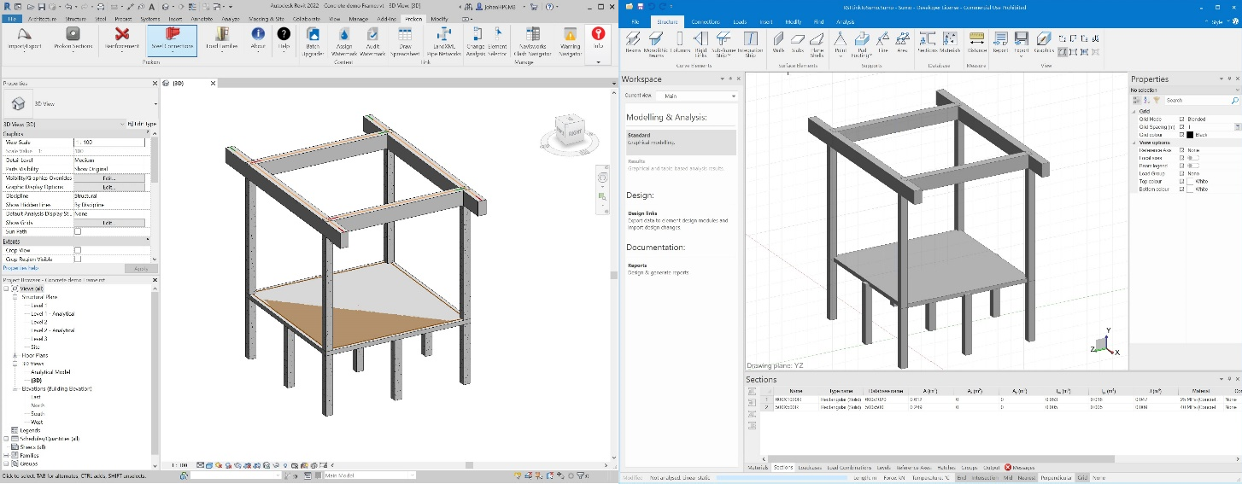

# Custom Families

The **PROKON Section Database** is directly available from within **Revit**. Custom **Revit**

Families can be generated from the information in the **Section Database**.

