## Prokon Steel

**Strut** is used to optimise and design steel members subject to axial stress.

The module primarily acts as a post-processor for **Sumo** and **Frame**, but also has an interactive mode for quick design checks of individual members without first performing an analysis.

* Post-process analysis data
* Optimise members
* Interactive input mode
* Detailed calculations

**What makes this module special?**

## Detailed Description

**Strut** is used to design axial force members in steel frames. These members are typically found in trusses with pinned joints where loads are applied at nodes. The result is a tensile or compressive force in each member and no bending moment. The design process is a simplified one that is easy to understand and can be applied to batches of elements.

The module primarily acts as post-processors for **Sumo** and **Frame**. A model is built and solved in the analysis program and **Strut** reads the output file.

The interactive mode is used to perform quick design checks of individual members without the need to first perform an analysis.

In **Strut** you can set up design tasks. Each task lists the members to be designed, their parameters such as effective length factors, slenderness limits and the design approach. Tasks can be saved and recalled later.

There are three design approaches:

* Select from preferred sections
* Evaluate current section
* Select lightest section

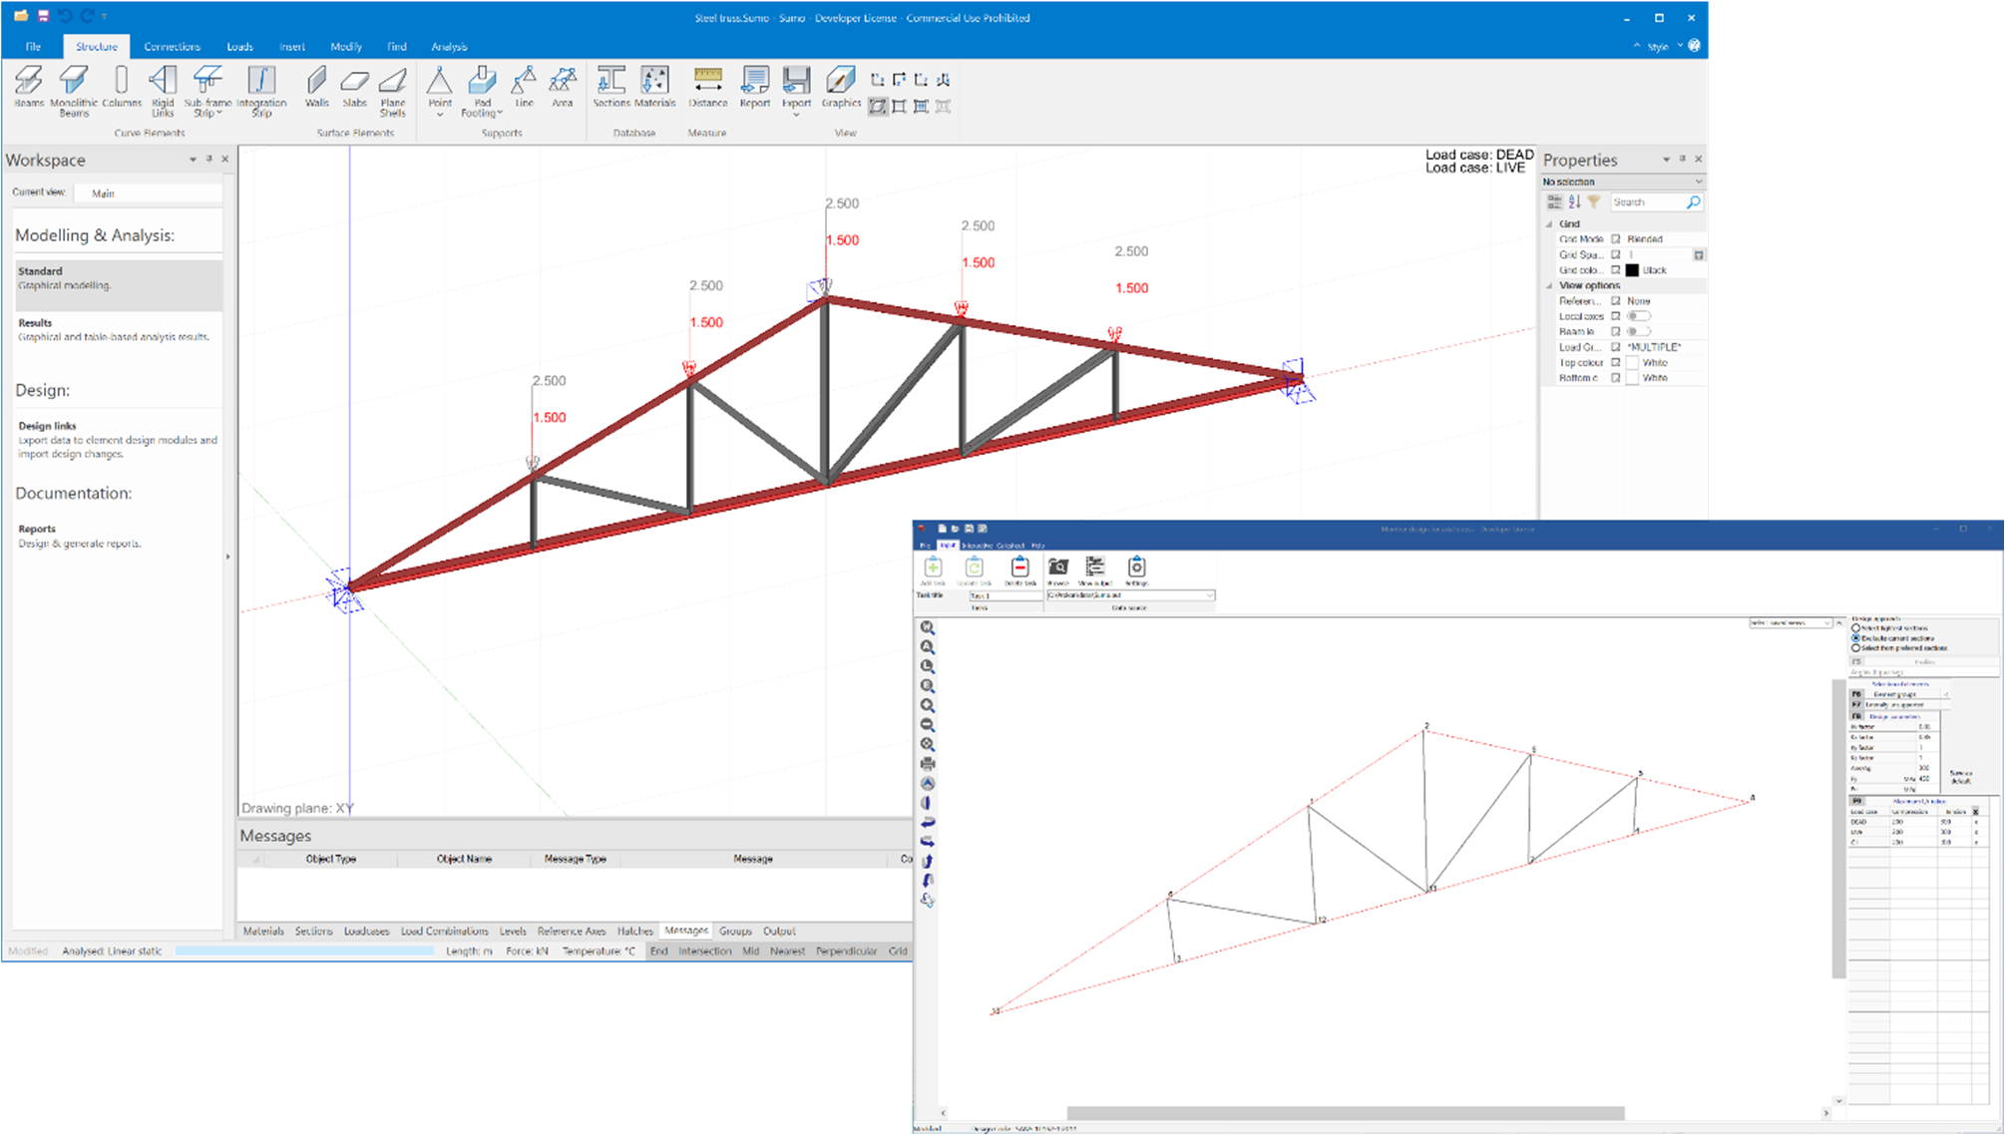

The output includes a summary of each member and a Pass/Fail result displayed in the sidebar. Detailed equations can be viewed for selected design codes.

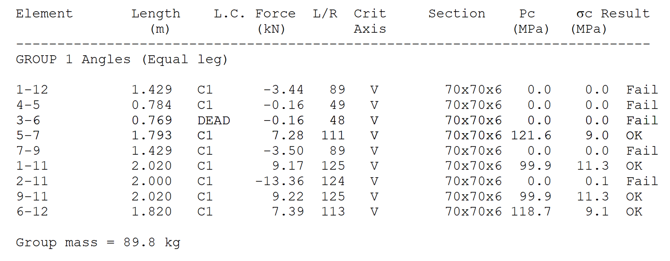

**Supported Design Codes**

**Design Codes**



* + AISC - 1989 ASD
  + AISC – 1999 LRFD
  + AS4100 – 1998
  + AS4100:2020
  + BS 5950 – 1990
  + BS 5950 – 2000
  + CAN/CSA-S16.1-94
  + CSA S16:19
  + CSA S16-01 2001
  + CSA S16-09 2009
  + CSA S16-14 – 2014
* Eurocode 3 – 2005
* GBJ 17-88
* IS:800 – 1984
* IS:800 – 2007
* NZS 3404 - 1997
* SABS 0162 - 1984
* SABS 0162 - 1993
* SANS 10162 – 2005
* SANS 10162-1: 2011

## Summary

Effortlessly design and optimise steel members subject to a combination of axial, bending, and shear stress, e.g., beams and columns in frames.

Easily process your analysis results from **Sumo** and **Frame** or use the interactive mode for quick design and checking of individual members without the need to first perform an analysis.

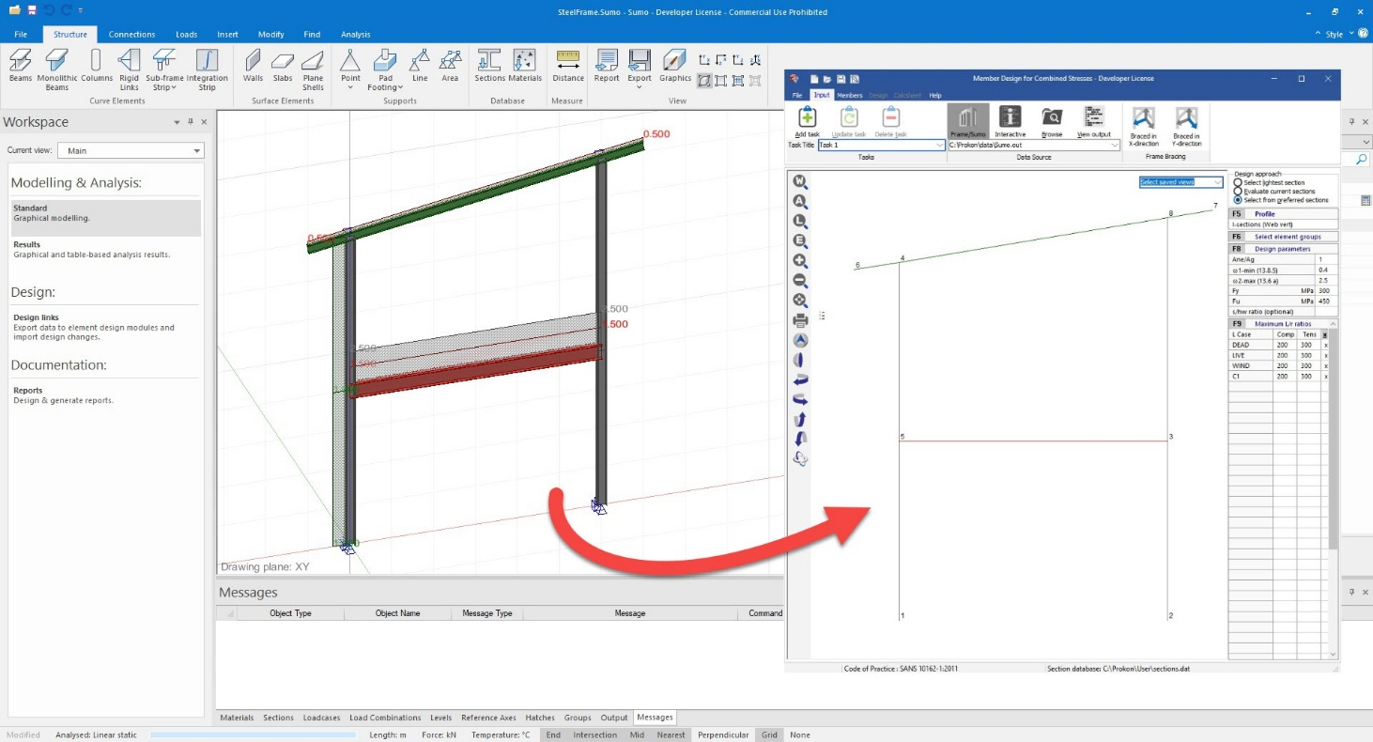

* Considers a combination of stresses
* Interaction with Sumo and Frame
* Three different design approaches

**What makes this module special?**

**Detailed Description**

**Combine** is a **PROKON®** steel member design module which allows you to effortlessly design and optimise steel members subject to a combination of axial, shear, bending stress. The steel member design modules primarily act as post-processors for the modules **Sumo** and **Frame**. Combine also has an interactive mode for quick design or checking of individual members without the need to first perform an analysis.

Simplify the design of a structure by breaking it up in design tasks. Each task lists the members to be designed, the design parameters such as effective length factors, and the design approach. You can save the design tasks to a file so that you can easily recall it later.

**Combine** provides three different design approaches, depending on what you would like to achieve:

* Select lightest section
* Evaluate current sections
* Select from preferred sections

The design results are published to a Calcsheet with a summary and in-depth design calculations for every member and graphs showing axial force and bending moment distribution along the length of the member. The design calculations will indicate whether a specific element fails or passes the required design checks.

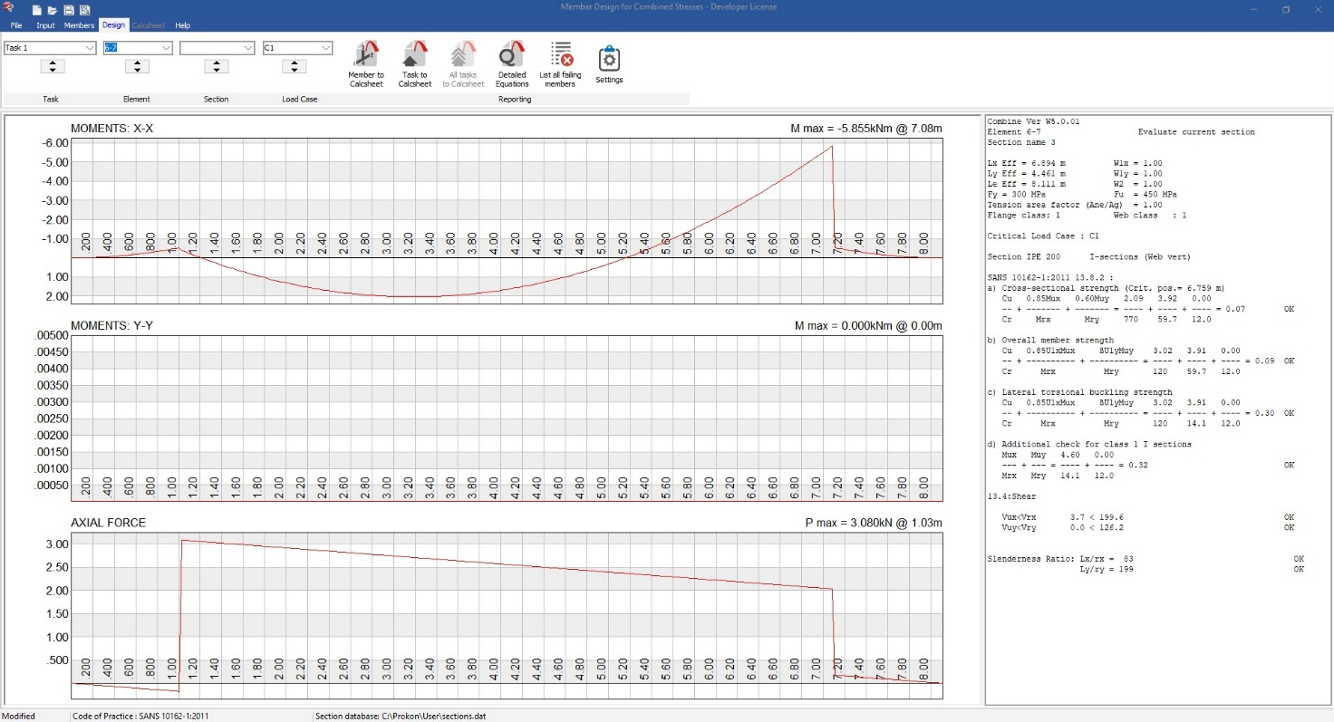

**Supported Design Codes**

**Concrete Design Codes**



* AISC - 1999 LRFD
* AS4100 - 1998
* AS4100:2020
* BS 5950 – 1990
* BS 5950 – 2000
* CAN/CSA-S16.1-94
* CSA S16:19
* CSA S16-01 2001
* CSA S16-09 2009
* CSA S16-14 – 2014
* Eurocode 3 – 2005
* IS:800 – 2007
* NZS 3404 – 1997
* SABS 0162 – 1984
* SABS 0162 – 1993
* SABS 0162 - 2:1993
* SANS 10162 - 2005
* SANS 10162-1:2011

## Summary

Swiftly design and optimise multi-span crane gantry girders with one or two cranes. The program allows for continuously or simply supported girders.

Multiple combinations of main beams and capping beams, including standard I- sections, plate girders and box girders are all supported.

**Crane Beam** calculates the envelopes for all the required design forces (including vertical loads and horizontal effects of the moving cranes), moments and deflections.

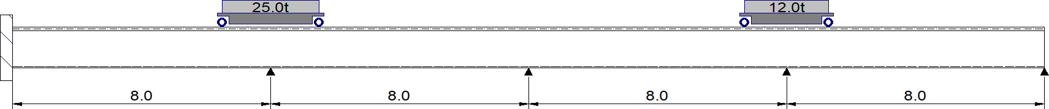

* Multi-span girders can be designed
* Two cranes can be used as design input
* Calculates force and moment envelopes
* Crabs can have up to four wheels

**What makes this module special?**

## Detailed Description

**Crane Beam** is used to swiftly design and optimise multi-span crane gantry girders with one or two cranes. The program allows for continuously or simply supported girders to be designed. Multiple combinations of main beams and capping beams, including standard I-sections, plate girders and box girders are also supported.

Enveloped results for all axes are plotted.

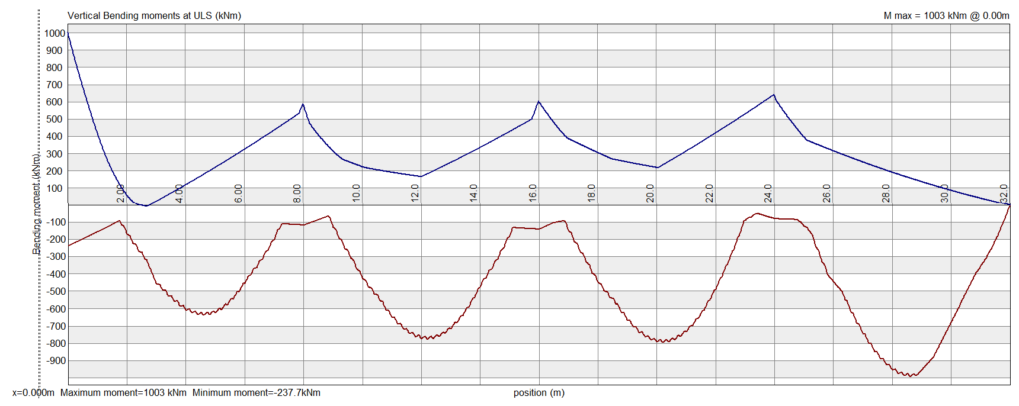

The design procedure for crane gantry girders is similar to that used for statically loaded girders. The various loading codes recognise the varying degree of duty of different types of cranes and gives the parameters for horizontal transverse effects. Especially in the case of heavier duty cranes, certain aspects of the design and construction may require special consideration.

The design output includes deflection, bending moment, and shear force diagrams. Detailed calculations are published in Calcsheet, where all relevant design checks can be seen.

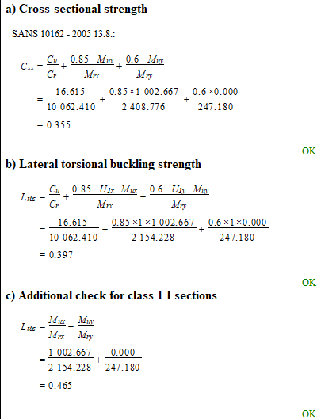

**Supported Codes**



**Design Codes**

* BS 5950 – 1990
* BS 5950 – 2000
* CAN/CSA-S16.1-94
* Eurocode 3 - 2005
* SABS 0162 - 1984
* SABS 0162 - 1993
* SANS 10162 – 2005
* SANS 10162-1: 2011



**Loading Codes**

* SABS 0160 – 1989
* Eurocode 1 – 2004
* SANS 10160 – 2009

## Summary

**Plate Girder** designs I-shaped sections with identical or different top and bottom flanges. The program also allows the user to model tapered elements. The program checks the behaviour of girders under specified loading and gives guidance regarding bearing and intermediate stiffeners. The analysis output can be viewed graphically, or detailed design calculations can be shown.

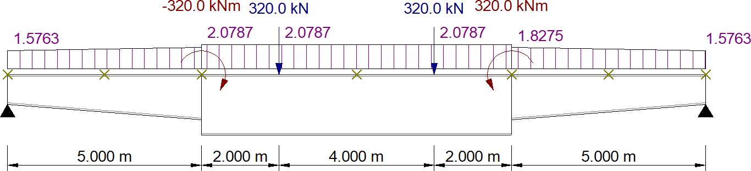

* Ability to model tapered sections
* Unsymmetrical I-sections can be used within design
* Graphical and detailed output given

**What makes this module special?**

## Detailed Description

Welded plate girders can often be effectively and economically used as flexural sections. Modern mechanised manufacturing and automated welding techniques have simplified the production of plate girders greatly, boosting their popularity.

**Plate Girder** can design I-shaped sections with identical or different top and bottom flanges. The program also allows you to vary the section properties along the length of the girder to model a tapered element.

The program checks the behaviour of girders under specified loading and gives guidance regarding bearing and intermediate stiffeners.

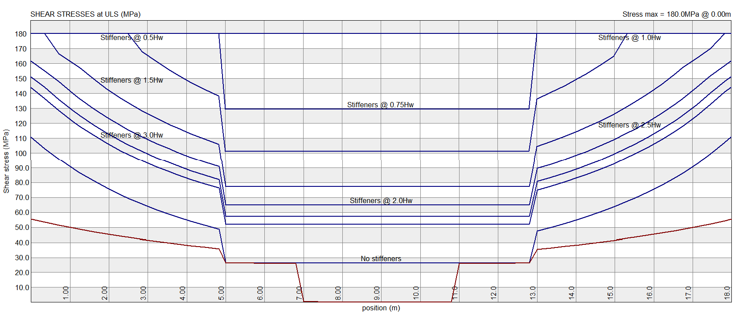

## Bi-axial bending moment

Plate girders are normally used to resist high bending moments and vertical shear forces. The program correspondingly assumes that these effects would govern the design and does not explicitly perform the checks for bi-axial bending moment.

The design output shows the complete interaction formulae, with the zero values for bending moments about the minor axis.

If required, the output formulae can be manually adjusted to include bending about the minor axis.

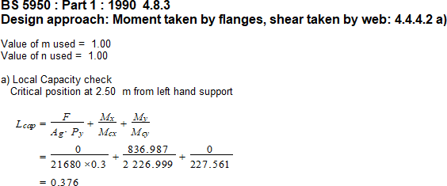

**Buckling under axial compression**

The program assumes that the effect of axial compression is small and therefore uses the full moment capacity for bending about the major axis. No capacity reduction is made on account of buckling about the major axis.

The analysis output can be viewed graphically, or you can view the detailed design calculations. Diagrams of the following results are given:

* The deflected shape of the plate girder.
* Ultimate limit state bending moment diagram. The bending moment diagram is drawn on the tension face of the girder.
* Ultimate limit state shear force diagrams.
* Bending stresses at ultimate limit state. The stresses in the top and bottom flanges are shown in red and yellow respectively.
* The shear stresses at ultimate limit state together with the shear capacity for various web stiffener spacing. The actual stresses are shown in red and the shear capacities in blue.

## Supported Design Codes



**Design Codes**

* BS 5950 – 1990
* BS 5950 – 2000
* CAN/CSA-S16.1-94
* SABS 0162 - 1984
* SABS 0162 - 1993

**Summary**

Design column baseplates subjected to axial force and bi-axial moments, as well as shear and torsion. **Base Plate** can design plates of any general shape that supports steel columns of any shape.

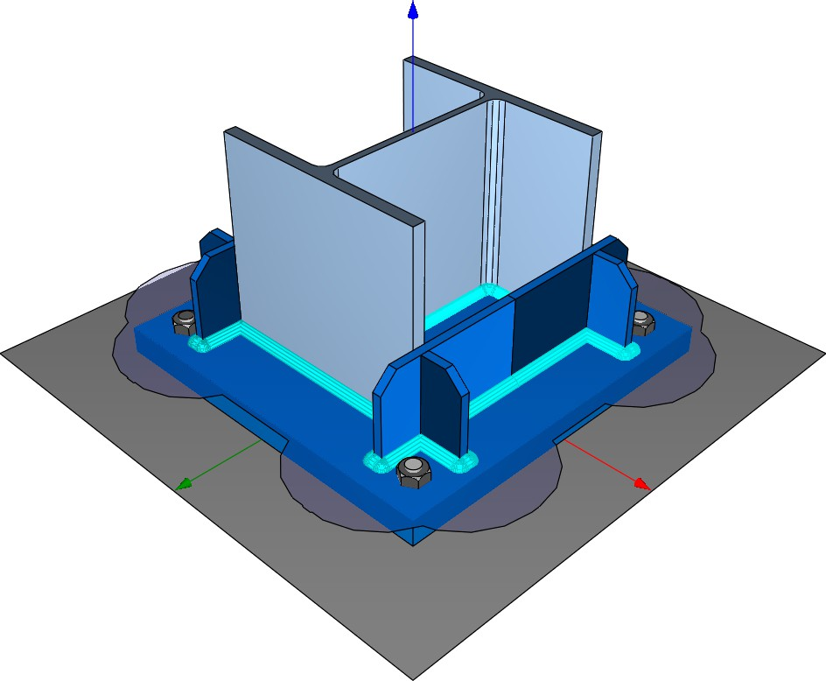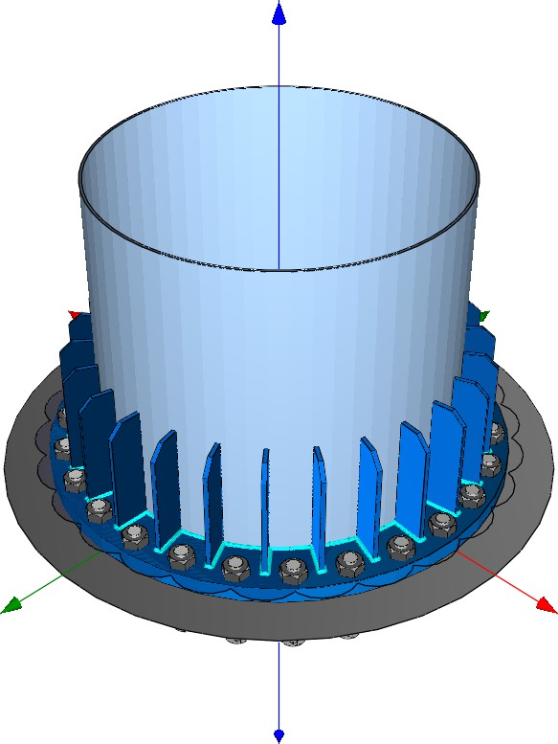

* Shear and torsion calculations
* Baseplates and columns of any shape can be designed
* 3D stress and strain representation

**What makes this module special?**

## Detailed Description

**Base Plate** assists in the design of column baseplates subjected to axial force and bi- axial moments, as well as shear and torsion. Stiffeners can optionally be added to the baseplate.

The design isn’t limited to only rectangular or circular baseplates. Custom baseplate shapes supporting custom steel column profiles can also be designed. Baseplates can bear directly on concrete or grout, or the plate can be elevated, and compression forces can be transferred though the anchors.

The following assumptions are made during analysis and design:

* Column forces are transferred to the baseplate and concrete though an effective area, determined by the column geometry and the plate stiffeners (if any).
* A plane is used to represent the strain across the effective area. The equilibrium point is determined iteratively to balance the internal forces with the applied axial load and biaxial bending.
* For each individual bolt, the module uses the plane of strain to determine its state of tension or compression.
* Torsion transfers to the bolts as shear.

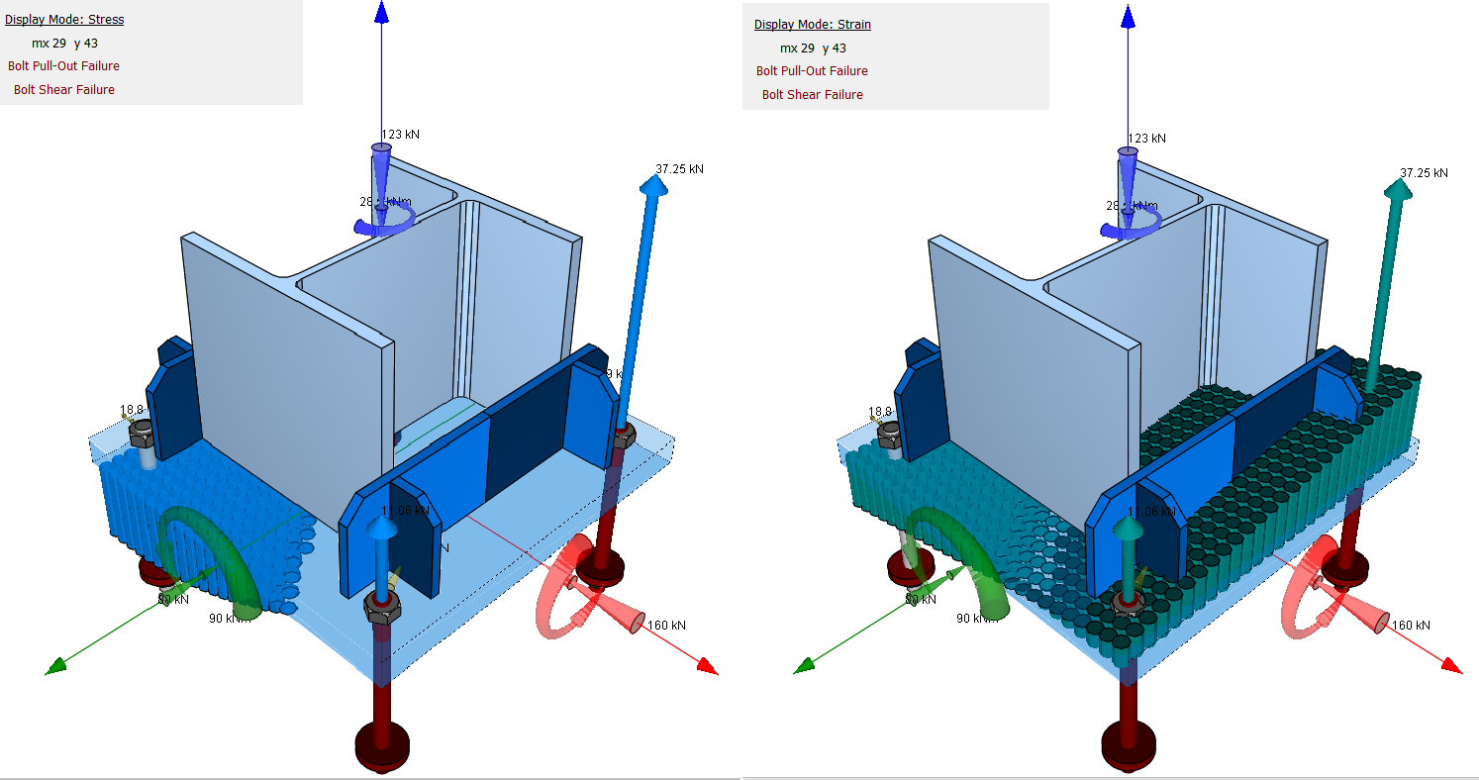

On completing the analysis, the module displays the resulting design forces and factors of safety for each of the load cases.

Design checks include:

* Concrete bearing stress
* Bolt tension or compression force
* Bolt shear force
* Plate bending stress
* Welds

For a better understanding of the analysis of the module, the strain diagram shows the effective bearing area used as well as the plane of strain used to find equilibrium.

The module includes functionality to generate detailed drawings of the connection for editing and printing using **Padds** or other CAD modules.

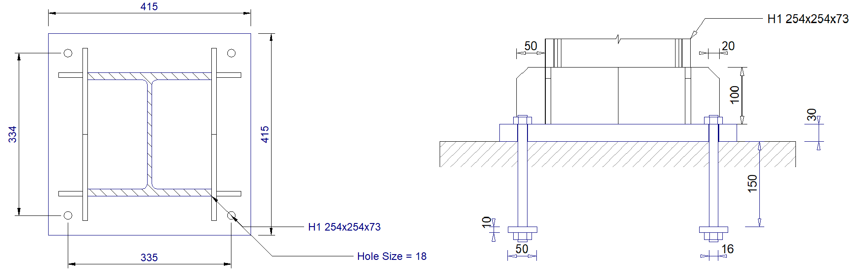

## Workflow

Each connection module can be used in stand-alone mode, but the strength lies with the ability to use the design links from **Sumo** to transfer the necessary forces and geometry to the design module. A drawing of the final design can be saved in either a **Padds** file or DXF format for final fabrication drawings.

## Supported Design Codes



**Design Codes**

* Eurocode 3 - 2005
* SANS 0162 - 2005

**Summary**

**Beam Column** is used to design the moment connection between a steel column and beam. The module considers vertical shear, axial compression or tension, and in-plane moment. It facilitates the design of bolted or welded connections and can include a beam haunch.

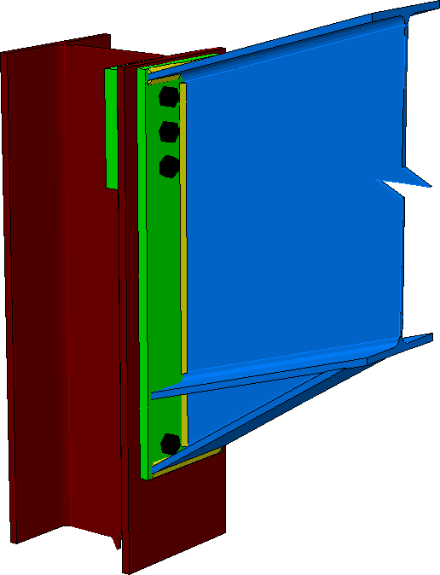

* Optimise beam-column connections
* Detailed calculations
* View the connections in 3D or 2D and save the pictures as CAD drawings

**What makes this module special?**

## Detailed Description

**Beam Column** supports all I and H-sections (universal columns and beams) available in the **Section Database**. The module includes an optimisation function which assists you in determining a suitable layout, e.g., end plate and stiffener size and thickness, bolt/weld sizes and spacing. The design table lists all the variable dimensions and parameters of the connection. A value for any property in the table can be calculated using the optimise function. Values for any individual property can also be fixed selectively to suit the user’s preferences.

Detailed Equations are included within a Calcsheet, where all relevant design checks can be reviewed.

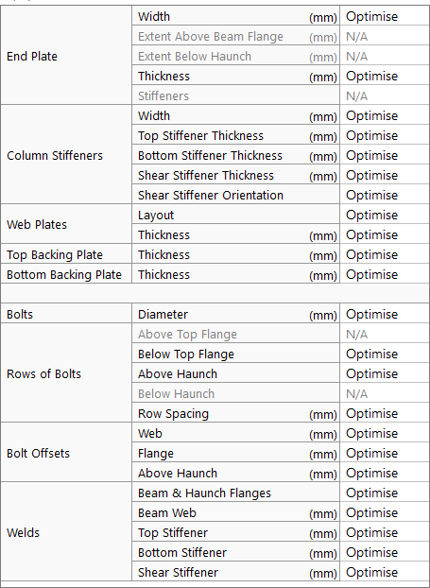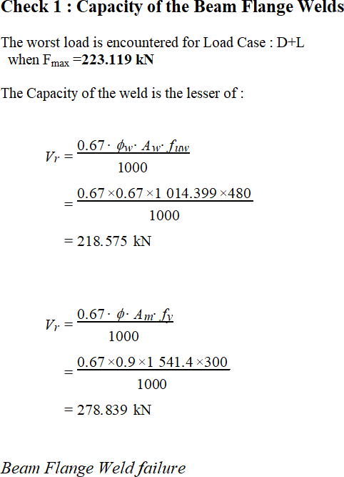

## Workflow

**Beam Column** can be used as stand-alone module, but the strength lies with the ability to use the design links in **Sumo** and import the necessary information. A drawing of the final design can be saved in either a **Padds** or a DXF format for final fabrication drawings.

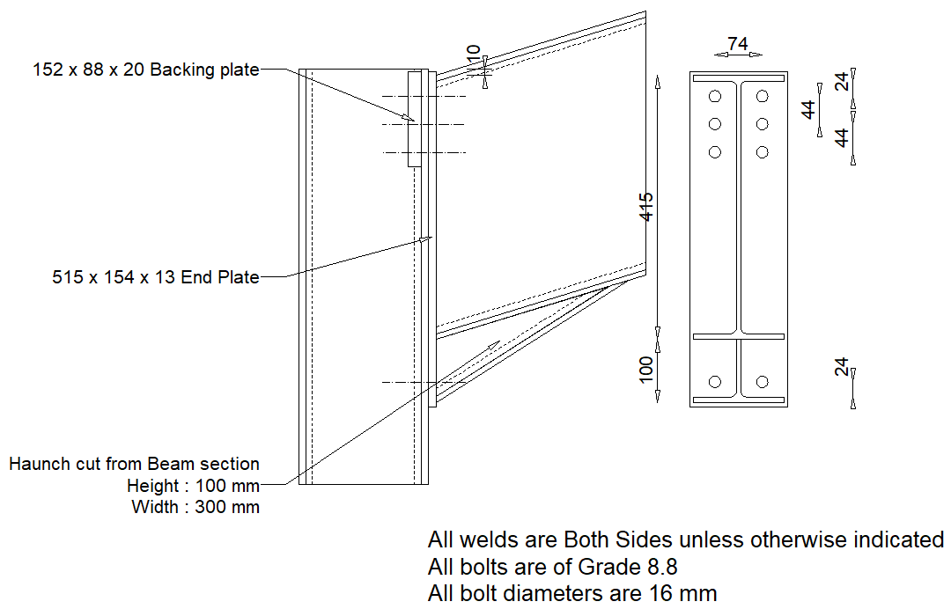

## Supported Design Codes



**Design Codes**

* AISC - 1999 LRFD
* AISC 360 – 16 LRFD
* BS 5950 – 1990
* BS 5950 – 2000
* CAN/CSA-S16.1-94
* Eurocode 3 – 2005
* SABS 0162 – 1984
* SABS 0162 – 1993
* SANS 10162 - 2005
* SANS 10162-1:2011

**Summary**

**Apex** is used to design the moment connection at the apex of a portal frame. The module considers vertical shear, axial compression or tension, and in-plane moment. It facilitates the of design bolted or welded connections and can include haunches.

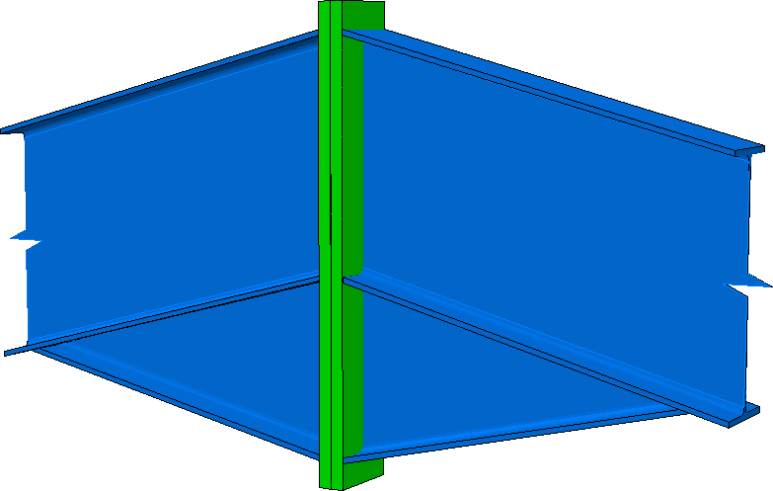

* Optimise apex connections
* Detailed calculations
* View the connections in 3D or 2D and save the pictures as CAD drawings

**What makes this module special?**

## Detailed Description

**Apex** supports all I and H-sections (universal columns and beams) available in the **Section Database**. The module includes an optimisation function which assists in determining a suitable layout, e.g., end plate size and thickness, bolt/weld sizes and spacing. The design table lists all the variable dimensions and parameters of the connection. A value for any property in the table can be calculated using the optimise function. Values for any individual property can also be fixed selectively to suit the user’s preferences.

Detailed Equations are included within a Calcsheet, where all relevant design checks can be reviewed.

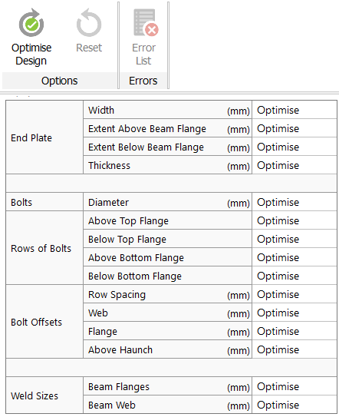

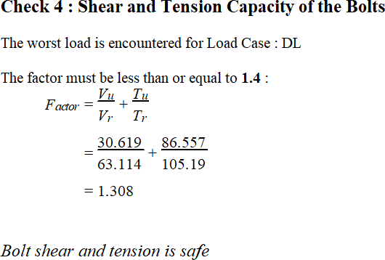

## Workflow

**Apex** can be used as stand-alone module, but the strength lies with the ability to use the design links in **Sumo** and import the necessary information. A drawing of the final design can be saved in either a **Padds** or a DXF format for final fabrication drawings.

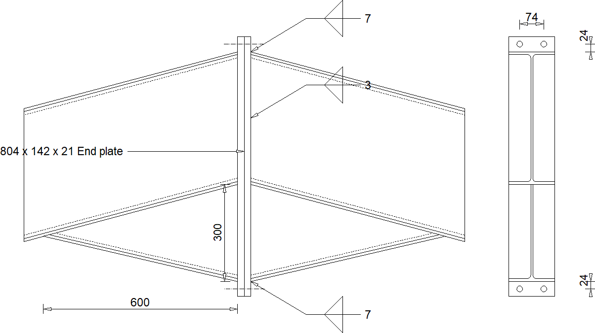

**Supported Design Codes**



**Design Codes**

* AISC - 1999 LRFD
* AISC 360-16 LRFD
* BS 5950 – 1990
* CAN/CSA-S16.1-94
* Eurocode 3 – 2005
* SABS 0162 – 1984
* SABS 0162 – 1993
* SANS 10162 - 2005
* SANS 10162-1:2011

## Summary

**Hollow Sections** performs design checks on welded hollow section joints in lattice structures. The connecting members transmit axial force and can be circular, square, or rectangular hollow sections. The main chord can be I, H, or hollow profiles. Supported connection layouts include K, T, N, X, and Y joints and combinations thereof. The module allows you to enter factored design forces in the chord and braces.

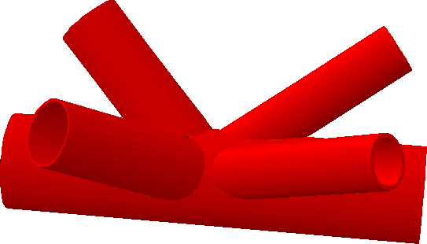

After analysing and designing the connection, the module displays the calculations on a Calcsheet and gives you the options for printing the design output or sending the data to the Calcpad.

* Various connection layouts
* Detailed calculations
* 3D representation of connection

**What makes this module special?**

**Detailed Description**

All design calculations performed by the module are according to the recommendations given in Annex K of Eurocode 3 – 2005. The design checks are performed as prescribed in the code, including the following:

Geometrical evaluation of the connection to ensure compliance with the design code.

* Plastification of the chord
* Chord shear failure
* Punching shear of hollow chord wall

Upon completion of the design, detailed calculations are displayed on a Calcsheet and gives you the options for printing the design output or sending the data to your Calcpad.

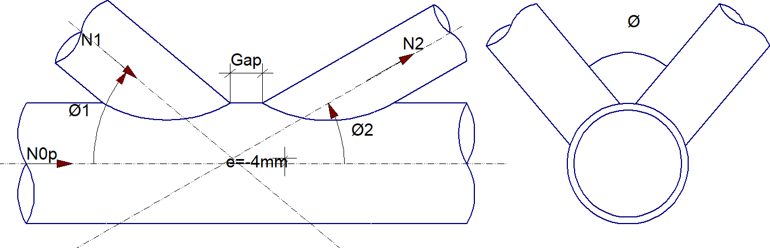

## Supported Design Codes



**Design Codes**

* Eurocode 3 - 2005

**Summary**

**Bolt Group** is used to calculate the maximum resistance of a bolt group and determine the smallest bolt size that can be used to resist an in-plane shear force. Both single and double shear cases can be considered.

* Evaluate current bolt group
* Optimise bolt group for economic design
* Linear and non-linear stress analysis
* Detailed calculations

**What makes this module special?**

## Detailed Description

The quick-and-easy to use **Bolt Group** calculates the maximum resistance of a bolt group subjected to an in-plane shear force. With this module you can also determine the smallest bolt size that can be used to resist an in-plane force with arbitrary orientation. Both single and double shear cases can be considered.

When determining the bolt forces, the module gives you the option to choose between a linear or non-linear method of analysis.

After the analysis, the design output displays the bolt forces graphically and provides you with the design calculations. You can export the resultant pictures as drawings to **Padds**, **AutoCAD®** and other CAD software.

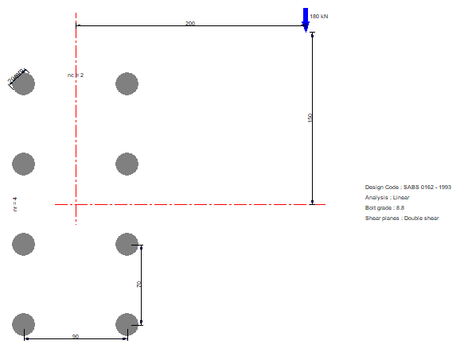

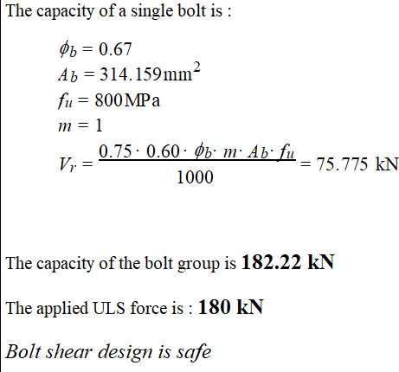

## Supported Design Codes



**Design Codes**

* AISC - 1999 LRFD
* AISC 360-16 ASD
* AISC 360 – 16 LRFD
* AS4100 – 1998
* AS4100 - 2020
* BS 5950 – 1990
* BS 5950 –2000
* CAN/CSA-S16.1-94
* CSA S16-01 2001
* Eurocode 3 – 2005
* IS:800 – 2007
* NZS 3404 – 1997
* SABS 0162 – 1984
* SABS 0162 – 1993
* SANS 10162 - 2005
* SANS 10162-1:2011

**Summary**

**Weld Group** is used to calculate the maximum resistance of a weld group and determine the smallest weld size that can be used to resist an in-plane force with arbitrary orientation.

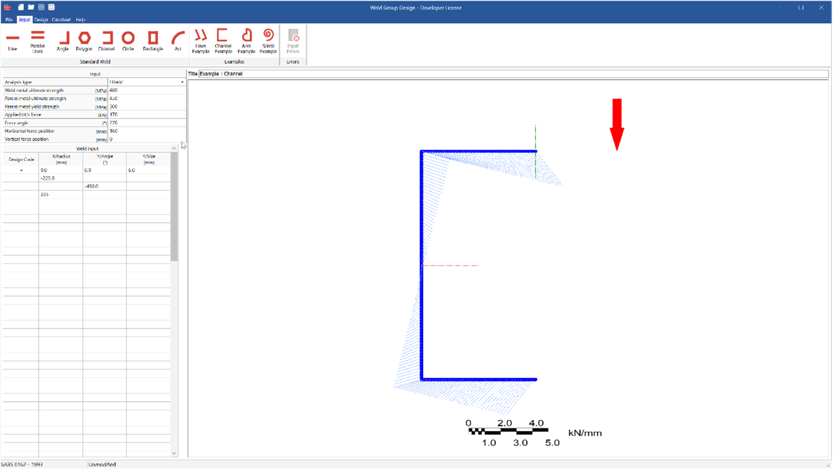

* Evaluate current weld group
* Optimise weld group for economic design
* Linear and non-linear stress analysis
* Detailed Equations

**What makes this module special?**

## Detailed Description

**Weld Group** is used to evaluate the capacity of a group of welds subject to an eccentric in-plane force. Any shape of weld can be defined by coordinates in the input table. For the analysis, there is a choice between linear and non-linear. The former assumes that the group’s centre of rotation coincides with the centroid of the group, while the latter uses the more accurate instantaneous centre of rotation method. A graphic of the stress distribution is displayed both evaluation and optimisation designs.

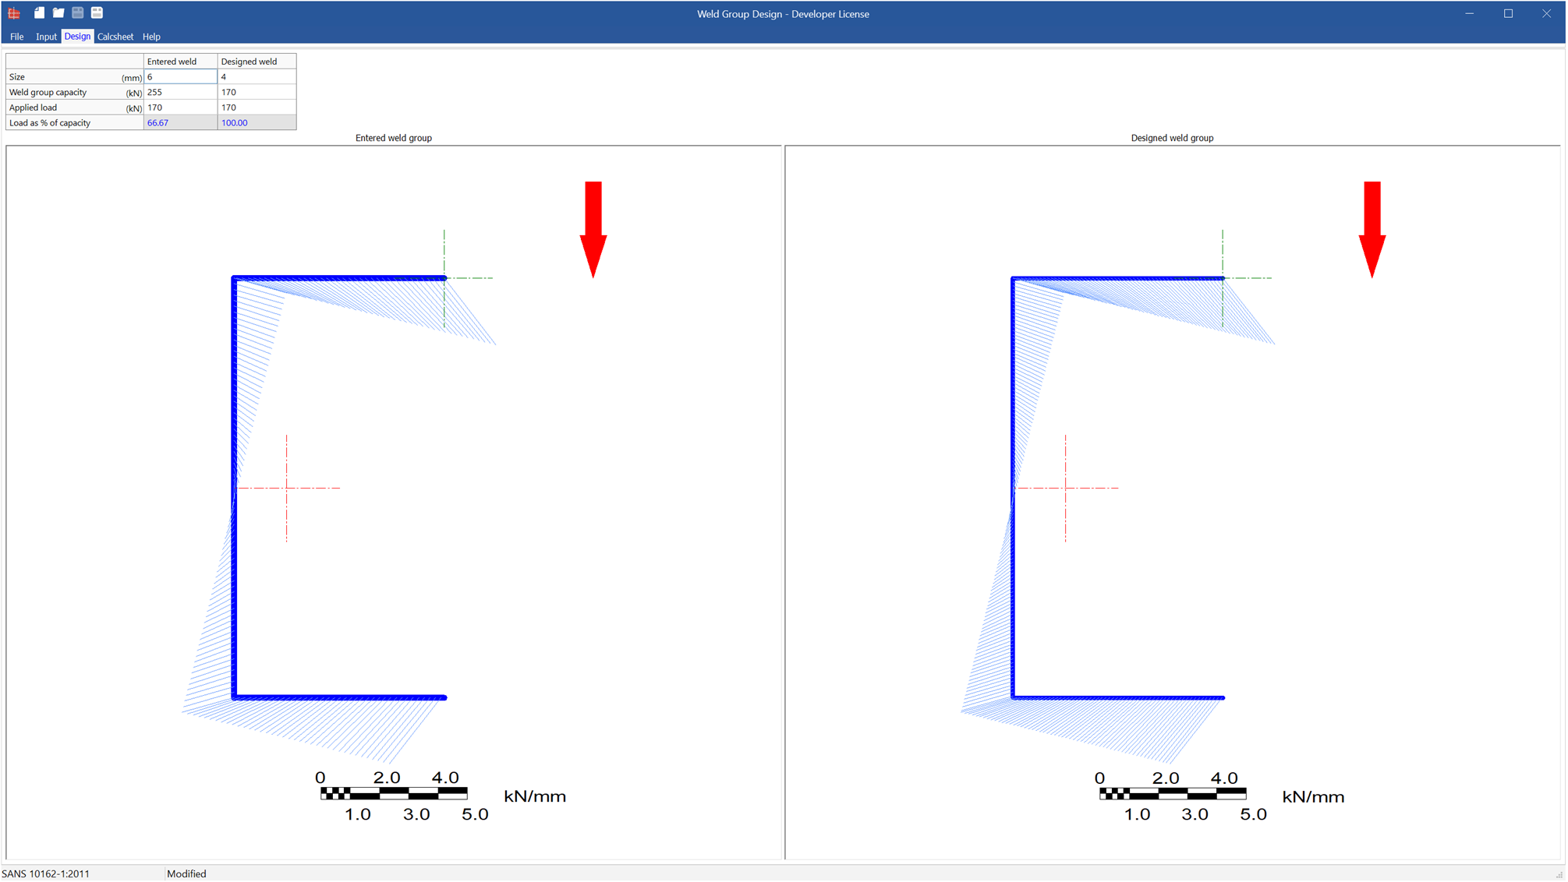

## Supported Design Codes



**Design Codes**

* AISC - 1999 LRFD
* AISC 360-16 ASD
* AISC 360-16 LRFD
* AS4100 – 1998
* AS4100:2020
* BS 5950 – 1990
* BS 5950 –2000
* CAN/CSA-S16.1-94
* CSA S16-01 2001
* Eurocode 3 – 2005
* NZS 3404 – 1997
* SABS 0162 – 1984
* SABS 0162 – 1993
* SANS 10162 – 2005
* SANS 10162-1:2011

**Summary**

**Cleat** designs the connection between a beam and a column when axial and shear force is present without bending. The module uses double angle web cleats to transfer forces between beam and column.

* Automatic bolt sizing and spacing
* Design a connection about the column’s strong and weak axes
* View connection from several angles
* Detailed calculations

**What makes this module special?**

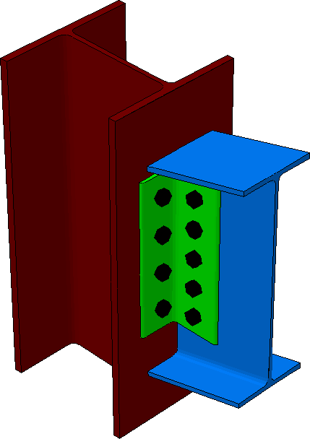

**Detailed Description**

**Cleat** can analyse connections that transmit shear and axial force. The designed connections are considered simple connections that have negligible resistance to rotation and is thus incapable of transmitting significant moments at ultimate limit state.

The modules make the following assumptions:

* The centre line of the beam and column are in the same plane
* The connection transmits end shear only
* Bolts have normal clearance holes
* All bolts have threads in their shear planes

The module supports I or H-sections and the column can be orientated about its strong and weak design axes. The layout of the bolts on the connecting member is defined by entering their number and spacing. The module provides automatic bolt sizing and spacing options to quickly get a workable bolt layout. To verify that you have defined the connection geometry as you intended, the module lets you view it from several angles either using dimensioned elevations or the 3D view.

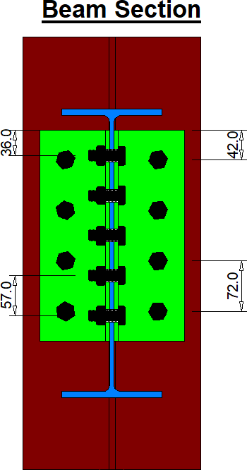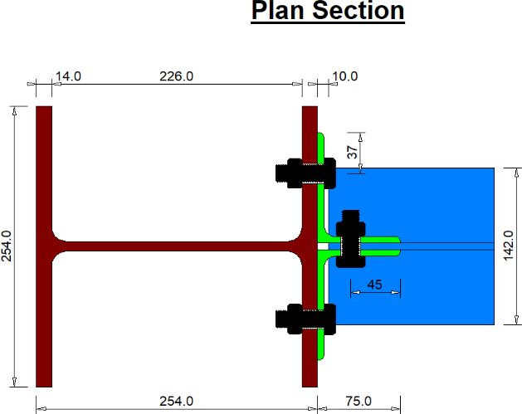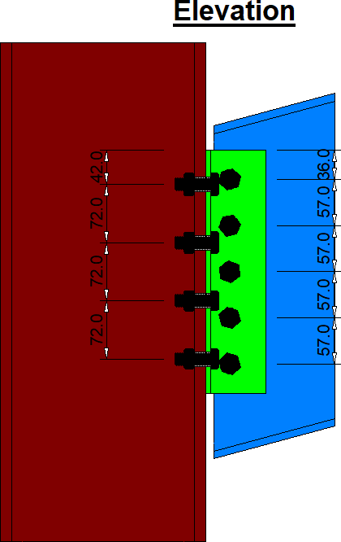

After the analysis you can view the design output on a Calcsheet with the complete design calculations.

**Supported Codes**



**Design Codes**

* AISC 360-16 LRFD
* AS 4100: 2020
* BS5950 – 1990
* BS5950 – 2000
* CAN/CSA – S16.1-94
* Eurocode 3 – 2005
* SABS 0162 -1984
* SABS 0162 - 1993

**Summary**

Fin Plate designs the connection between a beam and a column subjected to axial and shear forces without bending. The module uses a fin plate welded to the column and bolted to the beam to transfer forces between beam and column.

* Automatic bolt sizing and spacing
* Design a connection about the column’s strong and weak axes
* View connection from several angles
* Detailed calculations

**What makes this module special?**

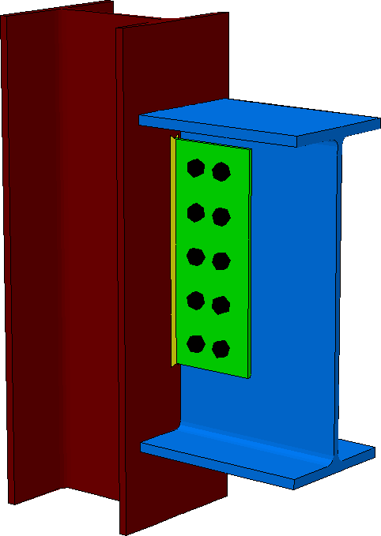

## Detailed Description

**Fin Plate** can analyse connections that transmit end shear and axial force. The designed connections are considered simple connections that have negligible resistance to rotation and is thus incapable of transmitting significant moments at ultimate limit state.

The modules make the following assumptions:

* The centre line of the beam and column are in the same plane
* The connection transmits end shear only
* Bolts have normal clearance holes
* All bolts have threads in their shear planes

The module allows you to enter I or H-sections and orientations with the relevant design loads. The layout of the bolts on the connecting member is defined by entering their number and spacing. The module also provides automatic bolt sizing and spacing options to quickly get a workable bolt layout. To verify that you have defined the connection geometry as you intended, the module lets you view it from several angles either using dimensioned elevations or the 3D view.

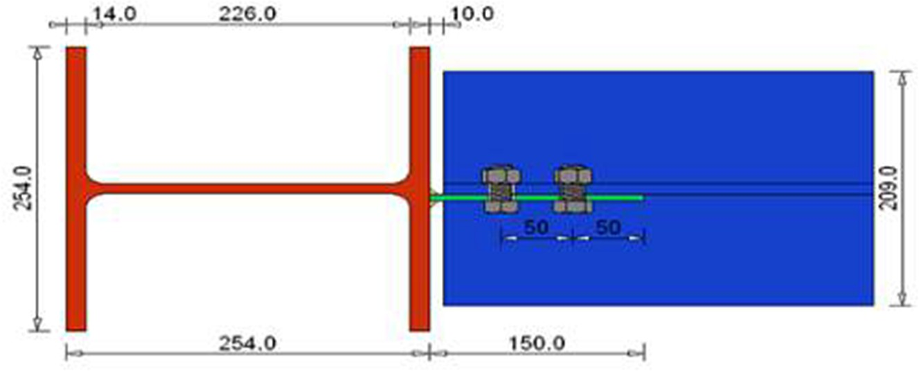

After the analysis you can view the design output on a Calcsheet with the complete design calculations.

## Supported Codes

**Design Codes**



* + AISC - 1999 LRFD
  + AISC 360-16 LRFD
  + AS 4100: 2020
  + BS5950 – 1990
  + BS5950 – 2000
  + CAN/CSA – S16.1-94
  + Eurocode 3 – 2005
  + SABS 0162 -1984
  + SABS 0162 – 1993

## Summary

**End Plate** designs the connection between a beam and a column subject to shear and axial forces without bending. The module uses an endplate welded to the beam’s web to transfer forces between beam and column.

* Automatic bolt sizing and spacing
* Automatic plate sizing
* Design a connection about the column’s strong and weak axes
* View connection from several angles
* Detailed calculations

**What makes this module special?**

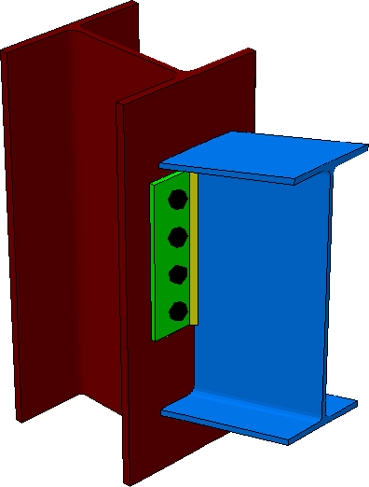

## Detailed Description

**End Plate** can analyse connections that transmit end shear and axial force. The designed connections are considered simple connections that have negligible resistance to rotation and is thus incapable of transmitting significant moments at ultimate limit state.

The modules make the following assumptions:

* + - The centre line of the beam and column are in the same plane.
    - The connection transmits end shear only.
    - Bolts have normal clearance holes.
    - All bolts have threads in their shear planes.

The module supports I or H-sections and the column can be orientated about its strong and weak design axes. The layout of the bolts on the connecting member is defined by entering their number and spacing. The module provides automatic bolt sizing and spacing options to quickly get a workable bolt layout. To verify that you have defined the connection geometry as you intended, the module lets you view it from several angles either using dimensioned elevations or the 3D view.

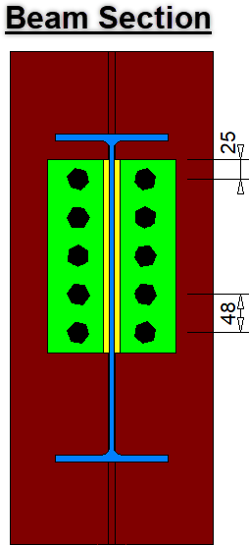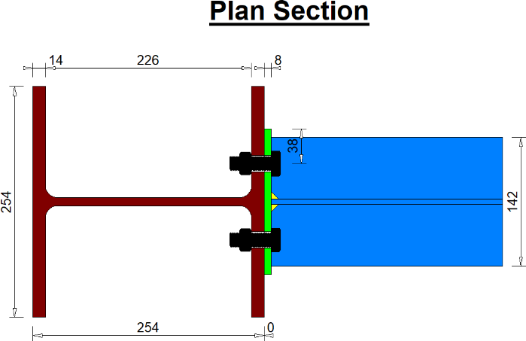

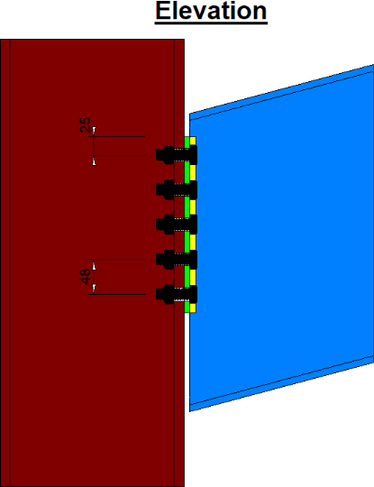

After the analysis you can view the design output on a Calcsheet with the complete design calculations.

## Supported Codes



**Design Codes**

* AISC - 1999 LRFD
* AS 4100: 1998
* AS 4100: 2020
* BS5950 – 1990
* BS5950 – 2000
* CAN/CSA – S16.1-94
* Eurocode 3 – 2005
* NZS 3404 - 1997
* SABS 0162 -1984
* SABS 0162 – 1993
* SANS 10162 – 2005
* SANS 10162-1:2011

**Summary**

**Anchor Bolt** allows you to design cast-in headed anchors subject to tension loads. The module can be used as a stand-alone product, or it can be used in combination with the output of **Base Plate**. The reinforcement layout can be imported from **Pad Footing** Design.

* Rapid results are given for otherwise tedious hand calculations
* Results are easily navigated to identify input parameters that need adjustment to satisfy design criteria
* Strong integration with **Base Plate** and **Pad Footing** modules

**What makes this module special?**

## Detailed Description

The module allows you to specify the anchor parameters, anchor layout, concrete base properties, and load distribution. If required, additional reinforcing can be specified.

Several failure mechanisms are considered. A summary of the results in the form of a visual representation is given to help identify parameters that need to be adjusted to ensure compliance with the required verifications in the code.

## Failure mechanisms

* + - Steel failure of fastener
    - Concrete cone failure
    - Supplementary reinforcement failure
    - Pull-out failure of fastener
    - Concrete splitting failure
    - Concrete blowout failure

A design report is published to the Calcsheet. Here you can specify all the required information to be contained within your report. This can include the input data, a result summary, and detailed design calculations.

**Theory used in this module**

For this module, the following assumptions apply:

* + - Anchors are subjected to tension loads only
    - Design loading is static
    - The load distribution was calculated using elastic analysis
    - Anchor forces are calculated from ultimate limit state actions
    - Accidental loads are not considered

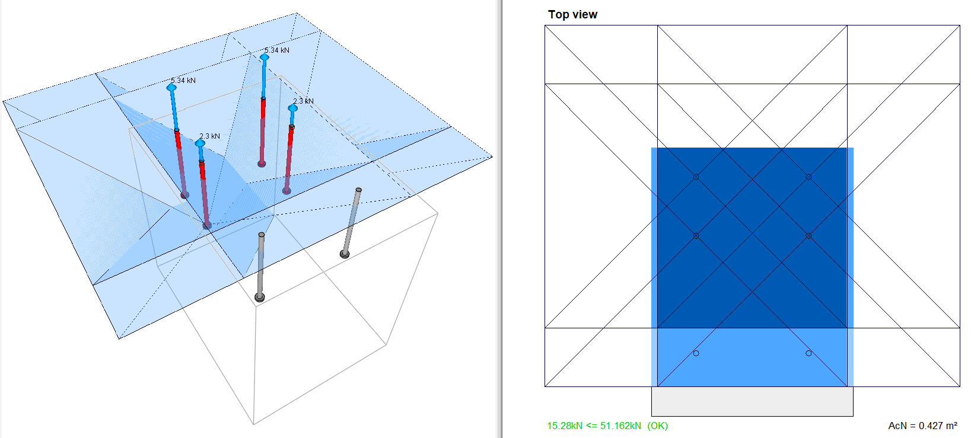

**Supported Codes**



**Design Codes**

* Eurocode 2-2004
* SABS 0100-2000