# Prokon Timber Beam

**Timber Beam** is used to check and optimise timber members subject to axial and bending stresses, e.g., beams, frames, and trusses.

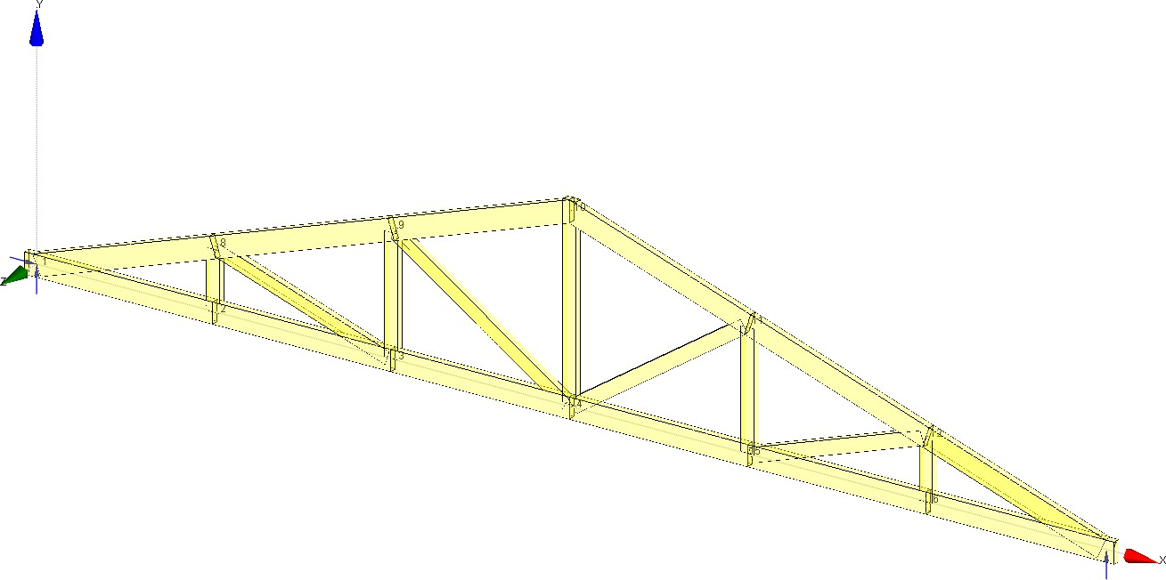

* Members subject to axial and bending stress
* Links with **Sumo** and **Frame**
* Interactive mode

**What makes this module special?**

# Detailed Description

**Timber Beam** can design sawn and laminated timber beams subject to axial and bending stress. The program primarily acts as a post-processor for **Sumo** and **Frame**. It also has an interactive mode to quickly check individual members without the need to perform a full analysis.

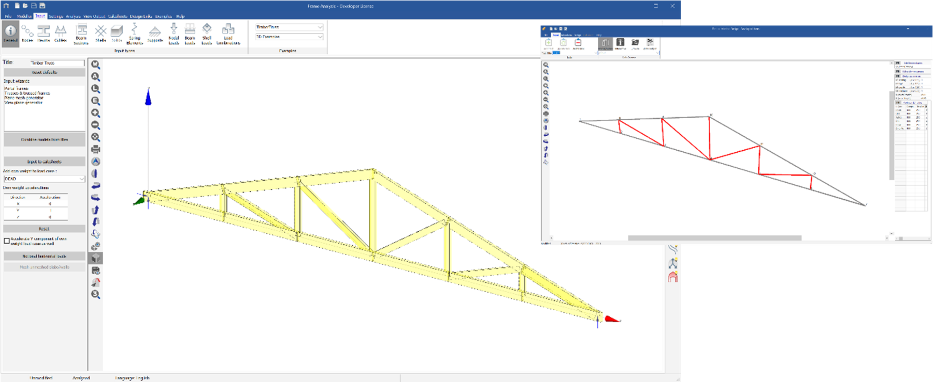

The output for each member includes the graphs showing bending moments and axial force. The calculations and results are printed in the sidebar.

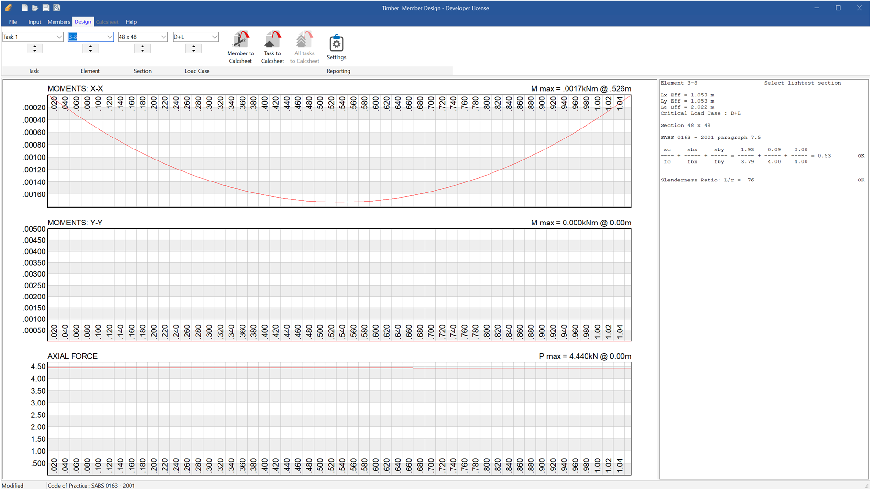

**Supported Design Codes**



**Design Codes**

* BS 5268 – 1991
* SABS 0163 – 2001
* SANS 10163 – 2: 2003